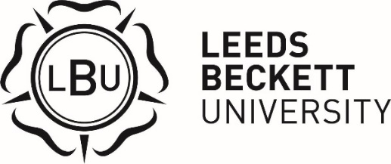

Soroptimist International of Leeds Scholarship
2023/2024

Overview

The Soroptimist International of Leeds Scholarship is supported by a global volunteer movement working together to transform the lives of women and girls with nearly 80,000 members in 124 countries. Soroptimist International Great Britain and Ireland (SIGBI) has 6,000 Members in 270 Clubs in 18 countries in Great Britain, Ireland and countries in Asia, the Caribbean and Malta, who work at a local, national and international level to educate, empower and enable opportunities for women and girls. The scholarship is a cash award of £9,000 to one first year female student, paid in instalments over three years. Applicants will need to be studying a STEM-related course, have an annual household income of £27,500 or less and have a permanent home address in the Leeds City Region or in Yorkshire. Students who are eligible to apply, according to information on their student record, will be contacted via their student email address and applications will be online through MyHub.
Eligibility Criteria

The scholarship is open to applications from candidates who meet the criteria below:

- Have a household income of £27,500 or less.
- Be in their first year of study of their first undergraduate degree.
- Be a female student studying a STEM-related course.
- Permanent home address in Leeds City Region or Yorkshire.
- Be a care leaver (desirable).

Application Process

Candidates who are eligible according to information on their student record will be contacted through their student email and notifications on MyHub. If you believe you are eligible but have not been contacted, please contact the Bursary & Scholarship Officer.

Applications will open in October 2023. If your application is successful you will be invited to an interview. Interview dates for this scholarship will be in November/December. Specific dates and times will be confirmed when applicants are successfully shortlisted for interview. Successful scholars will be notified in December.

Payment

The first instalment of scholarship payment will be awarded in January 2024 and paid directly to a nominated bank account. The payment schedule can be amended for accelerated degrees or sandwich degrees.

General

Full terms and conditions of the scholarship will be provided to successful scholars before formally accepting the scholarship.

The university retains the right to vary the terms and conditions of the application process as it deems appropriate.

If you have any queries please contact the Bursary & Scholarship Officer via email on bursaryandscholarship@leedsbeckett.ac.uk, or telephone 0113 812 5859.

