Uploading Documents to InPlace
- Log Into your InPlace account

- Locate the placement you need to upload to on your homepage and click the word “Detail” next to the name of company:
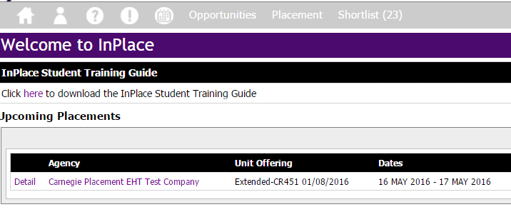

- Scroll down the page that appears to find the “UPLOAD” section and click on the subheading you want to upload to:
- Add today’s date to the date box: 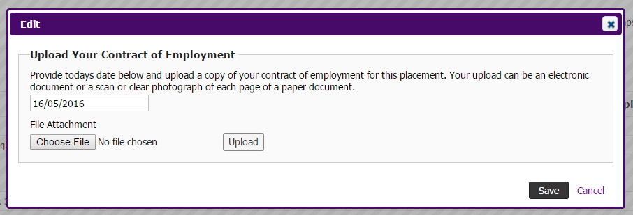
- Click “Choose File” and find the file you want to add
- CLICK “UPLOAD”
- CLICK “SAVE”

TIP: You can only upload one file in each section. If you are taking photos of your documents, paste the photos into a Word document and upload the single Word file instead.

