LEEDS BECKETT UNIVERSITY
CARNEGIE FACULTY

SCHOOL OF EVENTS, TOURISM AND HOSPITALITY

All UG Courses: 48 Week Placement Handbook

2016/17

The Carnegie Placement and Employability Unit (CPEU)
Leeds Beckett University
G03 Carnegie Hall,
Headingley Campus Leeds LS6 3QQ
Tel: + 44 (0) 113 812 6718
Office Email: placementswork@leedsbeckett.ac.uk
Facebook: www.facebook.com/placementswork
Contents
Introduction to your Placement Year 2
1. What is a placement? 2
2. Why do a placement? 2
3. Passing the year 3
4. Timeline of the year 4
5. Support & Contacts 4
6. Looking after yourself on Placement 5
Managing your placement 7
1. Placement To Do Checklist 7
2. Essential Placement Paperwork for You to Provide 9
3. Essential Placement Paperwork to Ensure Your Placement Supervisor Provides 9
3. Problem Solving Procedure 10
4. What is an Appraisal? 11
Assessment 12
1. Placement Assessment Overview 12
Stage 1: Interim Review (November) 12
Stage 2: Interim Review (February) 12
Stage 3: Completed Portfolio of Learning 13
2. What is a Skills Audit? 14
3. What is a Personal Development Plan? 15
4. What is a Learning Situation? 17
5. What is a Learning Log? 19
6. What is the Work-based project? 20
7. Employer Final Assessments 21
8. Structuring and Evidencing your Portfolio of Learning 22
What to do in a crisis 23
Insurance for placements abroad 23
Appendix A: Placement Descriptor & Key Skills 23
Key Skills 26
Key Skills Explained 27
Appendix B: Placement Assessment Criteria 28
Stage 1: Interim Review November (Online submission: Last Wednesday of November) 28
Stage 2: Interim Review February (Online submission: Last Wednesday of February) 29
Stage 3: Completed Portfolio of Learning 30
Work Based Project Marking Criteria 32
A Guide - Expectations during Placement 33

Introduction to your Placement Year

1. What is a placement?
A placement is a period of relevant, supervised work experience, assessed as part of a program of study. It is a great opportunity to gain some real life work experience.
Placement experience is a planned part of your education and training. It is to complement and be an extension of the work engaged in at the University and provides the opportunity for you to accept a large share of the responsibility for your own development, training and progress.
Placement experience has many purposes and placement aims to stimulate and encourage the development of your intellectual, practical, interpersonal and social skills.

2. Why do a placement?
It gives you a chance to see if you would enjoy a particular job
Unemployment rates for graduates who have done a placement are usually much
lower
Great way of gaining work experience & increase your employability skills
Get a head start in gaining a professional recognition in your field.
Makes you stand out from the crowd
Salaries for graduates who have done a placement year are also usually higher
Placement students often get a job offer from their placement company
You can use those insights and skills in your final year modules to your advantage
Greatly improves applications & interview skills, giving you a distinct advantage in your final year
Why do a placement?

3. Passing the year
In order to pass your placement year you must complete and evidence the following:
Placement Requirement* | How to evidence * | When do you submit this?
ALL placement experiences recorded on InPlace | Self Placement Form on InPlace | Once any opportunity is secured
November Interim Submission | Submit work via Turnitin for tutor to mark | Last Wednesday in November
February Interim Submission | Submit work via Turnitin for tutor to mark | Last Wednesday in February
A minimum of 48 weeks industry | Your placements supervisor must complete an Employer Final Assessment form or provide a written reference confirming the hours or weeks you have completed | September
A satisfactory Employer Final Assessment or reference | Your placement supervisor must provide satisfactory feedback using an Employer Final Assessment or written reference | September
Completed and achieved a pass mark on a Work Based Project – marked by your Placement supervisor | Your placement supervisor must mark a project you complete at the organisation. You must provide the mark sheet as evidence. | September
Completed and achieve a pass mark for a placement portfolio marked by your placement tutor | Submit a placement portfolio at the end of your placement for your tutor to mark | September
*further guidance on the placement requirements and evidence needed is provided in this handbook

4. Timeline of the year

Placement tutor allocated
Summer
2016
Placement year starts
Jun
2016
1st interim submission
(Last Wednesday of the month)

Nov
2016
Elective choices for next level modules

Feb
2017
2nd interim submission
(Last Wednesday of the month)

Feb
2017
Induction week submit placement portfolio

Sep
2017

5. Support & Contacts

a. Placement Tutor and Placement Office Mentor
Throughout your placement you will be allocated Placement Support Tutor and a Placement Office Mentor. Your Placement Support Tutor will act as your primary contact during your placement year and in addition, and at times when your Placement Support Tutor may be unavailable, your Placement Office Mentor is available all year to offer support and guidance to you.

b. Placement Office Contact Details
The Carnegie Placement and Employability Unit (CPEU), Leeds Beckett University,
G03 Carnegie Hall, Headingley Campus, Leeds, LS6 3QQ

Tel: + 44 (0) 113 812 6718
Office Email: placementswork@leedsbeckett.ac.uk
Facebook: www.facebook.com/placementswork

c. Communication
It is your responsibility to confirm to your tutor and placement office mentor the best way to contact you. Unless you state a different mode of communication the university will contact you using your University email address in the first instance.

6. Looking after yourself on Placement
Your health, safety and welfare both at work and the environment in which you will live and socialise are of paramount importance. Prior to commencing your placement you must undertake a compulsory Health and Safety (H&S) briefing session. Unless you have undertaken an H&S briefing your placement may not be approved.
This briefing session would typically cover H&S in general but should specifically focus on 6 Key areas as outlined in “UCEA Health and Safety Guidance for the placement of Higher Education students (2009)”

Key Area | Explanation
Work and/or Study | - Work that you will be carrying out on placement  - The work-based hazards to which you may be exposed.  - Control measures may include your professional knowledge and expertise.
Travel and Transportation | - Driving and/or travelling while carrying out the business of the placement provider can be a risk.  - Depending on the nature and location of the placement, you may face significant health, safety and welfare issues associated with your travel to and from the place of accommodation.
Location and/or Region | - The location of the placement can have considerable impact  - Laws and customs can be different in a foreign country.
General/ Environment Health | - You may face significant health, safety and welfare issues associated with the environmental conditions either in the place of work or the general location, with the accommodation or food and drink.
Yourself | - Your health, knowledge, skills and experience; and personality could have an impact on health and safety in particular environments.  - We will always encourage students to make us aware of any special needs they may have to ensure that the correct level of support can be provided whilst on placement.
Insurance Limitations | - An insurance assessment must consider the extent and limitations of the insurance arrangements of both the university and the placement provider, the contractual arrangements in place and the legal requirements in the country or countries where the placement will take place.  - Make sure you have comprehensive travel and medical insurance wherever necessary, for e.g. you should acquire a EHIC (European Health Insurance Card if on placement in Europe (see useful web links)  - The University can provide Travel Insurance for Students doing placement abroad

Prior to accepting or commencing a placement you are encouraged to consider these H&S factors, to seek out further information and to consider the risks associated not only with the placement provider but with the environment in which you will live and socialise.
The amount of information that you will need in advance will depend on the extent to which the placement is unusual, complex, or involves significant risk.

Managing your placement

1. Placement To Do Checklist

- Before your placement
Health & Safety
- Read the Student Placement Handbook
- Read the Code of Conduct Handbook
- Attend the compulsory Health & Safety briefing session
Register your placement(s)
- Complete a Self-Placement Form via InPlace for each piece of work

- Getting started in your placement – within the first few weeks
Personal Development
- Ensure you are given an induction and a health and safety briefing
- Develop & negotiate a Personal Development Plan (PDP) with your employer
- Schedule regular appraisals/reviews with your placement supervisor
(Keep evidence of these for your portfolio and ensure you have completed at least 3 by the end of the year)
- Discuss with the placement supervisor the possibility of having a mentor where possible, separate to your line manager, possibly from a different department, to oversee training, development and general learning processes of the organisation
Tutor visits
- Where appropriate, contact your Placement Tutor and arrange a visit
- Ensure a Pre-Visit Evaluation Form is completed by you and your supervisor before the visit

- During your placement
Interim Assessments
- Complete & submit your November & February interim assessments via Turnitin by the dates specified
Work Based Project
- Agree a Work Based Project with your employer and tutor
- Prior to starting the project, ensure your tutor has approved your Work Based Project Proposal form
- Ensure your employer marks your project and gives you a copy of the mark sheet for your portfolio
- Towards the end of your placement
Employer Final Assessments (EFA)
- Ensure each Placement Provider completes an EFA before the end of each placement
- Keep a copy of each completed EFA for your portfolio and send a copy to the Placement Office
Portfolio
- Compile your portfolio of learning to submit on or before the date specified
- Ensure you have copies of at least 3 appraisal reviews

Things to remember…
- As soon as you are allocated an academic tutor make contact with them
- Agree frequency & method of contact with your academic tutor
- Keep in contact with the CPEU. Update with issues, concerns & changes in circumstances
- Check your student email and MyBeckett account regularly for important information
- Keep track of the placement hours/days/weeks you have worked

2. Essential Placement Paperwork for You to Provide

Self-Placement Form via InPlace  (FOR EACH PLACEMENT) | - Placement Office uses the details you provide in this form to contact your placement supervisor. Please make them aware of this.  - Placement Office will request a job description from your employer, ask them to sign a health & safety declaration and provide a handbook.
Contract of Employment  (FOR EACH PLACEMENT) | - Please ensure you provide the Placement Office with a copy of your contract of employment for EACH placement.
Work-based Project Proposal | - Ensure this is approved by your academic tutor and placement supervisor prior to starting the project
Work Placement Visit Form | - When a tutor visit takes place, the student the supervisor and the tutor must complete the relevant visit forms (available to download via MyBeckett)
Withdrawal from Placement Request  (IF NEEDED) | - Please see problem solving procedure on next page

3. Essential Placement Paperwork to Ensure Your Placement Supervisor Provides

Work Based Project Mark Sheet | - Your placement supervisor should complete this form and return it to you once your project is complete.
Employer Final Assessment | - For every placement, your Employer should complete this form to provide feedback on your performance and to confirm the number of weeks completed.

3. Problem Solving Procedure
The following template should be used as a guide to solving problems that may arise whilst on placement. For further guidance you should refer to the “Placement Guidelines and Code of Conduct Handbook” which can be found on MyBeckett.
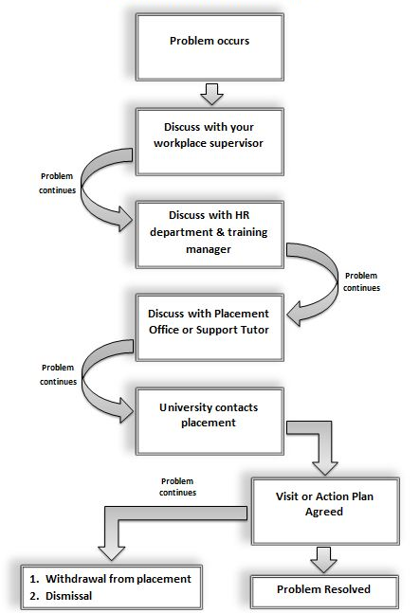
Advisory
- You MUST contact the Placement Office if you are struggling, do not just walk out or leave
- If you do walk out of a placement and have not attempted to follow the above procedure it will be considered the equivalent of walking of your course and you will be required to have a disciplinary meeting
- If you get sacked contact us ASAP

4. What is an Appraisal?
Appraisal is an integral part of the assessment process. Appraisals serve a number of purposes. Within the context of the placement it will:

- Provide an opportunity for you and your placement provider to formally indicate the direction and level of your performance, which in turn will help you to evaluate and amend your specific learning aims and objectives;
- Provide a structure for communications between you, the organisation and the University to help clarify expectations of you;
- Developmental therefore you should prepare for the appraisal in the same way as your placement provider must do;
- Provide the basis for a discussion about your strengths and weaknesses and how you are progressing and what needs to be done to rectify problem areas etc. After the appraisal you must prepare an action plan to take you forward to address areas identified for development;
- Helps you to monitor your PDP and provides you with the opportunity to draw attention to areas in the PDP that have not been covered yet.
- Guidelines and standard forms are available on MyBeckett

- It is acceptable to use the placement provider’s own assessment forms. If unsure contact your Placement Support Tutor for further guidance.

Assessment

1. Placement Assessment Overview
During your placement year you are required to submit three pieces of work. There are two staged assessments called the Interim Reviews. The Interim Reviews should be recognised as an opportunity for you and your Placement Support Tutor to monitor your progress and to provide you with timely feedback. The staged assessments contribute towards your final grade they are each worth 10% respectively.
At the end of your placement year you must submit a “Portfolio of Learning”, which is a reflective piece of work providing evidence of performance, achievement and progress. The aim of the portfolio is to produce work which allows you to reflect on the placement year and allows you to identify what you have learnt and assess its value to you personally.

Stage 1: Interim Review (November)

Staged Assessment 1
November, 10%
Approx. 1500 words
Current Skills Audit
Current Personal Development Plan (PDP)
1 Reflection on a Learning Situation
Discuss your PDP with your employer
Review comments & feedback from appraisals

Stage 2: Interim Review (February)

Staged Assessment 2*
February, 10%
Approx. 1500 words
Revised Skills Audit
Revised Personal Development Plan (PDP)
1 Reflection on a Learning Situation
Discuss your PDP with your employer
Review comments & feedback from appraisals

*Your second submission should build upon the work you submitted in November

Should you have any further need of guidance, after reading the Student Placement Handbook, please contact your Placement Support Tutor.

Stage 3: Completed Portfolio of Learning
Your portfolio is an on-going record of your progress and achievement whilst on placement. Some of the assessment will take place during your placement, this is outlined below.
The completed Portfolio of Learning will be submitted during your first day back at University, this is normally your induction day.
Staged
Assessment 1
10%

Staged
Assessment 2
10%

Introduction to Placement 10%

Personal Development Planning
20%
Skills
Profile
10%

Reflections on
6 Learning Situations
20%

Reflection on Work Based Project
10%

Additional Evidence + Presentation
10%

Completed Portfolio of Learning
8000 words
Submission of completed Portfolio of Learning
The hand in date for your completed Portfolio of Learning is September during your Induction week. This is normally arranged to coincide with your induction day. You will be notified of the exact details nearer the time.

2. What is a Skills Audit?

A skills audit is a review of your existing skills against the skills you need both now and in the future. It can help you to identify your existing skills, identify what skills you may need to carry out your existing job role more effectively and to plan, develop and improve the skills and knowledge needed for your future career. Regular review is necessary as your work priorities change and your skills development progresses.
A three stage process
Stage 1 - Determine Skills Requirement
First you write down, as a bullet point list, the knowledge and skills which you consider to be important for your current role. You may find it useful to refer to your job description (if there is one for your role). Next write down, again as a bullet point list, the knowledge and skills which you consider to be important in the future. You may find it helpful to discuss your list with your line manager or a more experienced colleague.
Stage 2 - Rating Your Ability
Once you have produced your list you need to rate your current ability against each one. This may be done using a 3 point rating of strong, weak and somewhere in-between or you may find it more useful to use a five point scale such as the one below.
1 | = | No current knowledge or skill (no current competency)
2 | = | Some awareness but not sufficiently competent to use it
3 | = | Familiar with and able to use the knowledge or skill (some competency)
4 | = | Proficient in the knowledge or skill and able to show others how to use it (high level of competency)
5 | = | Expert with a high degree of skill and/or comprehensive knowledge (fully competent)

Stage 3 - Your Future Development
The final stage is simply that of using the information to concentrate on developing the skill and knowledge areas where you have a low score or have identified that you are not fully competent.

Now you’re ready to write your Personal Development Plan…

3. What is a Personal Development Plan?
Overview
Prior to commencing placement you should begin to think about, and discuss with your tutor, your personal learning objectives and expectations for your placement. With the help of your tutor, you will develop an initial Personal Development Plan (PDP) [it may be referred to by some Placement Support Tutors as a General Learning Agreement (GLA) they are the same] The initial plan outlines, in very general terms, your own learning needs, aims and objectives.
As learning is an on-going process, you should use your PDP to discuss with the placement provider your roles and responsibilities and to negotiate with your placement provider a series of more specific learning objectives related to achieving that that task or role.
Your Personal Development Plan should be more detailed and should reflect changes in your roles or responsibilities as you progress through the placement year. You should review your PDP at regular intervals throughout your placement. For example, after each appraisal, or when you change roles or responsibilities, or when you change placements, and so on.
The Personal Development Plan (PDP) serves several purposes by:
- Acting as a contract of learning for your placement
- Providing a reference against which progress can be measured
- Serving as a basis for evaluation and validation of the learning experiences
- Providing the framework for writing up your portfolio

Process and Introduction
To introduce the PDP, give a general description of the placement you will be undertaking. For example, department you will be working in; projects you will be working on; people you will be working with; roles you will be undertaking.
Learning Objectives of your PDP
The PDP is your wish list in addition to the job description that the placement providers will have issued. State specifically what you intend to learn; what extra do you want do in terms of tasks and what specific skills do you want to develop and enhance. Include the knowledge and skills you want to gain and attitudes or values you want to clarify. Learning objectives are specific, measurable statements of what you hope to accomplish/learn during the placement. The objectives should be given careful thought and should be discussed with your supervisor (and where appropriate your Placement Support Tutor. The learning activities you describe here will be directly related to your learning objectives. They will enable you to work towards achieving those objectives and learn in the process.

The PDP should be discussed and negotiated with your supervisor who will say whether what you have identified is possible. It will give them the opportunity to revise what you are going to do on your placement. For instance if you want to gain financial skills then they may arrange for you to spend some time in the accounts section of the business. Alternatively you may have to make informal arrangements to do this outside of your normal work. However, this needs to be discussed and agreed. Finally the PDP must be submitted to the University as part of your interim assessment.
Outcome/Evaluation of your PDP
Having set your objectives it is your responsibility to provide appropriate evidence to demonstrate your progression and achievements. This supporting evidence should be submitted as part of the final portfolio and will help to determine your final grade (See Appendix C),

A Final word on your PDP…
The ultimate value of the Personal Development Plan lies in the dialogue it will foster between you, your Placement Support Tutor and your supervisor about the meaning and quality of your placement. It will serve as a contract. It can be used if you get ‘stuck’ in certain roles within the organisations and will act an aide memoir for you and your placement provider. In writing your agreement, you have in effect created the syllabus for your own course in an area of inquiry and high interest to you. You have spelled out what you will do and learn, how you will accomplish this, and how your progress will be evaluated.

4. What is a Learning Situation?
We learn from experience all day and every day. Learning is more than the acquisition of knowledge and skills. The complete process addresses the application and review of effects of that knowledge /skills.

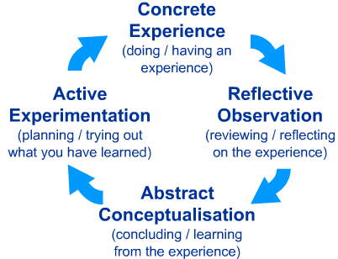 | 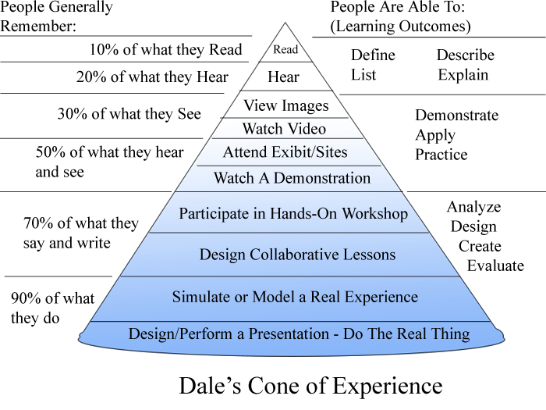

Within your Portfolio you are required to present at least 6 learning situations. The purpose of this exercise is to identify 6 critical learning situations that you experienced either directly i.e. “This happened to me…” or indirectly i.e. “I observed…”
Please see the table on the next page for a suggested learning situation structure.

Example ‘Prompt’ questions for reflection
- What happened? How did it feel? How did other people react?
- What choices did you make and what effect did they have?
- What have you learned for the future?
- How could you apply what you have learned to a different situation?
- What went well?
- What could have gone better?
- What was your role in the situation?
- How will you do things differently in a similar situation in the future?
- Are there any immediate or longer term actions that you need to take?
- How does it affect your skills development or the goals that you have set yourself?
- How would you explain what you have learned in a job interview?

How to structure your 6 Key Learning Situations
What happened?  Objective Description | - Identify a learning situation  - Briefly outline where the learning happened, when it happened. Who was there, why were they there. What was the context of the learning situation? What was your role?
What did you learn?  Subjective Reflection | - What were you thinking and feeling?  - What was your personal behaviour?  - What did you experience before during and after the learning?  - Identify strengths and weaknesses  - What actions enhanced or hindered the learning?  - Reflect on what skills, knowledge, learning outcomes you derived from the situation/project.  E.g. As a result of this incident:  “I must learn to be more assertive…”  “I learnt that training is essential before expecting workers to perform to their best ability…”  “I learnt to check all details before confirming with the Manager….”  “I now know how to be an effective manager….”
What next?  Future Planning | - What do you now think about the learning?  - What was good and bad?  - What else could you have done?  - If it happened again, what would you do? What would you change?  - How will you apply this learning in the future?  “E.g. When I become a manager, I will try and ensure that new employees will have an induction course within the first week etc.”
Review  Applying the learning | - Reflect on the learning processes you have gone through.  - Be critical about yourself:  - Did something go well? Then what did I learn from it? How can I build on it?  - Did something go badly? Then exactly what went wrong? How can I fix it, overcome difficulties, and improve upon it?  - Have my ideas changed? If so, why?  - Summarise the outcomes and map against your key skills statement.  E.g .“As a result of this situation I have developed the following skills: Assertiveness, Effective team management Enhanced communication skills”

5. What is a Learning Log?

A learning log is a simple, informal tool to help you to understand, reflect upon and learn through what you experience. It is a good idea to keep and review your own log/diary on a regular basis e.g. Daily/Weekly/Monthly throughout you placement. This will ensure you do not forget any valuable learning situations or events. You can then use your log to compile your portfolio and summarise all your experiences at the end of your placement. It can be used as an appendix in your portfolio as evidence of achieving certain learning outcomes in your PDP. It can also be used to help you write up learning situations in note form before you complete them properly.
You are advised to:
- Keep a learning log/diary;
- Record the learning that has taken place to be clear about the facts;
- Record your feelings, reactions and judgments about the learning;
- Assess the relevance and application of the learning.

How to go about writing a log
Select a suitable event
Try to choose an experience or event that means something to you and has impacted on you to make it as meaningful as possible. It’s often the case that the WORST experiences result in the BEST learning logs.
Choose something that happened that you genuinely learnt something from.
Select something simple that involves few people and is a discrete event. Don’t try to write about a huge piece of learning like a whole week’s work experience or an entire project.
Write it whilst it is fresh in your mind
If you leave it too long the event will become lost in time. Write on the day it happens if possible. You will be recording feelings and ideas that may otherwise become distorted with time.
The learning log is a personal commentary upon your experiences. It makes explicit to you (and the tutor) the learning processes supported and instigated by the course of study. At the end of each week you need to reflect upon what you have written in your learning log.
You should add notes to this log every day you do something on the project. Write in whatever style suits you, as these notes are for your own use, when you reflect on them in the next stages.

6. What is the Work-based project?
Also referred to as a Company Set Project, this project is intended to develop your practical knowledge and understanding of theoretical aspects of the course. It will help you develop skills in research, analysis, diagnosis of well-defined problems, development of strategies to address problems and in techniques of presenting information.

You will negotiate with your placement provider and Placement Support Tutor, regarding the nature of the project.

The project should address either a “real problem” you have seen/been part of, or a “current issue” within industry. It is anticipated the topic chosen should be of specific interest to you, as well as an area of which you have gained some experience during placement year.

Using a range of sources, suggestions should be made as to how this problem or issue could be resolved or improved. Suitable proposals and recommendations that could be implemented should then be made.

Project Proposal
Before starting your project you must compile a proposal. The proposal should outline the aims and objectives of your project, indicate people who would help, resources available and the time scales within which the project should be completed. This should be agreed by your Placement provider (and where appropriate your Placement Support Tutor) before beginning your project.

Marking of the Project
The placement provider will be asked to mark your project against the following criteria:
- Research/Collecting Information
- Approach and Attitude in Tackling Project
- Analysis and Conclusions
- Proposals & Recommendations
- Presenting Information and Final Document

Reflection on your Project
In addition to completing your project you are required to write a short personal reflection of between 300 to 500 words. This will be submitted within your portfolio and marked by your tutor.

The reflection should focus on skills developed as a result of completing the project.

Work-based Project Prompt Questions

- What happened? How did it feel? How did other people react?
- What choices did you make and what effect did they have?
- What have you learned for the future?
- How could you apply what you have learned to a different situation?
- What went well?
- What could have been better?
- How will you do things differently in a similar situation in the future?

7. Employer Final Assessments
At the END OF EACH AND EVERY PLACEMENT you must ensure that your placement provider has completed and returned an Employer Final Assessment form (Copies available for download on MyBeckett).
The Employer Final Assessments not only indicate how you have performed but also confirm the number of weeks that you have worked.
The expectation is that you will be taking every opportunity on placement to optimise the learning experience. This should be reflected in your placement providers on-going appraisals and ultimately in your Employer Final Assessment.

IMPORTANT PLEASE NOTE:
You cannot pass your Placement year until the Placement Office has satisfactory evidence your Placements via receipt of Employer Final Assessments.

If your placement provider marks your overall performance to be less than satisfactory you need to discuss the reasons for this with both your Placement Support Tutor and the Carnegie Placement and Employability Unit (CPEU).

Ultimately the Assessment Committee will review your overall profile and evaluate the extent to which you have attained the objectives.

8. Structuring and Evidencing your Portfolio of Learning
Introduction
Events Worked
3 x PDP Reviews
Skills Summary

Pre-Placement

Skills you need to gain

What, where, when, scale

Organisation
Environment
Post-Placement
Review skills and progress
Roles and responsibilities
Product/Service

Competitors

New goals and action plan

Skills gained

Size/Scale
Customers
Revise existing PDP
Mission / Goals

Challenges

Structure/Culture

PEST

Supporting Documentation
(Appendices should be referenced within the portfolio)
Work Based Project
6 x Learning Situations
Other relevant information
Marketing Materials/Press releases
Photographs
Brochures/Leaflets
Rotas/Schedules/Letters
Your CV

At least 3 appraisal reviews

An employer final assessment for EACH placement

Conclusion
Action plan for the future

General thoughts

Skills Gained

Skills gained summarised in bullet points

Kolb’s Learning Cycle

300 words each

Project Proposal

Project mark sheet

Portfolio reflection of 500 words

What to do in a crisis
In the unlikely event that you find yourself in a situation of intense difficulty or danger during your placement year and you cannot contact the Placement Office (i.e. outside of office hours) please contact the University’s 24 hour response line on:
+44 (0)113 812 6666

Insurance for placements abroad
For placements abroad, Leeds Beckett University may be able to provide comprehensive travel insurance. Please contact insurance@leedsbeckett.ac.uk for further details.
If you have taken out a travel insurance through the University please ensure you carry a copy of the policy with you during your placement as it contains important details of how to report and incident should a problem arise.

If you are unsure about any of the above information please contact the placement office in the first instance
Placement Office Contact Details
Carnegie Placement and Employability Unit (CPEU), Leeds Beckett University,
G03 Carnegie Hall, Headingley Campus, Leeds, LS6 3QQ

Tel: + 44 (0) 113 812 6718
Office Email: placementswork@leedsbeckett.ac.uk
Facebook: www.facebook.com/placementswork

Appendix A: Placement Descriptor & Key Skills

Module Definition
16 | Brief Module  Description | The industrial placement complements and extends the knowledge and skills developed during previous levels/semesters and in prior experience. It allows the student the opportunity to take responsibility for their own development and learning and to reflect on their progress. A key feature of the placement experience is to enhance the learner’s employability and future career prospects.
17 | Module Appropriate for  Study Abroad | No

Module Information Industrial Placement AS
19 | Attendance  requirements | Complies with University regulations on sandwich mode placements: students are expected to complete the equivalent of a minimum of 48 weeks of full-time employment.
20 | Delivery type | P – Placement

Module Learning, Teaching & Assessment Information
23 | Module Aims | This aim of the placement is to develop skills and learning in a work context. The module should also help the student to structure learning in the workplace in a way that will help them to develop personally and as a future manager. Students should also develop the skills to become a reflexive learner.
24 | Learning Outcomes | On successful completion of this module and the placement students will be able to:
 | Learning outcome 1 | Demonstrate the skills necessary to obtain a work placement, and work efficiently at operative and, where appropriate, supervisory/management level;
 | Learning outcome 2 | Display knowledge and skills in as many areas as possible/relevant within the sector, including financial management, information and control systems and administrative knowledge; together with an insight into future plans and policies;
 | Learning outcome 3 | Demonstrate enhanced social and transferable interpersonal skills including the skills of observation, investigation, analysis and assessment related to the types of problems encountered in the industries;
 | Learning outcome 4 | Show confidence, self-awareness and a more mature outlook, particularly in the context of employment relationships and responsibilities.
25 | Graduate Attributes | Attribute |  | Developed | Assessed
 |  | Enterprise
 |  | Digital Literacy
 |  | Global Outlook
26 | Module Content |  | The sector of the industry selected will depend on a student’s previous experience, performance and where possible, preference.  - A student will be expected to work in as many relevant departments as possible where maximum knowledge and skills can be acquired and practised. This should lead to supervisory/first line management level, depending upon length of placement, previous experience and proven capabilities;  - The specific content covered in each area will be negotiated between the student and supervisor in agreement with the University Placement Tutor;  - Placements overseas can be negotiated, subject to the criteria laid down in the Policy and Procedures document for Overseas Placement.
27 | Learning Activities |  | See module content.  In addition the indicative learning activities students will undertake are:  - Job search and application;  - Negotiation of learning agreement and activities in the workplace;  - Engagement with the Pebble pad or similar to record and reflect on the placement on a regular basis, and completion of the final portfolio;  - A project or series of smaller ‘real’ projects for the organisation.

Key Skills
Your placement should provide you with the opportunity to develop the following skill areas.

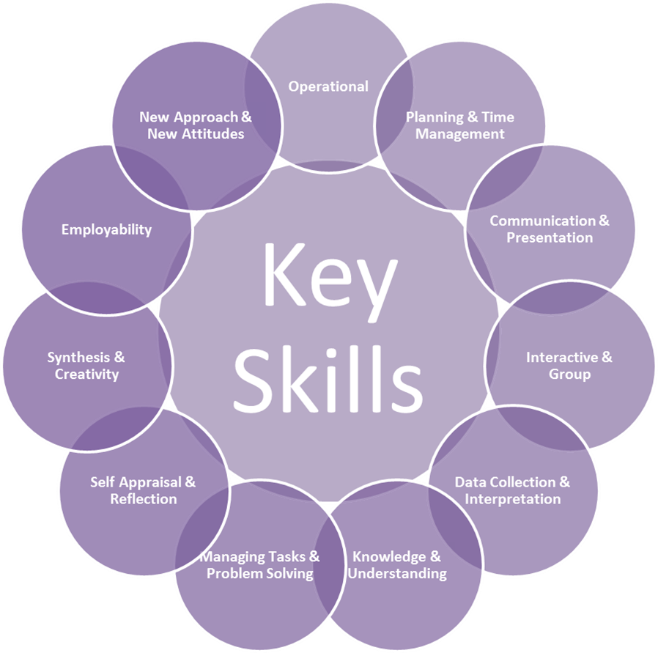

Key Skills Explained

Operational | - Carry out directed routine operations independently, following guidelines.  - Use a range of technical equipment and systems.  - Choose from a specified range of appropriate tools & techniques and use them for the accomplishment of simple tasks.  - Handle material and equipment in a safe way.  - Show an awareness of the ethical issues relating to the subject area.
Planning and Management of Time | - Manage own roles & responsibility by planning and organising own tasks under supervision.  - Manage own time effectively in achieving objectives.  - Organise and plan own work.
Communication and Presentation | - Receive & respond to various forms of information in a clear and concise way for business purposes.  - Present information in a variety of visual forms using appropriate  - Technology.  - Demonstrate accurate written communication skills.  - Communicate effectively as a member of a team.
Interactive and Group Skills | - Treat others’ values beliefs and opinions with respect.  - Relate to and interact effectively with individuals / groups.  - Work effectively as a member of a team.
Data Collection and Interpretation | - Begin to use a variety of information sources.  - Collect and organise data effectively.  - Correctly reference information.  - Apply numerical skills and techniques.
Knowledge and Understanding | - Have knowledge of key theories & principles relating to work practices.  - Have an awareness of the organisation’s policies.
Managing Tasks and Solving Problems | - Analyse simple routine & non-routine problems and identify possible solutions.  - Begin to appreciate the need for diversity in different situations.
Self-Appraisal and Reflection on Practice | - Start to recognise own strengths and weaknesses.  - Transfer skills gained to new and changing situations & contexts.
Synthesis and Creativity | - Begin to organise and evaluate relationship between knowledge and practice.  - Apply a range of techniques to develop ideas to create new or modified products or services.
Employability | - Show an awareness of the industry’s occupational requirements & work ethics.  - Undertake some personal and career development.  - Start to create network opportunities.
New Approach and Attitude to Placement | - Show a positive and enthusiastic attitude to work.  - Demonstrate commitment and motivation to learn.  - Eager to make the most of opportunities available, over and above what is expected.

Appendix B: Placement Assessment Criteria

Stage 1: Interim Review November (Online submission: Last Wednesday of November)

Criteria | Distinction  70 % + | Merit  60 – 69 % | Pass  40 – 59 % | Refer  Below 40 %
Stage 1  10% | PDP specifically identifies what is required from the placement experience along with comprehensive skills audit as well as evidence of action planning.  Excellent learning situation that is fully evaluated and analysed. | PDP clearly identifies what is required from the placement experience. Action planning and audit of skills may require further development.  Good learning situation that is evaluated and analysed. | PDP identifies what is required from the placement experience but with limited evidence of skills audit and action plan.  Learning situation identified but shows limited evaluation and analysis | Poor PDP that does not identify what is required from the placement experience.  Learning situation poorly identified with little or no evaluation and analysis.

Stage 2: Interim Review February (Online submission: Last Wednesday of February)

Criteria | Distinction  70 % + | Merit  60 – 69 % | Pass  40 – 59 % | Refer  Below 40 %
Stage 2  10% | PDP specifically identifies what is required from the placement experience along with comprehensive skills audit as well as evidence of action planning.  Excellent learning situation that is fully evaluated and analysed. | PDP clearly identifies what is required from the placement experience. Action planning and audit of skills may require further development.  Good learning situation that is evaluated and analysed. | PDP identifies what is required from the placement experience but with limited evidence of skills audit and action plan.  Learning situation identified but shows limited evaluation and analysis | Poor PDP that does not identify what is required from the placement experience.  Learning situation poorly identified with little or no evaluation and analysis.

Stage 3: Completed Portfolio of Learning
Criteria | Distinction  70 % + | Merit  60 – 69 % | Pass  40 – 59 % | Refer  Below 40 %
Introduction to Placement  10% | Comprehensive introduction and overview of the event environment. Demonstrating an in depth understanding of current issues and challenges. | Good introduction and overview of the event environment. Demonstrating an understanding of current issues and challenges | Limited introduction and overview of the event environment. Demonstrating a limited understanding of current issues and challenges | Little or no introduction and overview of the event environment.  Demonstrating a lack of understanding of current issues and challenges
Personal Development Planning  *minimum expectation is 3 PDP reviews  20% | Comprehensive evidence that continuous personal development has taken place.  PDP specifically identifies what is required from the placement experience along with comprehensive evidence of action planning.  Excellent structure and layout with evidence that negotiation with the placement supervisor has taken place. | A good range of evidence that continuous personal development has taken place.  PDP clearly identifies what is required from the placement experience. Evidence of action planning may require further development.  Very good structure and layout evidence that negotiation with the placement supervisor has taken place. | Limited evidence that continuous personal development has taken place.  PDP identifies what is required from the placement experience along with limited evidence of action planning.  Reasonable structure but limited evidence that negotiation with the placement supervisor has taken place. | Little or No evidence that continuous personal development has taken place.  Poor PDP that does not identify what is required from the placement experience.  Poor structure and little or no  evidence that negotiation with the placement supervisor has taken place.
Skills Profile  10% | A comprehensive record of the placement period with key skills well identified and fully summarised | A good record on the placement period with key skills identified and summarised | A limited record of the placement period with key skills broadly identified. Little analysis. | Little or no record of the placement period with key skills very poorly identified.

Stage 3: Completed Portfolio of Learning (continued)
Criteria | Distinction  70 % + | Merit  60 – 69 % | Pass  40 – 59 % | Refer  Below 40 %
Reflection on Six Learning Situations  20% | Excellent learning situations that are fully evaluated and analysed.  Extremely well structured with clear evidence that the learning outcomes have been achieved. | Good learning situations that are evaluated and analysed.  Well-structured with evidence that the learning outcomes have been achieved. | Learning situations identified but shows limited evaluation and analysis  Structured but limited evidence that the learning outcomes have been achieved. | Learning situations poorly identified with little or no evaluation and analysis.  Lacks structure and little or no evidence that the learning outcomes have been achieved.
Reflections on Work Based Project  10% | Extremely well structured with clear evidence that the intended outcomes have been achieved. | Well-structured with evidence that the intended outcomes have been achieved | Structured but limited evidence that the intended outcomes have been achieved. | Lacks structure and little or no evidence that the intended outcomes have been achieved.
Supplementary evidence & Presentation  10% | Excellent supporting evidence that is well referenced within the portfolio. Very logical, well-structured and very professionally presented. | Good supporting evidence that is referenced within the portfolio. Professionally presented, logical and structured | Supporting evidence provided but limited. Material is referenced within the portfolio but lacks structure and originality. | Poorly presented with a number of errors. Supplementary evidence provided but not referenced or structured within the portfolio. Just a collection of material.
Criteria | Excellent (16-20 marks) | Very Good (12-15 marks) | Good (8-11 marks) | Poor (5-7 marks) | Unacceptable (0-4 marks)
Research/Collecting Information  20 marks | Student has carried out extensive research. Utilised all sources available offered with the organisation, together with appropriate data from textbooks. | Student has used a combination of information from the organisation and textbooks but did not utilise all sources available. | Student has presented some relevant data used but sketchy and lacking in depth. | Student has identified Very few sources used from both organisation and textbooks. Lacking in detail. | Student did not utilise any sources from the organisation nor textbook data. Very weak
Approach and Attitude in Tackling Project  20 marks | Very positive, conscientious and worked hard throughout the project. Showed commitment and enthusiasm. Did not need and coaxing to complete the project. | Adopted a keen approach and worked hard to complete. Required some encouragement to maintain momentum. | Needed a lot of encouragement to start and complete the project. Showed some commitment once started and worked quite hard to complete | Very little motivation and commitment shown. Needed a lot of encouragement &  support throughout. | Showed neither enthusiasm nor interest to start and complete the project. Had to be continually encouraged to complete.
Analysis and Conclusions  20 marks | Used appropriate analytical methods and an excellent understanding of the topic. Conclusions realistic and appropriate. | Showed some understanding of topic and attempted to analyse the situation. Conclusions drawn but lacking in real depth. | A limited understanding and analysis with quite limited conclusions drawn. | Very little understanding and analysis. Did not really grasp the situation. Very weak conclusions. | No analysis evident or understanding. No really useful conclusions drawn.
Proposals & Recommendations  20 marks | All proposals are realistic and applicable to the operation. All proposals fully costed, if appropriate and justified. | Proposals reasonable and a majority are realistic and applicable to the operation. Most proposals costed, if appropriate and justified. | Proposals may need some further attention as not totally relevant to the operation. May have unrealistic costing and little justification. | Proposals unrealistic and not appropriate to the operation. No costing or justification for proposals. | No clear proposals that could be applied to the operation.
Presenting Information and Final Document  20 marks | All key points clearly summarised, interesting and relevant. A concise well-written and structured document. Logical structure, no errors, high standard presentation. | Most points clear summarised but contains some irrelevant information. A well-written document with a good structure. Presentation acceptable with few errors. | Key points apparent. A reasonable attempt at summarising information but a lot of irrelevant information. Document lacking in structure and focus. Presentation could be improved, too many errors. | Very few key points included. Information not relevant. Presentation unprofessional, lots of errors. Lacks structure and no focus. | Totally lacking in focus with very little relevant information. Unacceptable presentation - no structure and full of errors.

Work Based Project Marking Criteria

A Guide - Expectations during Placement
The University
During placement, you remain a student. Even where the placement provider has full responsibility for you as employee, or at the very least as visitor, the University retains a continuing share in the responsibility for your well-being and on-going learning, though you will ideally develop as an autonomous learner during the work based learning experience.
- The University should make provision for on-going student support in order that you can optimise the learning experience. For longer periods such as a sandwich placement, typically this involves giving you a contact who may be designated support and in the case of longer periods visiting you in the workplace to support autonomous learning and ensure satisfactory progress.
- Where appropriate, the University should develop and implement procedures defining what will take place and how such visits will be arranged and conducted.
- Although visiting procedures are not to be seen primarily as problem-solving exercises, the University should nevertheless ensure that in all cases procedures are in hand to enable any such situations to be dealt with appropriately.
- The University may also make some arrangement for you to return to the University during the placement or extended work-based learning period, for students to share experience with each other and the course team, and to enable briefing such as details of module choices on return to the University.
- The University will undertake such action as necessary to implement the assessment regime defined for the course, including possibilities such as E-portfolios.
You
- Most importantly, you should take every opportunity on placement to optimise the learning experience, relating to academic course content, developing personal and interpersonal skills, and learning professional expectations and behaviour.
- Ideally, and certainly where required by assessment, these should be not only developed but evidenced, for example in some kind of portfolio or journal.
- At the same time, you will probably also be undergoing a cultural change, perhaps experiencing the workplace for the first time or in a new context, discovering that placement providers have their own priorities, and adjusting to this new perspective may take time.
- Nevertheless, students on placement should realise that at all times they remain students as well as employees, and should behave so as to enhance the reputation of their course, school/faculty, and University and maximise the potential for repeat opportunities for future cohorts.
- At the earliest opportunity students should provide the University with any requested information such as details of placement provider, start date, work and residential addresses, telephones, Fax, email contact details, and name of workplace supervisor, to facilitate written and telephone contact with the University and where applicable to enable support arrangements to be set in place.
- Students should ensure that they are fully aware of all University requirements while on placement, including assessment, and comply as necessary.
- Depending on the time period, students are typically entitled to be visited while on placement but should recognise that both University staff and placement providers have many other calls on their time.
- A student who desires to be visited should contact the appropriate person, perhaps Visiting Tutor or Placement Tutor.
- Visits should not be viewed as something that takes place only in response to problem situations, but as an opportunity to discuss and optimise the learning process offered by the placement.
- Students should co-operate with the Visiting Tutor and make appropriate visit arrangements, such as meeting room/refreshments, availability of manager, parking spaces, travel instructions and hotel recommendations.
The Placement provider
- Note that in the UK placement providers have full legal liability for students as employees (or visitors, for very short periods).
- Provide induction and training including Health and Safety issues
- Wherever possible involve students in staff appraisal schemes, since this is a valuable way of learning about employment norms.
- Consider appointing a mentor for each student, distinct from the line manager and possibly from another department, to oversee the training, development and general learning processes of you.
- Ensure that the immediate supervisor or manager has access to the University contact, placement tutor or officer.
- Make appropriate provision for you to be visited at a mutually convenient time and place, providing a meeting room and ensuring availability of your manager.
- Co-operate with the University in all course requirements such as the need for you to undertake assessed work while on placement, possibly involving some procedure for dealing with sensitive/confidential data, and to attend any appropriate event at the University during the placement e.g. a residential or briefing day.
- If anything goes seriously amiss with the work-based-learning experience or you, involve the University immediately and jointly seek ways to resolve the situation, and if necessary involve the University in any disciplinary action.
- Provide, on request, an appropriate statement on your conduct and performance
- Provide you with a debrief session and receive suggestions as to how to make the work based learning experience even more rewarding for all parties.
- Where a student is required for the following year, involve the existing student in the recruitment process (e.g. drawing up the job- and person specifications) and ideally in the handover and induction of the new recruit.
- Recognise that after a period of placement your priority is to complete an academic course, and to encourage that process by means such as keeping in contact throughout your subsequent studies; where appropriate a bursary or opportunity of subsequent employment may be offered.

