2018/2019 Module Handbook
Professional Development in Practice
School of Health and Community Studies
Level 7
Semester 1 and 2
(20 Credits)
CRN 11453

Contents
1 What this Module is About 1
1.1 Introduction from the Module Leader 1
1.2 Module Aims 1
1.3 Module Learning Outcomes 2
1.4 Module Learning Activities 2
1.5 Graduate Attributes Developed and Assessed 3
1.6 Communication 3
2 Weekly Schedule 4
3 Key Resources to Support Learning 7
4 Assessment 8
4.1 Assessment Summary 8
4.2 Assessment Details 9
4.3 Feedback on Your Assessments 13
5 Understanding Your Assessment Responsibilities 14
6 E-portfolio instructions 16
6.1 Introduction 16
6.1.1 Aim 16
6.1.2 Objectives 16
6.2 Introduction to Pebble Pad 17
6.2.1 Creating a free alumni account at the end of the course 17
6.2.2 Personalising your PebblePad Space 18
6.2.3 PebblePocket 18
6.2.4 Navigating PebblePad 19
6.2.5 Creating ‘assets’ 19
6.2.6 Tagging, viewing and organising assets in PebblePad 22
6.3 The e-portfolio workbook 22
6.3.1 Access the workbook, save it to your asset store and submit it to the course workspace so that it can be viewed by your tutors 23
6.3.2 Share your workbook with your PT/mentors 24
6.3.3 Using your workbook 26
6.4 Assessment deadlines and checking your workbook in ATLAS 29
6.5 Support 30
7 Your Feedback on the Module 30

Student Name ____________________________________________________________
Email Address ____________________________________________________________
Course ____________________________________________________________
Group ____________________________________________________________
Module Tutor ____________________________________________________________
Tutor’s Email Address ______________________________________________________
Communication Protocol: module staff will reply to student questions within a reasonable time but this will normally be within office hours only. Students are advised to check this handbook and also to see if there are any online/noticeboard announcements or FAQ answers that deal with their enquiry before contacting staff.

What this Module is About

Introduction from the Module Leader
Welcome to your professional Development module, which will enable you to link, synthesise and embed all you are learning from the other course modules into practice
This module is designed to increase the skills and knowledge required for both the personal and professional development of the specialist practitioner in the current modernisation agenda. The overall impact of the learning will be demonstrated through e-portfolio work, using self-reflection as a methodology for effectiveness.
A significant element of the module is the V100 Community Practitioner prescribing element, which enables practitioners to prescribe safely and competently within the parameters of legislation

Course leaders

Paul Mackreth  p.mackreth@leedsbeckett.ac.uk | District Nursing Course Leader  Tel: 0113 812 4369
Dawn Taylor  d.taylor@leedsbeckett.ac.uk | Health Visiting Course Leader /Senior Lecturer  Tel: 0113 812 4441
Nicola Worrillow  n.worrillow@leedsbeckett.ac.uk | School Nursing Course leader/Senior lecturer  Tel: 0113 812 5750

Module Aims
To enable students to explore professional practice and personal development whilst demonstrating the NMC standards, and examine the scope for innovative care developments in a specialist practice area

Module Learning Outcomes
1. Demonstrate evaluative and critical understanding of the development if the Specialist Practitioner role and the scope for practice within the context of health, social policy and the changing political influences.
2. Critically explore and apply theory to utilise highly effective practice and the ability to develop and reflect as a result of learning.
3. Critically examine and creatively apply marketing and other strategies to promote the role of the Community Specialist Nurse effectively to both clients/patients and to commissioners of health care services within a multi – specialist and multi-agency approach.
4. Appraise and critically evaluate the ethical, legal and accountability issues that occur in the practice setting.
5. Analyse and critically evaluate extensively on complex situations and be able to demonstrate and provide a lead in a variety of scenarios.
6. (For prescribers only) Appraise and critically review the influences that can affect prescribing practice and demonstrate your understanding by managing your practice safely, appropriately and cost effectively.

Module Learning Activities
• Students will be expected to undertake the preparatory reading and exercises prior to each teaching session.
• Students are expected to attend and contribute to theory based sessions that will be delivered within the core programme.
• Students will then have the opportunity to divide in to smaller groups within their own specific specialism, to correlate the content of the session and their learning to each particular area of practice.
• Students will be self-motivated and independent learners in completing an e - portfolio containing 4 learning contracts. Each learning contract will reflect and associate to the NMC standards, demonstrating an explicit theory practice link.
• An identified Practice Teacher will support and assess the practice journey through the development of the portfolio and application of theory to the realities of the work environment.
Work Based Learning:
This module is linked to the PSRB placement requirements of the course
(Minimum 112 .5 days) which includes 15 days alternative placement and 50 days consolidation of practice. Extra face-to-face contact time has been included as required for integrated nurse prescribing.

Graduate Attributes Developed and Assessed
This module will enable you to demonstrate:
• A Systematic understanding of Knowledge and have a critical awareness of current problems and or new insights, much of which is at or informed by the forefront of their professional practice
• A conceptual understanding of evidenced based practice
• The ability to deal with complex issues systematically and creatively to make sound judgements and decisions in unpredictable situations
• Continuing independent development of new skills to a high level

More information on graduate attributes is available here:
https://skillsforlearning.leedsbeckett.ac.uk/local/graduate_attributes/category_homepage.shtml
Relevant information is also available within the Course Specification. The Course Specification is located with your Course Handbook on the Course Handbook web page: http://www.leedsbeckett.ac.uk/studenthub/course-handbooks/

Communication
Your first point of contact with this module will be via the MyBeckett page. On this page you will see the content of all of the taught sessions. You will also see that each session has associated prior reading. We do this so that the classroom based session can be more of a discussion than just a lecturer giving you information.
Anything in addition to this that is urgent or important to this module will be sent to you via the MyBeckett announcement. This will send the whole group an email. If you need to feedback anything about the module, then you can either contact the module leader or your group representative.

You must notify your Course Administrator if you are absent for more than one day (for example for an interview, emergency unforeseen circumstances, or for compassionate leave). If you are going to apply for mitigation you will need to provide written evidence of the reason for your absence (see section 3 of your Course Handbook).

Weekly Schedule
Semester 1 AND 2
Session | Date | Prior Reading | Core Lecture 10.00-13.00 |  | Learning outcomes
1 | 20th September 2018 | Pebble pad https://teachlearn.leedsbeckett.ac.uk/guides/learning-systems-guides/pebblepad/ | Portfolio Development  Induction to E-Portfolio  How to use Pebble pad |  | Increased knowledge and understanding surrounding:  •Pebble pad  •How to develop an E-Portfolio
2 | 27th September 2018 | What is a Learning Contract – Learning contract Guidelines | Portfolio Development  Learning Contracts  Learning Contract Process  Standards of Practice/NMC Domains |  | Increased knowledge and understanding surrounding:  •How to write a Learning Contract  •The standards of practice
Session | Date | Prior Reading | Core Lecture  10.00-12.00 | Specialist Lecture  12.00-13.00 | Learning outcomes
3 | 10th January 2019 | Compassion in Practice, Nursing Midwifery & Care Staff: Our Vision & Strategy (DH & NHS Commissioning Board 2012) | Developing the Culture of Compassionate Care (Six C`s)  Introducing the New Vision  The Key Messages  The Implementation Plan | How do the Six C`s impact on your Specialism? | Increased knowledge and understanding surrounding:  •The Six C`s  •The strategic Plan  •How this impacts on your practice
4 | 17th January 2019 | NMC Code of Conduct  Revalidation Guidance and Resources | Interpretation and Application of Legislation  NMC Requirements  Revalidation requirements  Learning Contracts | Professional Roles, Values & Responsibilities | Increased knowledge and understanding surrounding:  •NMC legislation  •Specific roles and responsibilities
5 | 31st January 2019 | Change4Life Marketing Strategy (DH 2009) | Marketing & Promoting  Using Marketing Principles  Media & Social Marketing | Marketing Strategies to Promote your Specialism | Increased knowledge and understanding surrounding:  •Marketing Principles  •How to market & Promote your specialism
6 | 7th February 2019 | Analyse Your Own Learning Styles – Making Learning Happen (Phil Race 2005) | Teaching & Development  Presentation Skills  Learning Theory | Personal Presentation  How are you viewed by others? | Increased knowledge and understanding surrounding:  •Presenting to individuals & groups  •How people learn  •Personal presentation
7 | 14th February 2019 | Change & transition: What is the difference (McLean 2011) | Transition & Change  Transition versus Change  Resilience in the Workplace | Strengths & Challenges  Personal Action Planning | Increased knowledge and understanding surrounding:  •The difference between Transition & Change  •Resilience and how to write a personal Action Plan
8 | 28th February 2019 | Quality Improvement in NHS Services (NHS Improvements 2013) | Clinical Governance & Quality Improvement  Clinical Supervision/7 Pillars of Clinical Governance  QIPP | How does the QIPP Influence your Practice?  Risk Management in your workplace | Increased knowledge and understanding surrounding:  •Clinical Governance  •The QIPP and how this influences your practice
9 | 7th March 2019 | The NHS structures explained (NHS Choices 2013) | Organisational Structures  The Changing NHS  How the NHS Works  Organisational Culture | Types of Bullying  Bullying in the Workplace  How to Deal with Bullying | Increased knowledge and understanding surrounding:  •NHS Structures & how the NHS works Organisational culture & Bullying
10 | 15th March 2019 | IPL Workshop
11 | 21st March 2019 | Sustainability ensuring continuity in Improvement (Institute for Innovation & Improvement 2013) | Sustainability  Sustainable Health a Priority  Monitoring & Evaluation  Improving Healthcare and System Ability | How Sustainable is your Service Provision? | Increased knowledge and understanding surrounding:  •Sustainability & Improvement  •How to sustain your service provision
12 | 28th March 2019 | Universal Health Debate (Idea – Independent Debate Education Association) | Universal/Targeted Services & Interventions  What is the Difference?  Approaches and Models  Integrated Service Delivery | The Right Person, with the Right Skills, Delivering the Right Service | Increased knowledge and understanding surrounding:  •Universal & targeted Services  •Who should deliver what, when & where?
13 | 2nd May 2019 | Securing Excellence in Commissioning Primary Care (NHS Commissioning Board 2012) | The Commissioning Cycle  Understand, Plan, Do & Review  Commissioning for Success | Evidence Based Practice | Increased knowledge and understanding surrounding:  •The Commissioning Cycle  •Providing Evidence Based Services
14 | 16th May 2019 | Putting Patients First (NHS England Business Plan 2013/14) | Service User Involvement  National Strategy  Benefits & Challenges | Directing Service Provision through User Involvement | Increased knowledge and understanding surrounding:  •National Directives and Strategy  •How to involve users in your service provision
15 | 23rd May 2019 |  | Portfolio, Learning Contracts and  Revalidation | Providing the evidence for your portfolio and Revalidation | Increased knowledge and understanding surrounding:  • E-Portfolio

Contact Hours
42 face-to-face teaching sessions.
A student guide on contact hours is available here: www.qaa.ac.uk/en/Publications/Documents/contact-hours-student.pdf.

Key Resources to Support Learning
Author/ Editor | Debbie Casey, Liz Clark And Sally Hayes
Title | Study Skills for Masters Level Students: A Workbook for Students of Health and Social Care
Edition | 1st edition
Publication Year | 2011
Publisher | Reflect Press Ltd
ISBN | 9781908625090
Harvard reference: | Casey, D., Clark, L. & Hayes, S. (2011) Study Skills for Masters Level Students: A Workbook for Students of Health and Social Care. London, Reflect Press.
Essential Reading Yes
Recommended for Purchase |  | Available online yes

Author/ Editor | Johns C
Title | Becoming a Reflective Practitioner
Edition | 3rd edition
Publication Year | 2009
Publisher | Wiley - Blackwell
ISBN
Harvard reference: | Johns, C. (2009) Becoming a reflective Practitioner. Oxford, Wiley-Blackwell
Essential Reading Yes
Recommended for Purchase |  | N

Author/ Editor | Courtenay, M. and Griffiiths, M.
Title | Independent and Supplementary Prescribing - An Essential Guide.
Edition | 2nd Edition
Publication Year | 2010
Publisher | Cambridge University Press
ISBN
Harvard reference: | Courtenay, M. and Griffiiths, M. (2010) Independent and Supplementary Prescribing - An Essential Guide. 2nd Edition, Cambridge University Press.
Essential Reading Yes
Recommended for Purchase |  | Y

All disabled students requiring additional support or alternative arrangements must declare and provide evidence of their disability to the Disability Advice Team as early as possible: www.leedsbeckett.ac.uk/studenthub/disability-advice.

Assessment

Assessment Summary
Assessment 1
Assessment Method: | Portfolio | Re-assessment Method: | Portfolio
Coursework and Practical  •Summative Assessment at midpoint  •IPL Assessment  •e-Portfolio (covering four learning contracts to demonstrate NMC proficiencies and one learning contract to demonstrate prescribing standards)  •Summative Assessment for final practice | Pass/Fail | Coursework and Practical  •Summative Assessment at midpoint  •IPL Assessment  •e-Portfolio (covering four learning contracts to demonstrate NMC proficiencies and one learning contract to demonstrate prescribing standards)  •Summative Assessment for final practice | Pass/Fail
Assessment Date  Time: | 28th June 2019  5pm | Re-assessment Date  Time: | 23rd August 2019  5pm
Feedback Method: | PebblePad  On-line | Feedback Method: | PebblePad  On-line
Feedback Date: | 26th July 2019  5pm | Feedback Date: | 20th August 2019  5pm
Learning Outcomes Assessed: | 1, 2, 3, 4, 5 and 6.

Assessment 2
Assessment Method: | Prescribing Exam and  portfolio | Re-assessment Method: | Prescribing Exam  And  portfolio
 | Pass/Fail |  | Pass/Fail
Assessment Date  Time: | 8th March 2019 | Re-assessment Date  Time: | TBC
Feedback Method: | On-line | Feedback Method: | On-line
Feedback Date: | 5th April 2019 | Feedback Date: | TBC
Learning Outcomes Assessed: | 4 and 6

Assessment Details
Coursework/ Portfolio
Student Instructions for Submission of Coursework
This module requires you to develop and submit your course work as an on-going process on to PebblePad.
What is PebblePad?
PebblePad is the University's e-portfolio tool. It is made up of two main elements:
Pebble+ is a private personal learning space that allows you to organise and keep track of your learning as well as to present evidence of your development and achievements (e.g. for assessment on your course or to support a job application)
ATLAS is the institutional space which your tutors will set up to allow you to submit elements of your e-portfolio for feedback and assessment.
How can I access pebblepad?
It can be accessed using any computer or mobile device with internet access and a web browser (if you do not have Flash you will be taken to an HTML-only version). You can access PebblePad by a direct link in this module.
Professional development in Practice
You will see the following link on the ePortfolio Documents page, which will take you direct to your account:
How does Pebble+ work?
It allows you to create ‘assets’ either by completing pre-built templates (e.g. for reflection, planning or recording achievement) or uploading digital files such as word documents, scanned forms and certificates, or audio and video files (video files are automatically converted and compressed for the web).
These assets can then be organised using tags. Multiple tags can be attached to an asset and you can then search for the asset using any of these tags.
Assets can be collated together for presentation and sharing with others both within and external to Leeds Met. Permissions can be set to allow for others to view, comment on, edit, and copy or share ownership of an asset, allowing you to choose what would like others to be able to do with an asset from simply viewing it to working on it together. If the pre-built templates offered within Pebble+ do not quite fit your needs, it is possible for you to create your own. Your tutor may also create course specific templates and share these with you to allow you to work on them (e.g. a reflective form focused on particular aspects of the course).
Please note: Tutors will follow up any suspected unfair practice found after the submission date as per University policy. Late penalties will apply as per University Regulations.
This module requires you to submit your work online.
Prescribing Exam and 1 Prescribing Learning Contract.
The Objectives are:
• Assess and consult with patient/clients, clients, parents and carers

• Undertake a thorough history, including medication history and current medication (including over-the-counter, alternative and complementary health therapies) to inform diagnosis

• Understand and apply the relevant legislation to the practice of nurse/midwife prescribing

• Critically appraise, use sources of information/advice and decision support systems in prescribing practice

• Understand the influences that can affect prescribing practice, and demonstrate your understanding by managing your prescribing practice in an ethical way

• Understand and apply knowledge of drug actions in prescribing practice

• Demonstrate an understanding of the roles and relationships of others involved in prescribing, supplying and administering medicines

• Prescribe safely, appropriately and cost effectively

• Practise within a framework of professional accountability and responsibility

Please note: Tutors will follow up any suspected unfair practice found after the submission date as per University policy. Late penalties will apply as per University Regulations.

Academic Criteria and weighting for Portfolio
Criteria and Weighting | 100-70 | 69-60 | 59-50 | 49-40 | 39-30 | 29-0
Knowledge  The theoretical underpinning of a subject, derived from collective academic enquiry and experts in the field, including knowledge that is contestable | Demonstrates originality and a deep understanding showing a mastery of the knowledge base from a comprehensive range of theoretical and practice approaches. | Demonstrates an understanding of a wide and relevant range of theoretical and practical approaches by utilising them effectively. | Demonstrates a deep understanding and mastery of the knowledge base from a comprehensive range of theoretical and practice approaches. | Demonstrates awareness of a limited range of theory and practice knowledge. | Demonstrates a very limited or inappropriate range of theory and practice knowledge. | Fails to demonstrate awareness or understanding of the knowledge base.
Relevance  Content is clearly related / connected/ significant | Tightly focused on the title throughout. Consistently addresses all reasonable implications, nuances and assumptions of the title with breadth and depth. | Communicates effectively by being directly relevant to the title and learning outcomes. Addresses most implications and assumptions of the title. | Relevant to the title and learning outcomes.  Some of the implications of the title addressed. | Mainly relevant to the title and learning outcomes but occasionally wanders from the point. Begins to address some of the implications and assumptions of the title. | Little relevant material.  Brief for assignment not followed. Only intermittent relevance to the title and learning outcomes, Topic is only superficially addressed. | Very little relevant material. Brief not followed. Irrelevant or patchy connection to title with little or no consideration of the topic.
Application  Utilisation of outcomes/ learning to a concrete or real life situation | Demonstrates excellent application of conceptual frameworks, principles and theories, showing critical appreciation, originality and vision in the generation of new insights to apply to/ inform practice. | Demonstrates good use of conceptual frameworks, principles and theories, showing good ability in the generation of new insights to apply to/ inform practice. | Demonstrates appropriate use of relevant conceptual frameworks, principles and theories. Ability generate new insights to apply to/ inform practice. | Demonstrates awareness of conceptual frameworks, principles and theories. Some ability to apply new insights to inform practice. | Demonstrates awareness of conceptual frameworks, principles and theories. Some ability to apply new insights to inform practice. | Lacks application of conceptual frameworks, principles and theories to practice. Displays unsafe practice in written work.
Analysis and Evaluation  Demonstration of a systematic examination and reasoned judgement on a range of issues/elements/ materials. | Exceptional deep, detailed, and critical analysis and evaluation of the material resulting in illuminating, and elegant conclusions that extend the sum of knowledge in the area. Creatively demonstrates new concepts, ideas or theories. | Clear evidence of critical analysis and synthesis.  Good and appropriate analysis of the material resulting in clear conclusions which serve to add to the sum of knowledge in the area. | Evidence of critical analysis. Adequate and appropriate analysis of the material results in generally clear  conclusions, which serve to substantiate , but offers little extension of the sum of knowledge in the area. | Generally adequate and appropriate analysis of the material that results in some  illuminating conclusions but does not expand upon  the sum of knowledge in the area. | Analysis of the material is superficial and/or fails to result in clear and/or illuminating conclusions.  The sum of knowledge in the area is not expanded, challenged or extended. | Analysis of the material is incomplete and superficial. There are little or no conclusions. The sum of knowledge in the area is not expanded, challenged or extended.
Synthesis  A combination of important points from several sources; infers relationships between sources | Exceptional work, demonstrating originality, independent thought, synthesis of ideas from credible sources and the generation of innovative views. | Elements of originality.  Good work showing independent thought, synthesis of ideas and critical engagement with alternative views. | Limited evidence of originality.  Demonstration of evidence of independent thought with some synthesis of ideas and critical engagement with alternative views. | Contains some independent thinking. Beginning to synthesise ideas and engage with alternative views. | No synthesis of ideas Expresses a personal position and is uncritical in its conformity to one or more standard views of the topic. | Unable to combine evidence or others’ views to create a new perspective of the topic.
Structured Argument  Systematic presentation of academic debate/s | Highly accomplished, original arguments are presented making creative use of a mode of argument and theoretical model/s to provide an intelligent structure. | Arguments generally clear and coherent, and logically constructed.  Uses an appropriate mode of argument and/or theoretical model/s. There are elements of originality in the arguments presented. | Arguments lack logic and coherence at times. Uses an appropriate mode of argument and/or theoretical model/s. | Arguments lack logic and coherence at times. Generally uses an appropriate mode of argument and /or theoretical model/s. | Very limited coherence and logic. Fails to make adequate use of an appropriate mode of argument and/or theoretical model/s. | The work is confusing. Arguments lack clarity. There is no evidence of attempts to use appropriate model/ mode of arguments.
Presentation and referencing | Presentation is polished with a creative approach to the topic.  A fluent academic writing style with accurate spelling and syntax.  Thoughts and ideas expressed clearly. Appropriate and complete references from a diverse range of sources. | Presentation logically structured.  Very well written with correct spelling and syntax.  Style is lucid with appropriate format.  Appropriate, complete and consistent references, which may contain minor inaccuracies. | Presentation satisfactory and meaning apparent but language not always fluent. Spelling and syntax satisfactory. Some in-consistencies in referencing but generally acceptable. | Presentation is logical but has minor lapses from standard syntax and spelling.  Generally lucid. Acceptable format.  Some in-consistencies in referencing but generally acceptable. | Presentation disorganised.  Rather poorly written with significant deficiencies in expression, and format.  Significant errors in referencing which is incomplete. | Presentation is very disorganised.  Very poorly written with significant deficiencies in expression and format  References incomplete and unacceptable.

Feedback on Your Assessments
You have been asked to provide evidence of achievement of the NMC standards and proficiencies (2001 or 2004 and 2008) through your e-portfolio workbook in Pebble Pad. This has now been assessed. Below you will find comments regarding your success in this process:
Part A | Brief Comments
Provide evidence of the developmental process and self-directed learning undertaken to achieve identified NMC Standards and Proficiencies.
Regular engagement with the e portfolio?
Demonstrate your ability to critically reflect on learning and experience in practice, identify strategies for personal and professional development and evaluate outcomes.
Demonstrate your ability to make explicit links between theory and practice demonstrating engagement with relevant literature.
Part B |  | Comments if needed
Assessment of attitudes in practice | Yes
Practice profile of student placement | Yes
Reflections on two teaching experiences, one of which should be a poster presentation | Yes
Reflections on alternative experience | Yes
Reflection on gaining and using feedback from users and carers | Yes
All tasks included on the ‘declarations’ page of your e-portfolio workbook | Yes
Does the work maintain confidentiality? | Yes

Feedback forms a large part of your learning experience and is vital to your personal and professional development. We have worked with our Student Union to produce the following guidance, which explains the benefits of feedback, the forms it may take and how to use it.
https://www.leedsbeckettsu.co.uk/studentvoice/coursereps/toolbox/feedbackpack

Understanding Your Assessment Responsibilities
Extenuating Circumstances and Mitigation
If you are experiencing problems which are adversely affecting your ability to study (called 'extenuating circumstances'), then you can apply for mitigation. You can find full details of how to apply for mitigation at: www.leedsbeckett.ac.uk/studenthub/mitigation.htm.
The University operates a fit to sit/fit to submit approach to extenuating circumstances which means students who take their assessment are declaring themselves fit to do so. More information is available at the above link and here: http://www.leedsbeckett.ac.uk/studenthub/examinations/
Late Submission
Without any form of extenuating circumstances, standard penalties apply for late submission of assessed work. Full details of the penalties for late submission of course work are available at www.leedsbeckett.ac.uk/public-information/academic-regulations.
Academic Misconduct
Academic misconduct occurs when you yourself have not done the work that you submit. It may include cheating, plagiarism, self-plagiarism, collusion and other forms of unfair practice. What is and what is not permitted is clearly explained in Factsheet for Students which is available to view at: www.leedsbeckett.ac.uk/studenthub/academic-integrity.
There are a range of resources available to help you understand what is and what is not permitted and how to use other people’s ideas in your assessed work. These include the Skills for Learning website which can be found at http://skillsforlearning.leedsbeckett.ac.uk
The serious consequences of plagiarism and other types of unfair practice are detailed in the Academic Regulations at www.leedsbeckett.ac.uk/public-information/academic-regulations.
Your e-portfolio workbook should:

•Provide evidence of the developmental process and self-directed learning undertaken to achieve identified NMC Standards and Proficiencies. This will require regular engagement with the e portfolio.

•Demonstrate your ability to critically reflect on learning and experience in practice, identify strategies for personal and professional development and evaluate outcomes.

•Demonstrate your ability to make explicit links between theory and practice demonstrating engagement with relevant literature.
All sections of the e-portfolios workbook should be completed and evidence must maintain confidentiality throughout.

The completed e-portfolio will be examined by internal and external examiners to ensure that relevant activities have been undertaken to meet the criteria. Constructive feedback on the process of portfolio development will be given through comments in your e-portfolio and tutorial support throughout the course.

Please also note that the e-portfolio will be assessed in June but the Final Practice meeting record and the Self-Declaration of Good Health & Good Character must be included on completion of practice.

Portfolio Assessment Checklist
Initial Formative Assessment (22/10/2018)
1 | Students must score themselves against each Standard of Proficiency in partnership with Practice Teacher/Mentor. Evidence must be provided to support the initial score.
2 | Practice Profile must be completed.
3 | Students must complete the ‘Attitudes in Practice’ (adapted from Hull self-assessment).
Progression Point Summative Assessment
(Full Time 17/01/2019) (Part Time 30/08/2019)
1 | Students must rescore themselves against each Standard of Proficiency in partnership with their practice teacher. Evidence of progression must be provided.
2 | Students must have written four Learning Contracts (Academically written at level 7) with clear aims and objectives.
3 | The ‘Attitudes in Practice’ (adapted from Hull self-assessment) must be completed for a second time.
4 | A Signed progression Point Form (By Practice Teacher) must be uploaded to Pebblepad.
Portfolio Submission (Full Time 28/06/2019)
(Part Time 19/06/2020)
1 | Students must refer to the marking feedback sheet for CSP/SCPHN Portfolio PGDIP
Final Practice Report
(Full Time 30/08/2019) (Part Time 28/08/2020)
1 | Final Practice report Form must signed by Practice Teacher following completion of consolidation period and uploaded on to Pebblepad.

E-portfolio instructions

Introduction

This document is for the use of the following people:

• The Student
• The Course Team
• The External Examiner
• The Students employer or sponsor

The e-portfolio is the responsibility of the student and these responsibilities include:

• Safekeeping of password data and e-portfolio contents
• Ensuring its availability for sharing with the practice teacher for review as required
• Maintaining confidentiality at all times (see self-declaration)

Aim
The aim of the e-portfolio is to enable you to identify learning needs, develop strategies, and provide evidence of learning outcomes. This is to meet the Nursing and Midwifery Council (NMC) standards of proficiency and your course learning outcomes.

Objectives
This e-portfolio serves two objectives:

1) Learning

2) Assessment

As a learning tool it will enable you to identify your learning needs, monitor your progress and evaluate learning outcomes. During this developmental process the portfolio enables you to use practice experience as a source of learning and encourages reflective writing. The NMC have emphasised that self-directed learning and critical reflection are integral components of the education process. These skills underpin the development of the portfolio and promote a lifelong learning approach. You are strongly recommended to maintain a learning journal to facilitate this process and inform your development towards the standards of proficiency.

As an assessment tool it will provide a record of your progression throughout the course and, finally, with evidence of experience and learning, demonstrating the extent to which you have been able to synthesise theory and practice in achieving standards of proficiency utilising your learning from all modules and practice experiences. The organisation of the practice element has been designed to encourage autonomy, and the use of the e-portfolio for assessment allows for the diversity of clinical practice areas and individual experience. Your ability to synthesise theory and practice will be evidenced in the completion of learning contracts included in the e-portfolio and in your on-going process of self-assessment and evidencing.

Your e-portfolio assessment takes the form of a workbook containing all the elements needed for you to develop proficiencies and be signed off in practice.

All activities are undertaken with the guidance of a practice teacher/mentor who will assess your practice at key points across the course. You will share this workbook with them following the instructions in this guidebook. This will provide them with authenticated access to your workbook so that they can assess and provide feedback.

As it is an assessed piece of work, the contents of the e-portfolio should achieve the minimum standards laid out in the level 7 marking criteria. There will be scope for originality in how you carry out the tasks based on your learning needs and personal styles. This will be discussed in detail during the Professional Development in Practice Module on the course.

Introduction to Pebble Pad
To create your e-portfolio, you will use the University’s e-portfolio tool Pebble Pad. Pebble Pad is the University's e-portfolio tool. It is typical of the e-portfolio tools that are becoming increasingly common in education and professional development. As well as being used by many Universities across the UK, it is also used by a number of organisations such as Dementia UK who use it for their Admiral Nurses (dementia specialist nurses) scheme, and employers such as the Calderdale and Huddersfield NHS Trust. It is increasingly being used by practicing nurses for revalidation. It is made up of two main elements:

Pebble Pad is a private personal learning space that allows you to organise and keep track of your learning as well as to present evidence of your development and achievements. This is your space and it is not possible for anyone within or beyond the course to access the items that you store in your Pebble Pad account. All your items are 100% private unless you share them. Pebble Pad allows you to create ‘assets’ either by completing pre-built templates (e.g. for reflection, planning or recording achievement) or uploading digital files such as pdfs, scanned forms and certificates, or audio and video files. These assets can then be organised using tags. Multiple tags can be attached to an asset and you can then search for the asset using any of these tags. Detailed instructions on creating and organising assets is provided within this guidebook along with instructions on how to prepare your e-portfolio assignments.

ATLAS is the institutional space which we have set up to allow you to submit elements of your e-portfolio for feedback and assessment at each year of the course.

You can access PebblePad from http://www.pebblepad.co.uk/leedsbeckett/. Log in using your standard University username (c-number) and password. These are the same details that you use to access MyBeckett and the University PCs.

Creating a free alumni account at the end of the course
You can create a free alumni account for life at the end of the course. This will allow you to continue using PebblePad for ongoing CPD and revalidation purpses. You should create your alumni account before you lose access to the University’s systems (shortly after you graduate). You must make sure that all assessment is completed and all marks ratified before you create your alumni account.. If you do not set up your alumni account you will lose access to your e-portfolio and its contents. Instructions on creating your alumni account are available on the Learning systems webpages at at http://libanswers.leedsbeckett.ac.uk/faq/178693.

Personalising your PebblePad Space
You can add a photograph to your profile in PebblePad from the home page. Please do this; it makes it easier for us to see your work and it also helps to personalise the e-portfolio (the photograph doesn’t have to be of you of course). You can add your photo from the ‘profile block’ by clicking on the image space to display your uploaded images to select from on the right. If you do not yet have a suitable image you can click the ‘Upload’ button to source one from your computer.
It is also possible to change the style of any asset that you create in PebblePad by clicking on the ‘properies’ button on the top-right of the page. You can change the banner image by clicking on the banner and then selecting ‘Replace image’. Again, this will display your uploaded images to select from. NB please make sure that images and styles are professional and that all contents can be seen clearly - ensure that you use dark text on a light background or vice versa.

PebblePocket
PebblePocket is an app available for Android from the Google Play store and Apple (iOS) from the App store. By installing PebblePocket, you are able to create five of the most important types of asset for your e-portfolio using your mobile device even if you do not have an internet connection.

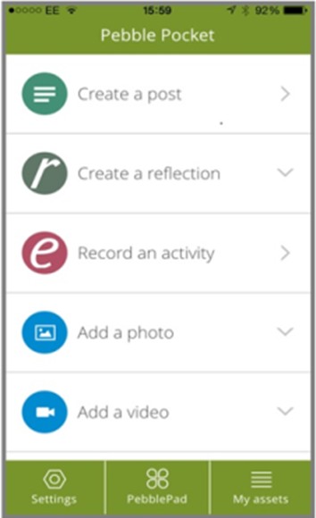

You can then send the assets you create direct to your PebblePad account when you are next connected. Providing you adhere to privacy and confidentiality rules, you will be able to use PebblePocket to record your reflections at any time whether you have a connection or not, for example on the way home from a placement session. You will also be able to take photographs and capture video using your device and send the resulting files through to your PebblePad account for use as evidence or to illustrate assets that you create.
PebblePocket probably provides the most straightforward way of getting video into your PebblePad account. Once you transfer the video to your asset store it is automatically compressed and added to a streaming server to optimise it for web display.

Navigating PebblePad

The PebblePad home screen has a number of panels providing quick access to the different types of assets that you can create along with links to assets that you have recently been working on and to the help files and videos. You can return to this anytime by clicking on the ‘PebblePad’ icon top-left.

In the top-left corner, you will find the menu button.



This provides access all the different option available in PebblePad and is the
easiest way to get to your asset store and to begin creating assets.

At the top-right, there are also three buttons which are available from anywhere within PebblePad. These are the search button which allows you to carry out a quick search through your assets, the history button which provides links to assets that you have been working on recently, and the log out button.

Creating ‘assets’
There are two ways of creating assets in PebblePad, adding files and completing PebblePad templates or pages.

Adding files
You can add a file to your asset store by selecting ‘upload a file’ to reveal the upload tool in a small pop-up window. This provides you with two ways to select files for upload. You can browse for files in your file manager (e.g. Windows/File Explorer, or Finder in Mac) and simply drag and drop them on the 'Drag a file here' area. Alternatively, clicking 'Or choose a file...' will open up a file manager window for you to browse and select the files you would like to upload.
You then add a title (the filename will automatically be added but you can overwrite this with an alternative title if you prefer) and description. You should also add tags to your file asset so that you can find it quickly and easily later. Click on ‘confirm upload’ to complete the process.
Once the file attachment has finished processing, you should check that your file is working and re-upload if necessary. If your file has not uploaded correctly, you will not be able to see it when you try to open it from your own PebblePad assets or from the workspace in ATLAS. If this is the case, you will need to re-upload the file and contact the Learning Systems team at learningsystems@leedsbeckett.ac.uk if you continue to experience problems with the upload.

File formats
When creating file assets it is important to be aware that these work in the same way as attaching a file to an email. The file asset is just a page with the title, description and tags and it contains a link to the attached file. In order to view your file, your tutor/mentor will need to have software that can open it. Therefore you are strongly recommended to avoid unusual file types which can cause access problems. For example, if you would like to attach a document or presentation, you should save these in Microsoft Office formats (“.docx” and “.pptx”). If you use software such as Open Office or Microsoft pages, you should ensure that you save these in doc format rather than formats such as “.odt” or “.pages” files. “.pdf” files also provide you with a useful option if your software allows you to save in this format. If you need to upload files in a format that you believe your tutor/mentor may not be able to open, please ensure that you contact them to discuss this before any deadlines.
To upload paper records into your PebblePad account, you will need to scan these and then upload the resulting digital file. In the University, you can use the iPrint machines in the library and have the resulting file emailed to your University email account as a pdf. Information about this is available at http://libguides.leedsbeckett.ac.uk/it_support/printing_scanning_and_copying/scanning
If you need to edit a file, you will need to use a suitable application to do this outside PebblePad and then to save your file and upload it into PebblePad overwriting the existing file. This is one good reason why it is preferable to create your assets as posts or using PebblePad templates if you are simply creating text-based records, reflections or plans.
Once your file asset is saved, you can access it again from your asset store (view – assets).

Completing PebblePad templates
PebblePad comes with a range of pre-built templates that you can use to create assets. These templates aim to guide you through the process of learning and development by, for example, providing you with reflective templates that will take you through a reflective model, prompting you with questions to guide and focus the process of reflection.
To fill in a template, choose it from the ‘Start working on… Templates and Workbooks’ menu item. Under ‘PebblePad templates’, you will see a list of templates and clicking on ‘See more’ will show you the full set. Click on a template to open it. For all templates, the first thing you need to do is add a title in the ‘save record as…’ field.
You can then fill in the record by adding text in the fields, following the prompts as needed.

Creating pages
Pages are very useful for bringing together different assets allowing you to add video and images onto the page, include links and provide an overall narrative on a single page. Select ‘Get creative’ from the main menu and click on ‘Create a page’ to begin. Once you make any changes, the ‘save’ button to the top-left will activate. Click on this to save your page by adding a title and selecting ‘confirm’. Click on the ‘Make you page stand out with a banner’ text to add your title on the page, then click on the ‘Add content’ button to add different elements to your page.

Clicking on the ‘Properties’ button to the right will allow you to change the display of your content on the page allowing you to adjust your page as needed.

Formatting and linking
You can format your text and add links to other PebblePad assets or to websites by selecting text and using the formatting and linking tools at the top of the page.

To add a link, select the text you would like to turn into a link and click on the link button. 
You will then be prompted to select the type of link to you would like to add (see image below).

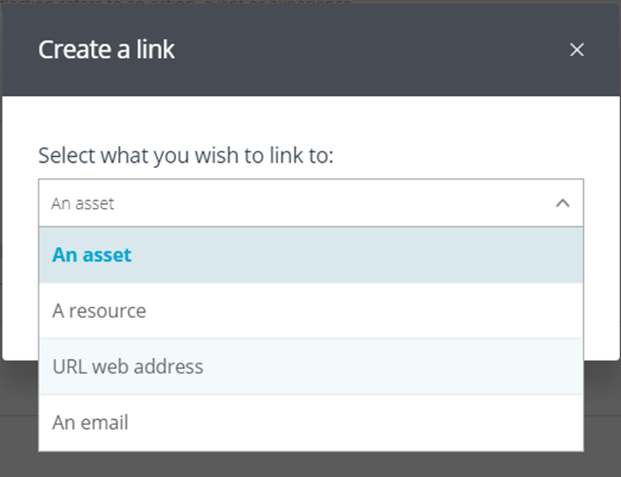

To add an asset link, click on ‘An asset’ and then click on the ‘Select asset’ button. This will bring up a list of your assets allowing you to select the asset you would like to link to.
To add a URL web address, open the web page you would like to link to in your browser, then copy the URL from the address bar. Return to PebblePad and select the text you would like to turn into a link, then click on ‘URL web address’. Paste the URL into the ‘Link to a URL’ box, then click on the ‘Confirm link’ button.
When linking to assets and websites, you should always preview your work to check that the links are working correctly and to edit them if needed. For links within work that has been submitted to ATLAS for assessment you should always check this within ATLAS.
Once you have saved a template you will be able to find it again in your asset store using either the title or by searching for tags.

Advantages of using the PebblePad templates and posts over file uploads
When creating an asset such as a plan or a reflection it usually makes sense to do this as a PebblePad template or page rather than uploading a word document. This makes it easier for you to edit and reuse the asset again later and also makes it much easier for others to view your work. You can do this by selecting the asset in your asset store, clicking on ‘Edit’ and continuing to work on the asset. To edit a word document, it is necessary to edit it within word, then save the file and overwrite it in PebblePad. Using PebblePad templates also makes it easier to link assets together allowing you to add links to other assets within templates and pages. You can also copy and paste content from a word processor into a template or page.

Tagging, viewing and organising assets in PebblePad
Tagging is the method used in PebblePad to organise assets and make sure that you can search for them later. You can add tags to your assets and then, by searching for any one of those tags in your asset store, you can filter your asset store so that it only displays the assets with the tag you are searching for. In this way, tags work just like folders. When you open a folder you see all the items that you have placed inside it. When you filter by tag you see only the items that you have added that tag to. The advantage of tags over folders is that you can add multiple tags to an item and then find it using any one of those tags. You can do the same thing in folders but only if you copy your item and paste it into multiple folders.
Effective tagging is essential for getting the most out of PebblePad. You will be able to find assets and use them later to, for example, complete assessments, support job applications and CPD processes, and evidence your achievements and progress. For example, when you are choosing items for any course assessments, you will find it easy to do this if you have added tags to your assets to indicate which part of the assessment they are relevant to. If you also add tags that are meaningful to you in some way (e.g. by theme, skill or setting) you are also more likely to be able to locate, review and edit assets for other purposes later.

Adding tags
When uploading files, the tag box appears allowing you to add tags there and then. For templates and pages, you can get to the tag box by clicking on the ‘I want to…’ button and choosing ‘Tag’. You can also edit tags or add further ones from the asset store or from an open asset by clicking on the info button (i). To add a tag, type into the tag box and then hit the ‘enter’ key or click on ‘add’. You only need to add a tag once. After this point, you will be offered existing tags once you begin typing and can select them from the list.

Viewing and organising assets in PebblePad
Everything you create or upload in PebblePad is kept in your Asset Store. The Asset Store lists all your assets in a scrollable list with the last modification date shown beneath the title. Next to each asset are the following icons from left to right: Comments, feedback, ‘shared with others’, ‘shared to web’, and ‘shared for assessment’. These will be highlighted to indicate when you have feedback or when the asset has been shared. The info button (i) to the right allows you to see the tags and also provides full information about the asset.
The search box at the top of the asset store allows you to search by keyword and will display assets if they have been tagged with this keyword or if it contained in the title, making it particularly useful for quick searches through your assets. You can also carry out an advanced search allowing you to search by tag by clicking on the ‘Advanced search’ button.
Remember also that that you can access your assets from anywhere in PebblePad by clicking on the ‘asset store’ button top-right. This also provides a keyword search function.
To do something with an asset in your asset store (e.g. copy, delete or share), select it by clicking on the icon to the left of the asset title (the icon is replaced with a tick once the asset is selected). Then click on the ‘I want to’ button to view the options.

The e-portfolio workbook
For the e-portfolio assessment, we have created a workbook containing all the elements needed for you to develop and submit your E-portfolio assessment (see image below). You will need to submit and share this with your course tutors and PT/mentor so that they can assess your workbook and provide feedback.
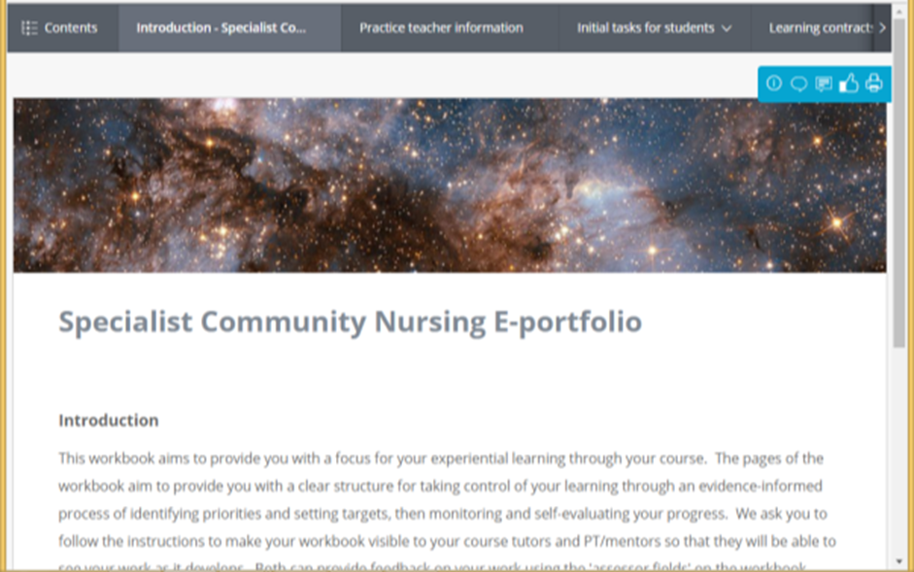

Access the workbook, save it to your asset store and submit it to the course workspace so that it can be viewed by your tutors

To access the workbook, select the ‘Start working on… Templates and Workbooks’ menu item. Under ‘Workbooks’, you should see ‘Specialist Community Nursing E-portfolio – 2017-18’ or ‘Community Specialist Practitioner E-portfolio - DN 2017-18’. Choose the correct option for your course and click on the link. NB You can only submit one workbook so make sure that you have selected the correct one for your course. Please check before doing this if you are unsure.

You will see the following message telling you that the workbook has been set to automatically submit to the course workspace:

This resource has been set to auto-share its response to a workspace when saved. All changes made will be reflected in the workspace.

There is a link to allow you to view the terms and conditions. To submit your workbook, you will need to select the ‘To share for assessment I agree to the terms of usage’ checkbox and then click on the ‘Continue’ button. This will open the workbook

Click on the information button to the top-right and then click on ‘Edit’ alongside the workbook title. Change the title of your workbook to include your full name at the beginning and then click on ‘Save’ (see image below)

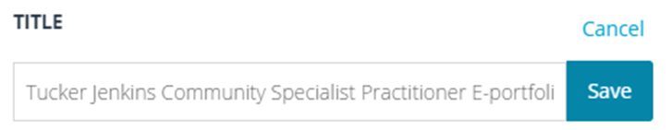
This will submit your workbook to the course workspace which will make it visible to your course tutors. You will receive an email confirming your submission and, if the workbook has submitted correctly, you should see the ‘shared for assessment’ highlighted next to it in your asset list (see image below)
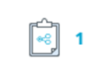

Share your workbook with your PT/mentors
Open your asset store and select your workbook by clicking on the icon to the left (see image below).

The icon will be replaced by a tick and the ‘I want to...’ button will be visible at the bottom of the screen. Click on this and select ‘Share’. This will open the ‘share’ panel (see image below).

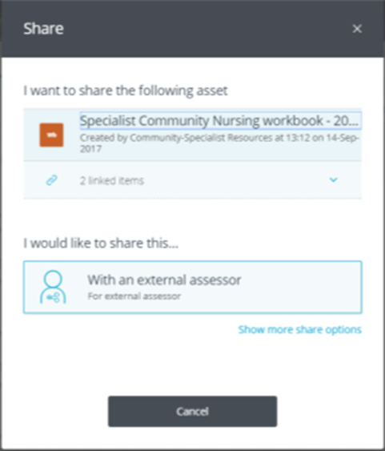

Click on ‘With and external assessor’ to reveal the ‘who am I sharing this with’ information.

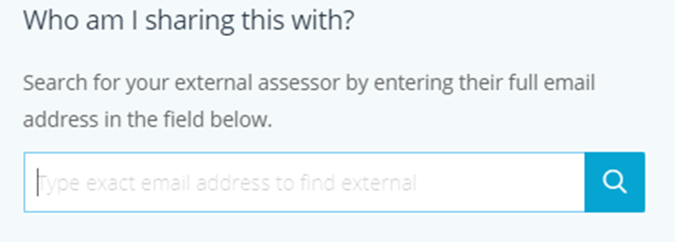

Enter your PT’s email address into the box. This must be in the exact format – e.g. correct capitalisation, spacing etc). In particular, take care to make sure that there is no capital letter at the beginning, so is your mentor’s email address is annie.mentor@nhs.net, searching for Annie.mentor@nhs.net would not find them. Click on the search button (blue box containing a magnifying glass icon)
Your mentor should be displayed below the box. Click on ‘Share asset’ at the bottom of the panel to confirm the share.
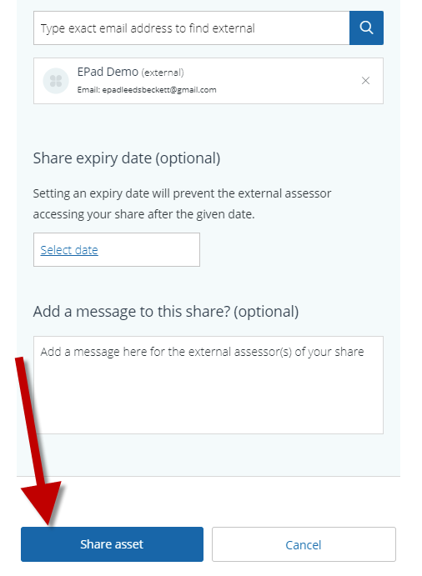
This will trigger an automated email to your PT from PebblePad (noreply@pebblepad.co.uk) with the subject line ‘Asset share (With external assessor permissions)’. Please follow up with your PT to check they have received the email and been able to access your workbook. In case of problems, please contact the Placement Unit at nursingplacements@leedsbeckett.ac.uk.

If, when you enter your PT’s email address and press the search button, you receive the following message:

No external user was found with that email address

Contact the Placement Unit at nursingplacements@leedsbeckett.ac.uk.

Using your workbook

The workbook consists of a number of pages grouped under the following menu items:

Introduction
Practice teacher information
Initial tasks for students
Learning contracts
NMC Standards pages
Reflections
Meeting records and declarations

You can navigate these pages using the links at the top or you can click on the ‘contents’ button top-left to open the menu (see image below).

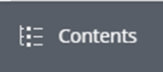

When you save your workbook, any changes you make will be visible to tutors and PTs. On each page, you will also see ‘assessor fields’ which are completed by your PT / tutors. When they add comments to these fields and save the contents you will be able to see these within these fields.

Brief guide to the workbook sections:

Initial tasks for students

You should begin my completing the ‘student information page’ by completing the boxes. You should also create a ‘page’ introducing yourself and attach this using the evidence link (rosette) under ‘About me’.

To create your page, select ‘Get creative’ from the main menu and click on ‘Create a page’ to begin. Once you make any changes, the ‘save’ button to the top-left will activate. Click on this to save your page by adding a title and selecting ‘confirm’. Please remember to save your work regularly.
Click on the ‘Make your page stand out with a banner’ text to add your title on the page. You can also change the banner image by clicking on the ‘Replace image’ button.

Then click on the ‘Add content’ button to see the types of content blocks that you can add onto your page.

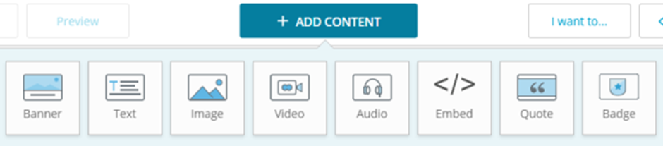

Add a text block to include your ‘about me’ text and click on ‘Image’ for an image block. You could even add a video to introduce something about you if appropriate.

Clicking on the ‘Properties’ button to the right will allow you to change the display of your content on the page allowing you to adjust your page as needed.

Once you have created your page, save it to your asset store. Then come back to the Student information page of your workbook, click on the evidence link

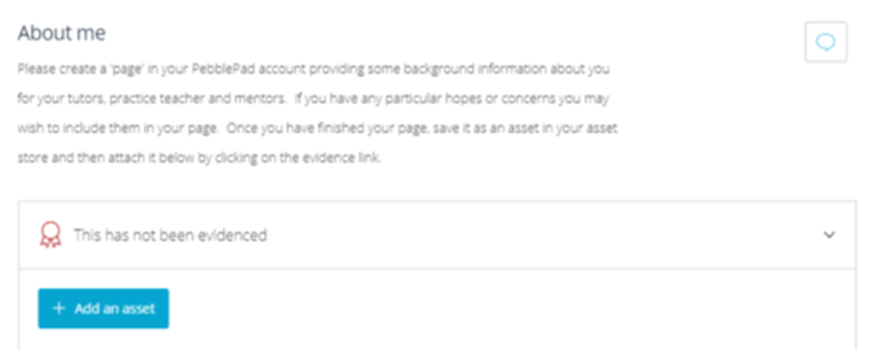

and select ‘Add an asset’. Your asset store will appear to the right. Select your ‘about me’ page and then click on the ‘Done’ button to attach your page. The rosette icon will change colour and a number will appear indicating that you have linked your page.

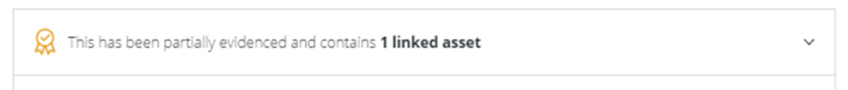

Once you have completed the student information page, you should complete the ‘Assessment of attitudes in practice’ and ‘Practice profile’ pages.

Learning contracts

The learning contract pages provide you with a page for each learning contract. There are boxes to allow you to outline the key elements of your learning contract. You should add links to supporting assets within your learning contacts by selecting text and using the link option (see the ‘Formatting and linking’ section above.

NMC Standards pages

Stage 1 (Initial ratings)

Complete all ratings under ‘Initial rating’ for each standard. This is a formative assessment which will provide the basis to identify your learning needs with your practice teacher/mentor.

Stage 2 (Mid-point ratings)

This is a summative assessment at progression point when you should have reached step three of the taxonomy as minimum for each of the NMC standards and attached evidence to support this rating (see Guidance for self-assessment below for definitions of the stages). The practice teacher/mentor will access your e-portfolio to inform discussions and allow them to make a recommendation on whether your progress is satisfactory at this stage of the course. Your e- portfolio should contain a number of agreed learning contracts on the learning contract pages with some evidence of progression through to step three of the taxonomy to show initiative, recognising gaps in your skills, knowledge and/or service provision (these learning contracts do not have to be completed but you have to be demonstrating some evidence which relates theory to this aspect of practice). You will have demonstrated engaging with all aspects of your portfolio including part A and part B tasks.

Stage 3 (Final ratings)

This is a summative assessment at the end of the course. Prior to your final meeting with your PT/mentor, you should have met all the proficiency standards (step five of the taxonomy as a minimum) and provided evidence to support your ratings (see Guidance for self-assessment below for definitions of the stages).

After the meetings at stages 2 and 3, you will need to scan and upload the relevant meeting records and documentation into your PebblePad account and attach it to the ‘Declarations’ page in part B of your e-portfolio workbook.

Guidance for self-assessment

The assessment for student learning and student experience has been adapted from Steinaker and Bell`s Experiential Learning Taxonomy (1979). This approach is intended to support the student’s progression and development in practice during their journey on the course to become a SCPHN.

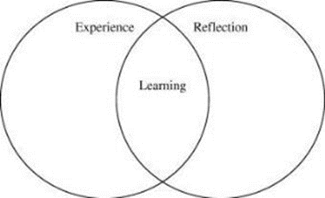

Figure 1: Experiential Learning

Experiential learning involves making meaning from a direct experience and is most valuable in any situation in which change is the goal. The aim of the Specialist practitioner programme is to develop competent practitioners through a progression of change, which will be structured and formatted through the experiential learning taxonomy. The taxonomy will be presented as a sequence of the five steps involved in the process of reflecting on experience after being exposed to it:

Step One – Exposure (Observing something of interest, experiencing something that requires further investigation, researching and finding out more)

Step Two – Participation (Reviewing the situation, getting involved and exploring the wider picture)

Step Three – Identification (Processing the knowledge, recognising the need for change and development, interpreting the situation)

Step Four – Internalisation (Critical analysis and synthesis of the knowledge, adding personal ideas, improvement and transformation)

Step Five – Dissemination (Communicating transformation, sharing and spreading new ideas, sustaining developments)

For successful completion of the programme the student MUST attain Step Five in all the standards of proficiency at the summative assessment. If a student does not achieve in one or more of the standards of proficiency they will be awarded a fail. A fail of any of the standards of proficiency constitutes a fail of the practice portfolio and therefore an overall fail of the SCPHN course.

Steinaker, N.W. & Bell, M.R. (1979) The Experiential Taxonomy: a new approach to teaching and learning, London: Academic Pres

Reflections
The reflections pages provide you with templates for reflecting on your teaching experiences, your alternative experience and the process of gaining and using feedback from users and carers.

Meeting records and declarations
These pages allow you and your mentor to complete the records of your initial, mid-point and final meetings. There are also pages for your evaluation and confidentiality statements, and for your Self-declaration of good health and good character. These pages consist of sections that yiou need to complete and ‘assessor fields’ to be completed by your PT.

Assessment deadlines and checking your workbook in ATLAS
Until the deadline, any additions or changes that you make to your workbook are immediately displayed on the workspace when you save your work in PebblePad. Therefore you are strongly recommended to add your assets into your workbook well in advance of deadlines and to continue to work on them subsequently as needed. Be aware that if you are working on your workbook when the deadline is reached, only the work done at the last save point will be visible. This includes any assets that you have linked within your workbook. They will only be visible if you save the workbook before the deadline.

If you experience technical problems that you believe will affect your assessment, please let your tutor know as soon as possible. It will not be possible to consider reports of problems made after the deadline. As with any assessment, the responsibility the content of your workbook lies with you and technical issues will not be accepted as a mitigating factor for problems such as missing evidence or files that have not uploaded correctly. You are strongly recommended to check that your submission and its contents are visible to tutors on the workspace in ATLAS as follows:

•Click on the ATLAS button (a blue globe icon, lop-left) to open ATLAS in your browser (see image below).


•Click on the workspace name to view your submissions. You should see your submission displayed on the page.

•When you click on your submission you will be able to view it exactly as your tutors will see it so that you can check it and make sure that any links to evidence are working correctly and re-upload the evidence if necessary.

Support
In case of difficulties that you cannot solve using the instructions provided in these instructions, please use the following contacts:

For course specific questions about the process and content of your e-portfolio, please contact your course tutor.

For questions, comments or suggestions about these instructions, please contact Rob Shaw, Faculty Learning Technologist at r.a.shaw@leedsbeckett.ac.uk.

For technical questions about PebblePad (e.g. problems with access to PebblePad, sharing assets, uploading and viewing files, ‘bugs’) or to comment on functionality / suggest functionality enhancements please contact the Library at library@leedsbeckett.ac.uk / 0113 812 1000

Your Feedback on the Module
A mid-module review will be timetabled into your module by week 7. This is an opportunity to resolve modular issues promptly early on in the module. In addition, you will have the opportunity to feed-back formally at the end of your module. These comments will be reviewed by your course team and some may be considered via the course monitoring and enhancement process, in which your Course Representative is involved.

