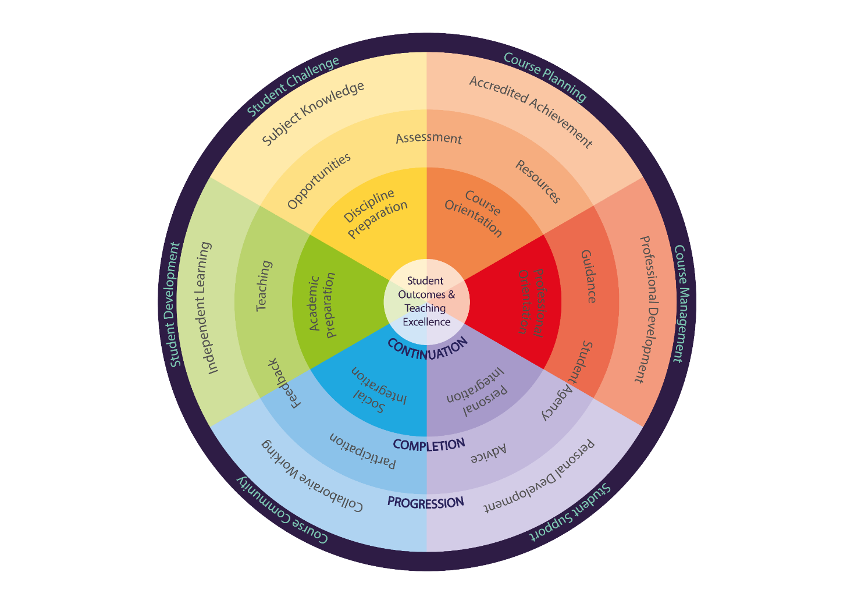
January 2023
The Inclusive Course Design Tool

The Inclusive Course Design Tool (ICDT)

Introduction
The Inclusive Course Design Tool is a broad, self-evaluation tool which considers a range of evidence-based factors which influence attainment, belonging and inclusion.
Institutional priorities (for continuation, completion and graduate employment) and requirements for the UK Quality Code for HE, our institutional APP and FHEQ requirements and outcomes are encapsulated in the Tool’s reflective questions.
Consideration of all diverse student groups and how to maximise their learning and attainment is fundamental to course design and delivery and we must ensure all students are satisfied with their learning experience and support them to complete their studies with a positive outcome.
Course teams should take a light-touch approach and consider the questions listed here, to reflect on practice as part of ongoing course enhancement or as part of a new course design. You should discuss the questions as part of a course team meeting or round table discussion. You may want to just concentrate on improving one section or question that your team prioritise as needing development/enhancement.
Questions marked with a ⚑ highlight some areas which may help to address and reduce our black and minority ethnic (BAME) student award gap. Resources and guidance for each question are linked at the end of each question.

After using the Tool, you may identify that your team needs further guidance to implement your actions. You can contact clt@leedsbeckett.ac.uk for further signposting and help. The Centre for Learning and Teaching Educational Development Programme includes sessions on the design of inclusive practice.
Please see the ICDT webpage for details on submission deadline.
Submit the completed document to the Dean, along with your summary action plan, who will compile a School-wide report for AQSC.
https://teachlearn.leedsbeckett.ac.uk/teaching-and-learning/inclusive-practice/the-inclusive-course-design-tool/

PLANNING YOUR COURSE

Excellent course planning requires a curriculum focused on course orientation and induction, constructive alignment of assessment and resources, and a clear and transparent route to the achievement of a qualification.

1. PLANNING YOUR COURSE | Self-evaluation | Where details can be found  (e.g. in course documentation) | Course Team plan/ideas for enhancement (if applicable)
1.1 Have you included a clear statement related to inclusive programme values within your student-facing course documents? (Supporting resources) | o Not yet started  o Developing  o Enhancing  o Not applicable
1.2 ⚑ Do your course design consider students’ prior learning and lived experiences (especially those students who may be from underrepresented groups)? (Supporting resources) | o Not yet started  o Developing  o Enhancing  o Not applicable
1.3 Do you identify, specific students who may need additional support, including those with Reasonable Adjustment Plans (RAPs) at pre–arrival, during induction and review regularly throughout the course? (Supporting resources) | o Not yet started  o Developing  o Enhancing  o Not applicable
1.4 Do you offer a choice of assessment methods/tasks/topics to reduce the need for alternative assessments and is this choice clearly embedded in the course assessment strategy? (Supporting resources) | o Not yet started  o Developing  o Enhancing  o Not applicable
1.5 Do you have a clear system for considering the clarity of assessment criteria and the calibration of the marking processes? (Supporting resources) | o Not yet started  o Developing  o Enhancing  o Not applicable
1.6 How do your assessment submission dates account for religious and cultural observances, i.e. Ramadan? (Supporting resources) | o Not yet started  o Developing  o Enhancing  o Not applicable
1.7 ⚑ Do you regularly review the appropriateness of the language and/or imagery used in your course and module materials? (Supporting resources) | o Not yet started  o Developing  o Enhancing  o Not applicable
1.8 Are the teaching materials and resources, provided to students, developed using best practice advice on accessibility and inclusivity (for example font size, file type)? (Supporting resources) | o Not yet started  o Developing  o Enhancing  o Not applicable

MANAGING YOUR COURSE

Course management requires a professional learning environment focused on practical orientation to the Institution, providing day to day organisation, listening and responding to the student body and establishing professional expectations and behaviours.

2. MANAGING YOUR COURSE | Self-evaluation | Where details can be found  (e.g. in course documentation) | Course Team plan/ideas for enhancement (if applicable)
2.1 ⚑ Does your course team monitor course admission and application data and address any areas of concern, for example gender, disability, ethnicity, IMD or POLAR groups. (Supporting resources) | o Not yet started  o Developing  o Enhancing  o Not applicable
2.2 Are students made aware pre-entry of any requirements that may affect their ability to successfully complete the course such as professional competencies, additional costs, compulsory placements. (Supporting resources) | o Not yet started  o Developing  o Enhancing  o Not applicable
2.3 Does your course have a consistent language and structure across all its online spaces, and course materials that students can easily navigate? (Supporting resources) | o Not yet started  o Developing  o Enhancing  o Not applicable
2.4 Does the course team have strategies in place to understand and share feedback with each other on their students? (Supporting resources) | o Not yet started  o Developing  o Enhancing  o Not applicable

SUPPORTING THE STUDENTS ON YOUR COURSE

Student support requires an inclusive environment which values and promotes individual student perspectives and provides personalised academic support and guidance for each student to develop and succeed individually.

3. SUPPORTING THE STUDENTS ON THE COURSE | Self-evaluation | Where details can be found  (e.g. in course documentation) | Course Team plan/ideas for enhancement (if applicable)
3.1 Do you have a clear process for each student to discuss and progress their learning experience with a named Academic Advisor (AA)? (Supporting resources) | o Not yet started  o Developing  o Enhancing  o Not applicable
3.2 ⚑ Do you actively offer opportunities in your course for all students to feel able to participate and share their diverse experiences, build connections and develop a sense of belonging early in the course? (Supporting resources) | o Not yet started  o Developing  o Enhancing  o Not applicable
3.3 Do you offer formative bite-size assessment opportunities, so students have an opportunity to “fail safely” and seek support? (Supporting resources) | o Not yet started  o Developing  o Enhancing  o Not applicable
3.4 Do you run defined sessions for students who may have failed elements of their assessments (e.g. structured summer support, revision sessions etc)? (Supporting resources) | o Not yet started  o Developing  o Enhancing  o Not applicable
3.5 Do you have clear accessible course communications to promote engagement at critical times for all your students (e.g. pre-arrival, assessment periods, mark release dates, study abroad, during off-campus placement, when there are timetable changes)? (Supporting resources) | o Not yet started  o Developing  o Enhancing  o Not applicable
3.6 ⚑ Is space and time provided for staff reflection on matters of discrimination and inequality, including racism? (Supporting resources) | o Not yet started  o Developing  o Enhancing  o Not applicable
3.7 ⚑ Is time given to remind students of the support available to them, and the procedures in place should they wish to raise a concern about the behaviours or attitudes of others which have impacted them? (Supporting resources) | o Not yet started  o Developing  o Enhancing  o Not applicable

4. BUILDING THE COURSE COMMUNITY
A learning community requires a focus on social integration, encouraging students to feel a sense of belonging and to learn from others through teaching approaches that involve regular interaction, integrated feedback and opportunities for students to develop as collaborative learners.

4. BUILDING THE COURSE COMMUNITY | Self-evaluation | Where details can be found  (e.g. in course documentation) | Course Team plan/ideas for enhancement (if applicable)
4.1 ⚑ Does the programme promote opportunities for academic and social belonging amongst the students? (Supporting resources) | o Not yet started  o Developing  o Enhancing  o Not applicable
4.2 Do you seek and engage with student feedback about the course timetable? Do you consider how timetables might affect different student groups? (Supporting resources) | o Not yet started  o Developing  o Enhancing  o Not applicable
4.3 ⚑ Do learning activities facilitate a compassionate learning environment and engage students in a range of views, perspectives and cultural contexts? (Supporting resources) | o Not yet started  o Developing  o Enhancing  o Not applicable
4.4 ⚑ Do your module reading lists and course content represent a diversity of contributors with consideration given to race and ethnicity, gender, sexual orientation, religion and belief, disability, age and socio-economic background? (Supporting resources) | o Not yet started  o Developing  o Enhancing  o Not applicable
4.5 ⚑ Does the way you allocate students to group work activities ensure students mix with all peers and make connections from across their cohort? (Supporting resources) | o Not yet started  o Developing  o Enhancing  o Not applicable

5. DEVELOPING ALL THE STUDENTS ON YOUR COURSE
Student development requires offering approaches that prioritise students' academic preparation and academic literacies, thought provoking teaching and timely, formative feedback that empowers students to become independent learners.
5. DEVELOPING ALL THE STUDENTS ON THE COURSE | Self-evaluation | Where details can be found  (e.g. in course documentation) | Course Team plan/ideas for enhancement (if applicable)
5.1 ⚑ Do course teams actively explore appropriate behaviours of students in both online and physical classroom settings with students? (Supporting resources) | o Not yet started  o Developing  o Enhancing  o Not applicable
5.2 Are there planned opportunities in the curriculum/course design and delivery for all students to create some elements of course activity if they wish? (Supporting resources) | o Not yet started  o Developing  o Enhancing  o Not applicable
5.3 Are there clear, embedded and accessible opportunities for all students to benefit from quality-and-equality-checked placements, paid internships? (Supporting resources) | o Not yet started  o Developing  o Enhancing  o Not applicable
5.4 Are academic skills development and diagnostic learning opportunities integrated into the course e.g., academic integrity, writing skills? (Supporting resources) | o Not yet started  o Developing  o Enhancing  o Not applicable

6. CHALLENGING ALL THE STUDENTS ON YOUR COURSE
A course requires a curriculum designed to prepare students for studying the discipline and provides learning opportunities and assessments which stretch and stimulate the students to become succeed.
6. CHALLENGING ALL THE STUDENTS ON THE COURSE | Self-evaluation | Where details can be found  (e.g. in course documentation) | Course Team plan/ideas for enhancement (if applicable)
6.1 Does the course team offer a range of differentiated activities, learning opportunities and reading to support and challenge all students as part of each module? (Supporting resources) | o Not yet started  o Developing  o Enhancing  o Not applicable
6.2 Are the assessment methods inclusive for each level of the course (i.e. are they designed to provide all students with opportunities to perform to the best of their ability)? (Supporting resources) | o Not yet started  o Developing  o Enhancing  o Not applicable

Provide a summary of the action points which you will prioritise for the next academic year.

Action Points agreed by the Course Team (to be submitted to the Dean)
Course Name: ________________________________________________________________ | Date: ________________________________
Course Director:_______________________________________________________________ | Signature: ____________________________

Resource links

PLANNING YOUR COURSE
https://rl.talis.com/3/beckett/lists/E8990AD3-3E46-728D-7183-89B584349168.html?lang=en&login=1#94B76A0D-FD3D-7FF7-BAA8-D1B58DB04078

MANAGING YOUR COURSE
https://rl.talis.com/3/beckett/lists/E8990AD3-3E46-728D-7183-89B584349168.html?lang=en&login=1#290ECE47-D3D2-0EE6-057C-206409E287E4

SUPPORTING THE STUDENTS ON THE COURSE
https://rl.talis.com/3/beckett/lists/E8990AD3-3E46-728D-7183-89B584349168.html?lang=en&login=1#902D2E23-642B-B25F-D613-E1A0F750F5A1

BUILDING THE COURSE COMMUNITY
https://rl.talis.com/3/beckett/lists/E8990AD3-3E46-728D-7183-89B584349168.html?lang=en&login=1#91932865-0FCA-7FB4-4BB0-D4DFE49EB278

DEVELOPING ALL THE STUDENTS ON THE COURSE
https://rl.talis.com/3/beckett/lists/E8990AD3-3E46-728D-7183-89B584349168.html?lang=en&login=1#580424BC-105C-7DFE-7EDB-8E7D1F049B87

CHALLENGING ALL THE STUDENTS ON THE COURSE
https://rl.talis.com/3/beckett/lists/E8990AD3-3E46-728D-7183-89B584349168.html?lang=en&login=1#F0B7B83B-1916-FB30-B8A9-DE4CDDA9D64D

BIBLIOGRAPHY
https://rl.talis.com/3/beckett/lists/E8990AD3-3E46-728D-7183-89B584349168.html?lang=en&login=1#DD9AF487-21C6-6716-C9CC-AA88531DEC7D

