FRAMEWORK AND GUIDELINES / OCTOBER 2026

Research-informed Framework and Guidelines
  - Ethical and Inclusive AI Curriculum and Assessment Design Canvas
How student focus-group findings, peer-reviewed research and sector guidance inform the Canvas’s design principles and practical staff guidance.
Research basis: Student consultation and published evidence
Prepared by: Dr Hajar Fatorachian and Mr Hadi Kazemi; Leeds Beckett University

Purpose
These guidelines explain how the Ethical and Inclusive AI Curriculum and Assessment Design Canvas can support responsible AI integration in higher education. They connect student consultation findings with peer-reviewed research and sector guidance and offer practical principles, illustrative questions and decision-making steps for educators designing or reviewing curricula and assessments.

Four linked evidence components
Student voice | Published scholarship | Sector guidance | Design translation
Undergraduate and postgraduate focus-group themes | AI literacy, assessment integrity, human agency and inclusion | UNESCO, QAA, Jisc, HEPI, TEQSA, ICO and W3C | Design principles, staff prompts, assessment guidance and review questions

Executive summary
The focus-group findings show two consistent messages. Students recognise AI’s value for explaining concepts, generating ideas, structuring work, saving time and providing language-related support. They also want training, clear rules, opportunities to verify outputs and continued interaction with lecturers. These expectations fit wider evidence that students want assessment-specific guidance, equitable access and support for critical judgement (Attewell, 2025; Stephenson and Armstrong, 2026).
The underlying framework therefore treats responsible AI integration as a curriculum-and-assessment design problem: educators decide which forms of AI assistance serve the learning outcomes, what students must demonstrate independently, how expectations are communicated, and what provision is needed for learners with different circumstances (Miao and Holmes, 2023; Perkins et al., 2024; QAA, 2026).

The evidence-to-design chain
Stage | Evidence or decision | Result
1 Understand learners | Focus-group themes on benefits, needs and concerns | A student-informed problem definition
2 Review external evidence | Peer-reviewed research and international/UK sector guidance | Ethical, pedagogical and quality-assurance requirements
3 Translate into principles | Align AI assistance with learning, inclusion, integrity and human oversight | Seven design principles plus privacy as a cross-cutting safeguard
4 Apply to a module | Choose appropriate AI use, assessment instructions and verification activities | Completed or revised assessment design and student guidance
5 Review & improve | Student feedback, staff usability and assessment quality evidence | Iterative refinement of the Canvas and practical guidance

What constitutes evidence in this framework?
Student consultation evidence (P). The research team’s thematic summary of undergraduate and postgraduate student focus groups. The findings are presented as thematic summaries rather than verbatim transcript quotations.
Research evidence (R). Peer-reviewed scholarship explaining AI literacy, opportunities and risks, assessment integrity and thematic analysis.
Policy and sector evidence (S). Published guidance and sector reports supporting design decisions. Publications released in 2026 are used as later corroboration and updating context; they are not represented as sources originally consulted when the Canvas was first developed.
Design interpretation (D). The framework principles, illustrative questions, staff guidance and indicators derived by bringing P, R and S together. These are analytic design translations to align with the final published Canvas.

Scope
The focus is curriculum and assessment decision-making in higher education, particularly how AI can support learning without obscuring students’ own understanding. The framework is applicable across disciplines, qualification levels and modes of delivery, with decisions made at the level of the relevant task and institutional policy.

1. Student consultation and evidence base
The framework draws on research-informed practice integrating AI into undergraduate and postgraduate teaching and assessment, together with student focus-group findings. These student perspectives were considered alongside academic scholarship and sector guidance to inform the principles and practical questions presented in the Canvas.
The research team’s summary describes thematic analysis of student focus-group discussions. Discussions were initially reviewed individually and coded, then themes were compared across groups and refined into seven combined themes. This process is consistent with the principle of searching for and interpreting patterned meaning in qualitative data, although a claim of adherence to a particular Braun–Clarke analytic variant would require the detailed methodological record (Braun and Clarke, 2006).

Seven themes identified through student consultation
Theme | Student-reported finding
1. Learning and academic support | Explanation of concepts; ideas; assignment planning and structure
2. Efficiency and time saving | Faster work, productivity and reduced routine effort
3. Training and curriculum integration | Workshops, prompting skills and early/module-based AI education
4. Ethical use and integrity | No direct copying; check outputs; comply with assessment requirements
5. Inclusion and language support | Benefits for international students and users of additional languages; confidence
6. Teaching and communication | Clearer expectations, engagement, dialogue and less anxiety around AI
7. Risks of overdependence | Loss of independent thinking, weaker human interaction, excessive reliance

2. Research and policy foundations

2.1 Human-centred and responsible use
UNESCO’s guidance for generative AI in education and research stresses human agency, equity, privacy and pedagogical appropriateness. Its teacher competency framework adds AI ethics, pedagogy and professional learning to technical capability (Miao and Holmes, 2023; Miao and Cukurova, 2024). This supports designing AI use around learning and staff/student judgement, not simply around what a tool can produce.

2.2 AI literacy as an explicit educational outcome
A peer-reviewed conceptual review identifies four connected aspects of AI literacy: understanding AI, using and applying it, evaluating and creating, and addressing ethical issues (Ng et al., 2021). Large-language-model research also identifies opportunities for tailored explanation and support alongside hallucination, bias and over-reliance risks (Kasneci et al., 2023). Together these sources support guided practice in prompting, verification and critical evaluation rather than unstructured tool access.

2.3 Assessment integrity and demonstrable learning
The AI Assessment Scale offers a task-specific approach to making the permissible extent of AI involvement explicit (Perkins et al., 2024). Research on ChatGPT and academic integrity argues for clear expectations and support for staff and students (Cotton, Cotton and Shipway, 2024). TEQSA’s expert-led assessment reform guidance emphasises appropriate learning and assessment in an AI-rich society (TEQSA, 2023). QAA’s 2026 sector analysis similarly foregrounds the validity of evidence of student learning and consistency across provision (QAA, 2026).

2.4 Inclusion, student experience and agency
Attewell’s Jisc student research documents a demand for practical, course-specific guidance, equitable AI access, staff–student dialogue and continued human feedback (Attewell, 2025). A UK undergraduate survey finds widespread student use of AI, significant perceived learning benefits and concerns around skills loss, isolation and uneven institutional support (Stephenson and Armstrong, 2026). QAA’s transnational project also examines ethical and equitable GenAI use in assessment (QAA, 2025). These findings corroborate the study’s themes while identifying additional considerations for implementation.

2.5 Privacy and accessible implementation
Institutional guidance should address whether identifiable student or third-party data may be entered into external AI tools; appropriate data protection and risk controls depend on the actual processing, platform and institutional arrangements (ICO, n.d.). Downloadable and future interactive Canvas resources should be checked for accessible content and controls using WCAG 2.2, alongside applicable university accessibility requirements (W3C, 2024).

Implications for the Canvas
These sources collectively support assessment-specific rules, learner agency, critical evaluation, accessible alternatives and professional oversight. They provide the evidence base for the principles and guidance presented in the following sections. The 2026 sector reports are included as subsequent corroboration and context, rather than being presented as inputs to earlier design decisions.

3. The underpinning framework
The Ethical and Inclusive AI Curriculum and Assessment Design Canvas is informed by seven interconnected principles developed through a synthesis of student focus-group findings, academic research and sector guidance. Together, they provide a foundation for integrating AI into curriculum and assessment design while maintaining educational value, academic integrity, equitable participation and human judgement.
Privacy, security and tool suitability operate as a cross-cutting safeguard. They should be considered alongside relevant institutional policies, assessment regulations and approved AI tool requirements.
Figure 1. The seven underpinning design principles and the cross-cutting safeguard
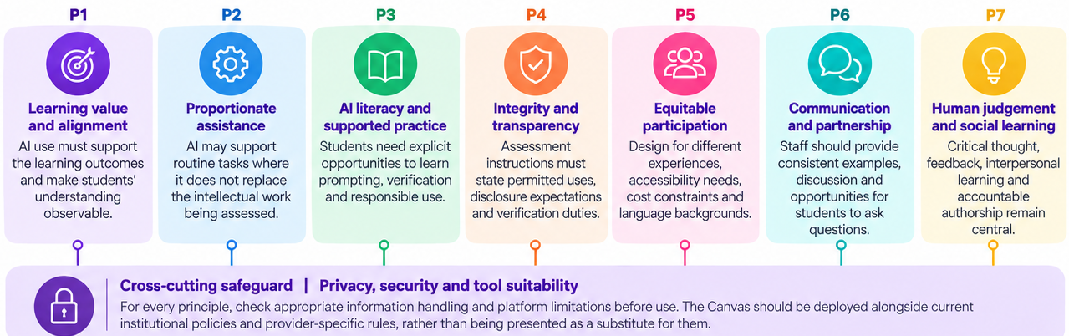

These principles synthesise student themes and sources detailed in Section 2 and the reference list, including Kasneci et al. (2023), Perkins et al. (2024), Ng et al. (2021), Miao and Holmes (2023), Attewell (2025), QAA (2025, 2026), W3C (2024) and ICO (n.d.).

4. Theme-to-design traceability matrix
The matrix translates the seven themes reported from undergraduate and postgraduate student focus groups into practical curriculum and assessment considerations. Each theme is connected to underpinning principles (P1–P7), an illustrative question for Canvas users and an associated action for academic colleagues.
The questions represent research-informed design interpretations, not quotations from students or verbatim fields in the existing Canvas. Corroborating research and policy sources are included within the figure.
Figure 2. Student evidence mapped to design principles, illustrative questions and staff guidance
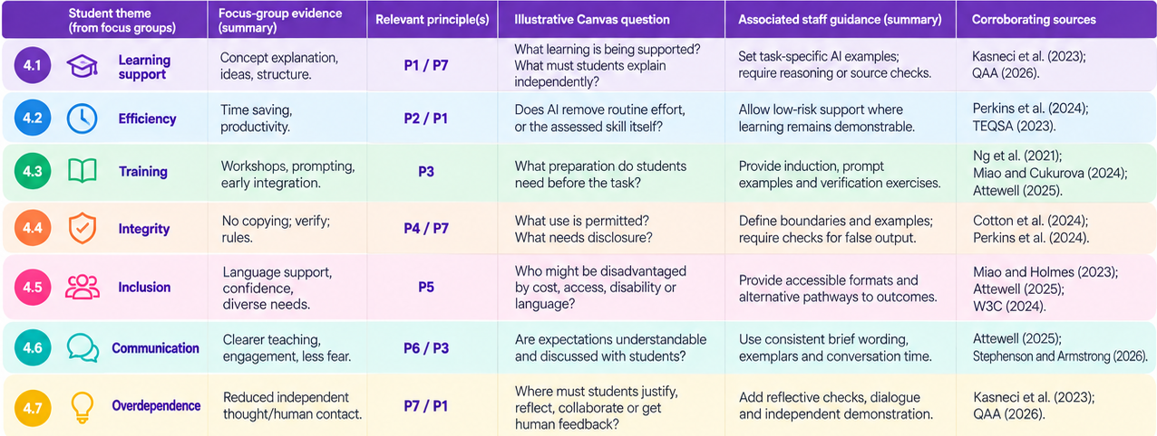

For reading the matrix, start with the relevant student theme, follow its P1–P7 code to Figure 1, and adapt the suggested question and staff action to the learning outcomes, assessment task and institutional context. Full bibliographic details appear in the References section.

5. How academic colleagues can use the framework
The following decision cycle converts the framework into a repeatable curriculum-and-assessment review. It is a suggested staff workflow consistent with the research base, not a claim that the published Canvas contains these exact fields.
Review step | Key decision and practical output | Evidence
1. Define learning outcomes | Identify what students must know, analyse or justify without AI; record intended learning evidence. | P1, P7
2. Specify legitimate AI support | Choose permitted activities (e.g., concept explanation, idea exploration, draft structure); identify prohibited substitutions. | P2, P4
3. Design authenticity checks | Include student reasoning, oral explanation, drafts, reflections, source verification or staged work when proportionate. | P1, P4, P7
4. Plan inclusive access | Check disability-related adjustments, language support, cost, digital access and equivalent non-AI routes. | P5
5. Teach responsible AI use | Provide guided practice in prompting, evidence-checking, bias, privacy and disclosure. | P3, P4
6. Communicate clearly | Publish module- and assessment-level instructions; check consistency with university policy and marking criteria. | P6, P4
7. Review and refine | Gather staff/student feedback, check accessibility and whether outputs show intended learning. | P1–P7

Illustrative assessment-brief wording
“You may use an approved AI tool to clarify concepts, explore alternative approaches and organise an initial plan. You must verify factual claims using appropriate sources and produce the analysis and conclusions yourself. State briefly whether and how AI was used. Do not upload personal, confidential or restricted information to an unapproved tool. If you cannot or do not wish to use AI, an equivalent route to completing the assessment will be available.”
This is sample wording only; actual permissions should be aligned with the learning outcomes, local assessment regulations, institutional guidance and approved tool arrangements.

Illustrative teaching activity
For an operations and logistics case study, students can compare an AI-suggested response with credible literature, module data and their own analysis. The assessment can ask them to explain where the AI reasoning is incomplete and justify a revised recommendation. AI is then used to support critical engagement, while the assessed evidence remains the student’s own evaluation (Ng et al., 2021; Perkins et al., 2024).

6. Quality, inclusion and evaluation

6.1 What the current framework delivers
- A clear rationale for why and when AI should be incorporated into learning and assessment tasks.
- A structured way to identify permitted AI assistance, student disclosure expectations and assessment integrity safeguards.
- Consideration of fairness, language needs, accessibility, resource disparities and privacy before adoption.
- Practical prompts for building AI literacy, sustaining human dialogue and evidencing independent learning.
- A basis for consistent conversations among programme teams, quality assurance colleagues and students.

6.2 Suggested evidence for ongoing review
Area | Example measure | Interpretation
Accessibility and equity | Usability feedback across student groups; proportion reporting access barriers | Identify and address avoidable barriers; do not treat absence of complaints as proof of inclusion.
Clarity of guidance | Student ability to identify permitted/prohibited AI use in scenarios | Check whether instructions are understood across modules.
Critical judgement | Quality of student source verification, reasoning and reflection | Assess intended skills, not mere tool use.
Student experience | Feedback on confidence, training usefulness and human interaction | Use feedback to refine learning support and communication.
Teaching uptake | Staff downloads, pilot use, assessment revisions and feedback | Differentiate available, used and independently evaluated resources.
Assessment outcomes | Appropriately defined attainment/completion measures and comparable cohorts | Describe associations; avoid attributing changes to AI alone.

6.3 Ethical considerations in gathering student evidence
Focus-group and evaluation reports should explain recruitment, consent, secure information handling, data minimisation and anonymisation as appropriate. In particular, published materials should not include identifiable student examples or transcript quotations without the relevant permissions. The thematic summary provided here supports theme-level interpretations; it does not supply quotations or participant-level outcome data (Braun and Clarke, 2006; ICO, n.d.).

6.4 Accessibility of downloadable and digital resources
Provide accessible headings, adequate contrast, keyboard navigation and readable downloadable formats. When developing digital or interactive resources, test against WCAG 2.2 as relevant, involve users with different accessibility requirements, and record the review process. Accessibility should be considered throughout design and evaluation (W3C, 2024).

References
Attewell, S. (2025) Student perceptions of AI 2025. Jisc report, 22 May. https://www.jisc.ac.uk/reports/student-perceptions-of-ai-2025
Braun, V. and Clarke, V. (2006) ‘Using thematic analysis in psychology’, Qualitative Research in Psychology, 3(2), pp. 77–101. https://doi.org/10.1191/1478088706qp063oa
Cotton, D.R.E., Cotton, P.A. and Shipway, J.R. (2024) ‘Chatting and cheating: Ensuring academic integrity in the era of ChatGPT’, Innovations in Education and Teaching International, 61(2), pp. 228–239. Published online 13 March 2023. https://doi.org/10.1080/14703297.2023.2190148
Information Commissioner’s Office (ICO) (n.d.) Guidance on AI and data protection: About this guidance. UK Information Commissioner’s Office. Available at: https://ico.org.uk/for-organisations/uk-gdpr-guidance-and-resources/artificial-intelligence/guidance-on-ai-and-data-protection/about-this-guidance/ (accessed 15 October 2026; guidance subject to revision).
Kasneci, E., Sessler, K., Küchemann, S., Bannert, M., Dementieva, D., Fischer, F., Gasser, U., Groh, G., Günnemann, S., Hüllermeier, E., Krusche, S., Kutyniok, G., Michaeli, T., Nerdel, C., Pfeffer, J., Poquet, O., Sailer, M., Schmidt, A., Seidel, T., Stadler, M., Weller, J., Kuhn, J. and Kasneci, G. (2023) ‘ChatGPT for good? On opportunities and challenges of large language models for education’, Learning and Individual Differences, 103, article 102274. https://doi.org/10.1016/j.lindif.2023.102274
Miao, F. and Cukurova, M. (2024) AI competency framework for teachers. Paris: UNESCO. ISBN 978-92-3-100707-1. https://doi.org/10.54675/ZJTE2084
Miao, F. and Holmes, W. (2023) Guidance for generative AI in education and research. Paris: UNESCO. ISBN 978-92-3-100612-8. https://doi.org/10.54675/EWZM9535
Ng, D.T.K., Leung, J.K.L., Chu, S.K.W. and Qiao, M.S. (2021) ‘Conceptualizing AI literacy: An exploratory review’, Computers and Education: Artificial Intelligence, 2, article 100041. https://doi.org/10.1016/j.caeai.2021.100041
Perkins, M., Furze, L., Roe, J. and MacVaugh, J. (2024) ‘The Artificial Intelligence Assessment Scale (AIAS): A framework for ethical integration of generative AI in educational assessment’, Journal of University Teaching and Learning Practice, 21(6). https://doi.org/10.53761/q3azde36
Quality Assurance Agency for Higher Education (QAA) (2025) Supporting the ethical and equitable use of Generative AI (GenAI) for Formative and Summative Assessment: a transnational perspective. Collaborative Enhancement Project final report, 30 June. https://www.qaa.ac.uk/docs/qaa/members/qaa-project-final-report.pdf?sfvrsn=e26ade81_7
Quality Assurance Agency for Higher Education (QAA) (2026) The perfect storm: AI, assessment and a sector under pressure. State of the Nation report, 9 July. https://www.qaa.ac.uk/news-events/policy-and-leadership/state-of-the-nation
Stephenson, R. and Armstrong, C. (2026) Student Generative Artificial Intelligence Survey 2026. HEPI Report 199. Higher Education Policy Institute, 12 March. https://www.hepi.ac.uk/reports/student-generative-ai-survey-2026/
Tertiary Education Quality and Standards Agency (TEQSA) (2023) Assessment reform for the age of artificial intelligence. Assessment Reform Guiding Principles, published 23 November. Expert-led report with lead authors Jason M. Lodge, Sarah Howard, Margaret Bearman and Phillip Dawson. https://www.teqsa.gov.au/guides-resources/resources/corporate-publications/assessment-reform-age-artificial-intelligence
World Wide Web Consortium (W3C) (2024) Web Content Accessibility Guidelines (WCAG) 2.2. W3C Recommendation (originally published 5 October 2023; revised 12 December 2024). Edited by Alastair Campbell, Chuck Adams, Rachael Bradley Montgomery, Michael Cooper and Andrew Kirkpatrick. https://www.w3.org/TR/WCAG22/

Student consultation evidence
Undergraduate and postgraduate focus-group thematic summary supplied by the research team. The student findings are reported at theme level; no identifying participant information or unattributed quotations are included.

