Centre for learning and Teaching, Leeds Beckett University



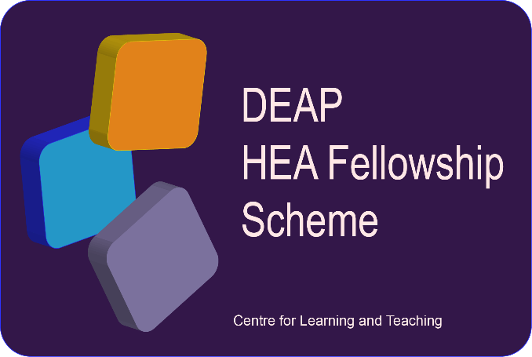
LEARNING EXCELLENT
ACADEMIC PRACTICE (LEAP)
HANDBOOK 2023-2027

Learning Excellent Academic Practice (LEAP)

Contents
Learning Excellent Academic Practice (LEAP) 1
1.LEAP: who is it for and why do it? 3
2. Pathway details 3
2.1 Workshop series 4
2.2 The LEAP VLE Module 5
3.What’s Next 5



1.LEAP: who is it for and why do it?
CLT have developed a framework to support Developing Excellent Academic Practice (DEAP), which is the umbrella term used for all the developmental practice sharing sessions available within our Educational Development Programme (EDP). The LEAP pathway sits within this wider programme and is aimed at colleagues who may:
- have joined us from professional practice,
- are working in professional services,
- are working as a graduate teaching assistant,
- are a PhD student who is just beginning to teach,
- colleagues who simply wish to enhance their ability to support learning and improve the student experience.

Sessions in the broader DEAP Educational Development Programme are open to all colleagues across the university involved in supporting Learning and Teaching and are therefore by their nature ‘generic’ sessions. The LEAP pathway is specifically designed to support you as a member of staff in building your practice by providing bespoke sessions and resources.
- LEAP provides opportunities to learn about the underpinning learning theories for Higher Education, using tools and building skills within a connected community of practitioners.
- LEAP introduces key concepts, including engaging learners, inclusive learning, reflection, and observations of practice.

- LEAP is designed to be experiential, which means that you will have the opportunity to think, plan, do and reflect.

- LEAP is designed to support you in building your learning and teaching practice and is mapped to the Dimensions of the Professional Standards Framework (PSF).
LEAP is not a direct route to HEA Fellowship, but rather provides the opportunity for greater understanding the requirements for a Fellowship application by mapping the sessions to the Professional Standards Framework PSF2023.

2. Pathway details

LEAP will be a self-paced rolling programme with start dates in September and January each year. There are four core sessions which will offer you early support in building your teaching practice and are mandatory for all participants, together with a wide range of optional developmental sessions available through the university’s Educational Development Programme (EDP). For example, you can join workshops on designing a learning session, creating inclusive assessment, developing effective and active learning spaces, and giving effective feedback. Colleagues can view the sessions available in the EDP as a self-audit to enable them to identify areas they feel would benefit from specific development and choose workshops to support that. We would encourage colleagues to join as many of the optional sessions as possible.

2.1 Workshop series
Core Session | Details | Dimension (A’s, K’s, and V’s)
1.  Learning Excellent Academic Practice  September and January | Starting your journey on the LEAP Pathway. Attendance at induction is critical to successful engagement in the programme. We will share details of how LEAP will work in developing you as an effective HE practitioner, outline the support available and the expectations of engaging with the series, and how this all fits within the wider context of the HE landscape. | All
2.  Engaging learners  September and January | We will discuss a range of challenges relating to optimising engagement in timetabled sessions including examples from our own university. Together we will devise ‘management’ strategies which align with our subject-specific approaches to teaching and learning. Appropriate sources of ongoing support will be identified including tools for engaging learners at a distance and relevant local learner conduct policies | V2, V5  K1, K4, K5  A1-A4
3.  Embedding inclusivity  October and February | This session will talk you through some of the challenges that lie ahead and will offer you support together with milestones we can all work towards. Addressing the need to tackle inequality and realise the importance of working together with students as partners, to ensure our maximum impact. | V1, V2, V5  K1, K2  A2, A4
4.  Reflective practice  November and March | This workshop will explore various aspects around reflective practice. You will explore different models of reflection, delve into creative reflective practices, and critically reflect on your own academic practice and that of others to enhance CPD and life-long learning. | V3  K3  A5

2.2 The LEAP VLE Module

The MyBeckett VLE is a platform utilised by courses across the university. The operation and interface provide a familiar platform on which our undergraduate and post graduate learning programmes are based. The module will provide LEAP-enrolled participants with a systematic approach to the pathway, together with a repository of information associated with each core session. Participants will be enrolled on the module during the first core LEAP Induction sessions that will take place in September and January.

3.What’s Next

LEAP is primarily designed to help you build confidence in your support for learning and teaching, to enhance your practice and to improve the experiences of our students.
CLT offer a wide variety of sessions designed to support you in developing your practice. These are delivered by the CLT core team and our CLT Associates, who are drawn to work with us from across all Schools and Services, offering excellent insights into teaching delivery. More information about upcoming events, as well as access to videos of previous DEAP events and Podcasts can be found here: https://www.leedsbeckett.ac.uk/staffsite/services/centre-for-learning-and-teaching/find-and-book-a-session/

Once you have completed the four core sessions on the LEAP pathway, you may wish to consider working towards accrediting your development by preparing for an application for Associate Fellow (Descriptor D1) within our broader Advance HE accredited internal DEAP CPD Fellowship Scheme.
Eligible participants do need to have completed at least one academic cycle at LBU to begin to make a claim. This means that you need to have evidence of your impact on student learning and achievement over at least one year of teaching and/or supporting learning at LBU. The LEAP pathway will have offered you the opportunity to begin to build an evidence base, but it is not a guarantee for an application, there is a waiting list of colleagues wishing to apply to join the Scheme. For full details of the criteria and process for an application, see the DEAP Fellowship Handbook.

