Attendance Monitoring Operating Procedures

For 2016/17 the University has launched a new mobile app for students – the Leeds Beckett App. This app will provide access to online learning tools along with information and functionality to support all areas of student life from health and wellbeing to social events, from transport to food. The app will also enable students to automatically sign in to all lectures and tutorials, replacing the previous paper-based registers.

In the case of attendance capture, the app has access to both a students’ timetable and a system of iBeacons located in each teaching space across the University. iBeacons, are simple Bluetooth transmitters that transmit a unique ID that is picked up by mobile devices.

The app puts these two pieces of information together to enable a student to be checked into their classes without the need to do anything other than have the app installed on their phone or tablet and to ensure that Bluetooth is activated.

How the system works
Students simply enter the teaching space when their event starts and the mobile app does the rest. It intelligently polls the beacon to check the location, and then registers the student’s attendance against the scheduled event. No interaction is required as the application’s default position enables ‘auto-check in’, consequently there is no need for the student to have the app open and as long as Bluetooth is enabled then the app will work in the background. The student will get immediate feedback in the form of a push notification to reassure them that their attendance has been registered.

Each event has a predefined check-in window – the time within which a student can register their attendance. This has a start time 10 minutes before teaching activity and closes 10 minutes before the end. The student will receive a push notification 5 minutes before the start of their event, reminding them they have a forthcoming class – it will also act as a prompt to enable Bluetooth if they have not done so already. If they have not checked in within the first 15 minutes of the class, they will then receive a second reminder prompting them to do so.

Check in window
Teaching Session
09.00-10.00

Check in Open | First Reminder | Second Reminder | Check in Closes
08.50 | 08.55 | 09.15 | 09.50
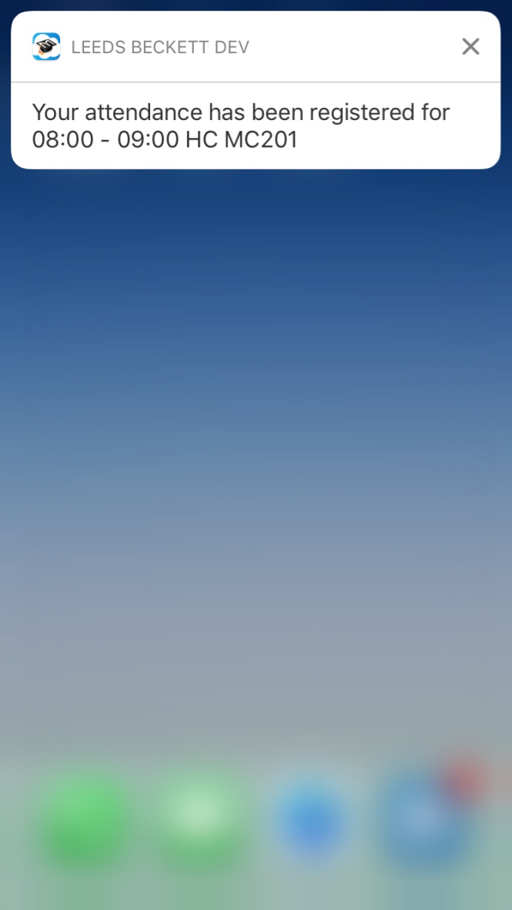
Lecturer Check-in facility – from w/c 3 October 2016
It is recognised that a very small number of students will not own a smart phone or tablet and the app provides the facility for academic colleagues to check in students.

For seminars/tutorials only colleagues are asked to undertake the following:

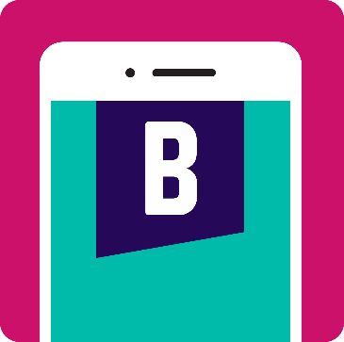

- Login into the desktop within the classroom your normal login and password.

- Click on the Leeds Beckett app icon as above.

- Click on the ‘Register Attendance’ tile.

ALTERNATIVELY
- If you have downloaded the app to your phone or tablet go straight to the Register Attendance tile:
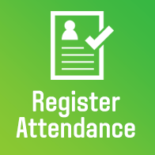

This screen shows the current class that the lecturer has and provides a summary of the students currently checked in or not checked in, along with the total number of students. To manually check students into a class, the lecturer clicks the green button ‘Check in students’, to go to screen 2. Screen 2 provides a list of students who are not currently checked into the class. To check an individual in, the lecturer finds them on the list and then clicks the ‘Available for check-in’ button. This registers the student’s attendance with the service, and provides an indication ‘Checked in!’ shown in screen 3. You can click on the back arrow to return to the class summary screen.

Screen 1 Screen 2

Screen 3

You can check a student in after the event (but only on the day of the event). Moreover, you will be able to view your past teachings events and retrieve the attendance list.

