How to search for Postgraduate Research Courses on the Applicant Portal
Programme Title | Mode of attendance | Programme search word
PhD – Doctor of Philosophy | Full time | Doctor
PhD – Doctor of Philosophy | Part time | Doctor
MRes – Master of Research | Full time | Master
MRes – Master of Research | Part time | Master
MPhil – Master of Philosophy | Full time | Master
MPhil – Master of Philosophy | Part time | Master
Professional Doctorates | Part time only | Professional

Programme of Study section – Postgraduate (Research) Full Time PhD course selection
To apply for a full time PhD, please follow the below guidance to make your selection in the ‘Programme of Study’ section of the Applicant Portal:
- Select ‘Full Time’ in the ‘Mode of Attendance’ section.
- Type ‘Doctor’ in the ‘Programme Title’ section and click ‘Search’.
- Press ‘Select’ next to ‘Doctor of Philosophy’ (term of entry of your choice) in the ‘Programme Title’ section.
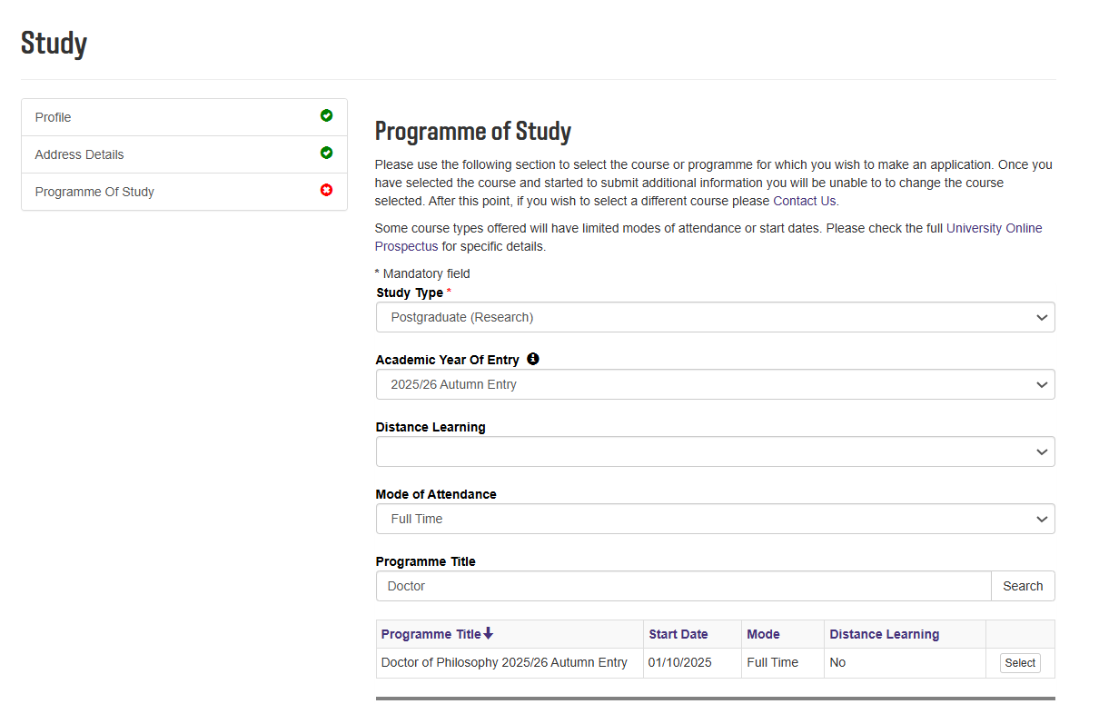

Programme of Study section – Postgraduate (Research) Part Time PhD course selection
To apply for a part time PhD, please follow the below guidance to make your selection in the ‘Programme of Study’ section of the Applicant Portal:
- Select ‘Part Time’ in the ‘Mode of Attendance’ section.
- Type ‘Doctor’ in the ‘Programme Title’ section and click ‘Search’.
- Click on the ‘2’ in the bottom right corner, this will display other available programmes.
- Once you have chosen the correct Programme Title*, click on ‘Select’.

Page 2.
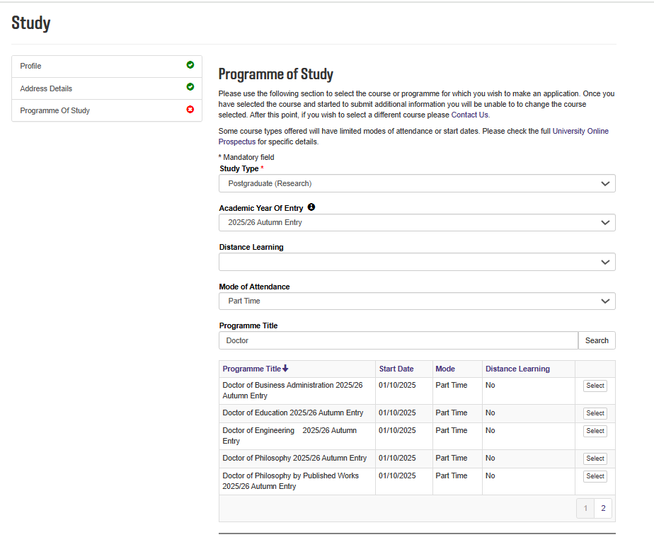

Programme of Study section – Postgraduate (Research) Full Time MRes course selection

To apply for a full time MRes, please follow the below guidance to make your selection in the ‘Programme of Study’ section of the Applicant Portal:
- Select ‘Full Time’ in the ‘Mode of Attendance’ section.
- Type ‘Master’ in the ‘Programme Title’ section and click ‘Search’.
- Press ‘Select’ next to ‘Masters by Research’ (term of entry of your choice) in the ‘Programme Title’ section.
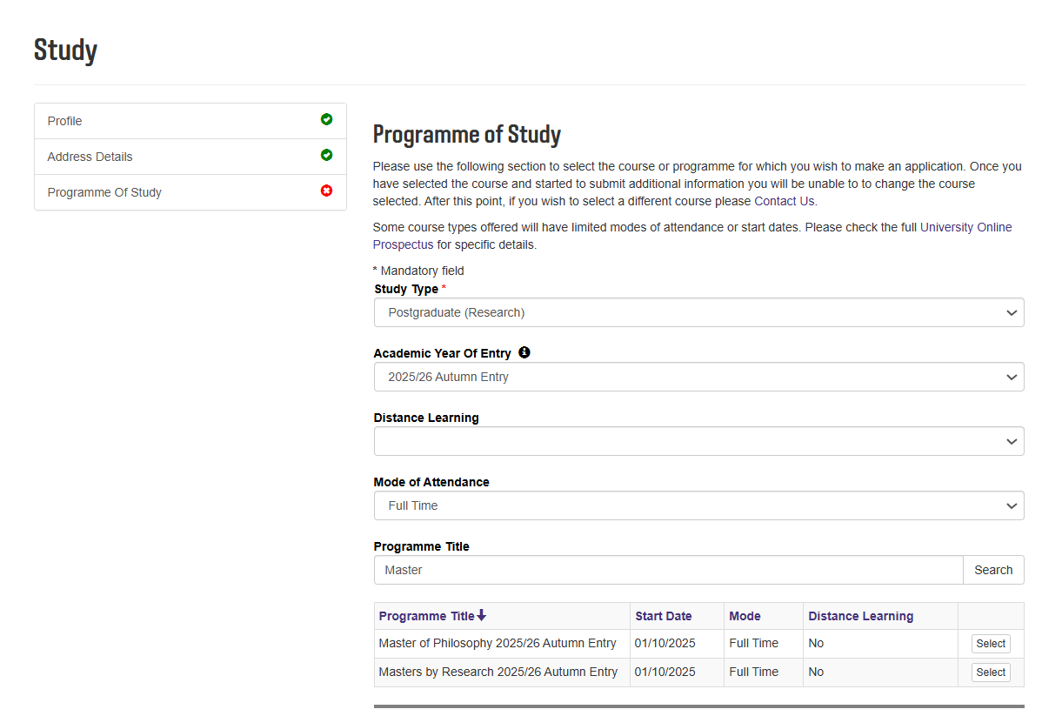

Programme of Study section – Postgraduate (Research) Part Time MRes course selection
To apply for a part time MRes, please follow the below guidance to make your selection in the ‘Programme of Study’ section of the Applicant Portal:
- Select ‘Part Time’ in the ‘Mode of Attendance’ section.
- Type ‘Master’ in the ‘Programme Title’ section and click ‘Search’.
- Press ‘Select’ next to ‘Masters by Research’ (term of entry of your choice) in the ‘Programme Title’ section.
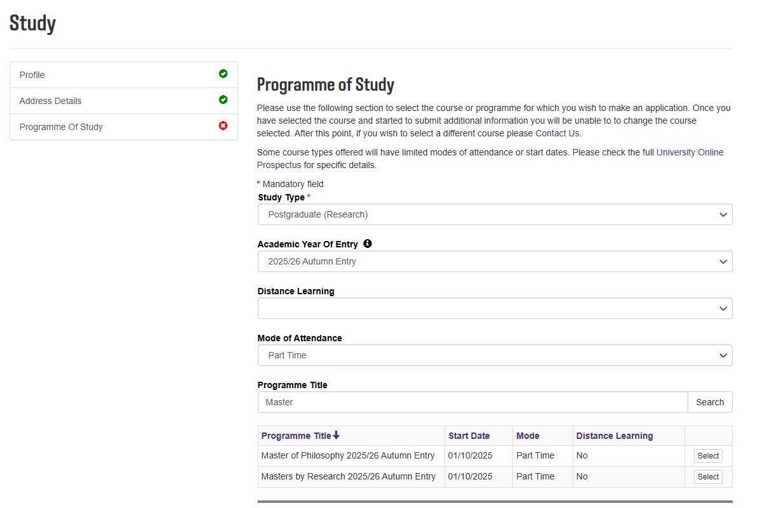

Programme of Study section – Postgraduate (Research) Full Time MPhil course selection

To apply for a full time MPhil, please follow the below guidance to make your selection in the ‘Programme of Study’ section of the Applicant Portal:
- Select ‘Full Time’ in the ‘Mode of Attendance’ section.
- Type ‘Master’ in the ‘Programme Title’ section and click ‘Search’.
- Press ‘Select’ next to ‘Master of Philosophy 2025/26’ (term of entry of your choice) in the ‘Programme Title’ section.

Programme of Study section – Postgraduate (Research) Part Time MPhil course selection
To apply for a part time MPhil, please follow the below guidance to make your selection in the ‘Programme of Study’ section of the Applicant Portal:
- Select ‘Part Time’ in the ‘Mode of Attendance’ section.
- Type ‘Master’ in the ‘Programme Title’ section and click ‘Search’.
- Press ‘Select’ next to ‘Master of Philosophy’ (term of entry of your choice) in the ‘Programme Title’ section.

Programme of Study section – Postgraduate (Research) Professional Doctorate course selection
Available part time Professional Doctorates (Page 1)
- Doctor of Professional Practice in Built Environment
- Doctor of Professional Practice in Construction Law
- Doctor of Professional Practice in Planning and Housing Studies
- Doctor of Professional Practice in Sport
To apply for one of the above Professional Doctorates, please follow the below guidance to make your selection in the ‘Programme of Study’ section of the Applicant Portal. Please note that these are only available to study part time.
- Select ‘Part Time’ in the ‘Mode of Attendance’ section.
- Type ‘Professional’ in the ‘Programme Title’ section and click ‘Search’.
- Once you have chosen the correct Programme Title, click on ‘Select’.
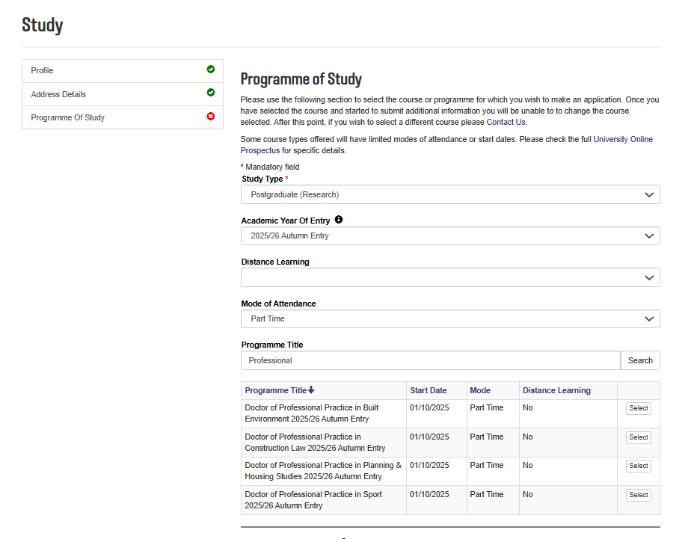

Available part time Professional Doctorates (Page 2)
- Doctor of Business Administration
- Doctor of Education (October intake only)
- Doctor of Engineering
To apply for one of the above Professional Doctorates, please follow the below guidance to make your selection in the ‘Programme of Study’ section of the Applicant Portal. Please note that these are only available to study part time.
- Select ‘Part Time’ in the ‘Mode of Attendance’ section.
- Type ‘Doctor’ in the ‘Programme Title’ and click on the ‘2’ in the bottom right corner, to display these programmes.
- Once you have chosen the correct Programme Title, click on ‘Select’.

