Mental Health in Schools Knowledge Exchange
Creating positive mental health and wellbeing in schools from the inside out

Carnegie Centre of Excellence for Mental Health in Schools is delighted to be bringing together leaders from education and mental health at our third annual conference. The Knowledge Exchange with theme of ‘Creating positive mental health and wellbeing in schools from the inside out’ will aim to inspire, empower and equip delegates to strengthen their understanding to support the mental health of the next generation.
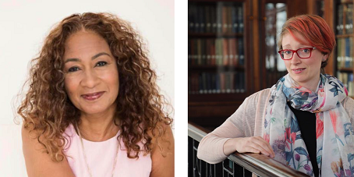
(Lefft Alison Kriel – Conference Chair | Right Pooky Knightsmith – Keynote Speaker)
Cost:
£120 for school mental health award schools and Mental Health and Wellbeing Lead Governors £150 for schools and £180 for non school settings. An early bird discount of £140 until the 25th March.
Our Knowledge Exchange will feature a series of round table discussions facilitated by experts within their field event and will be chaired by Alison Kriel, CEO of Amaya Trust and our keynote speaker will be Pooky Knightsmith, Mental Health Advisor, Author Speaker & Educator and School Mental Health Award Coach.
Why attend?
- Implement new approaches to mental health, leading to improved attendance, behaviour and attainment in students.
- Learn effective strategies to build resilience in students and staff.
- Learn from practical examples of student led peer support programmes.
- Learn more about the School Mental Health Award
- Implement new approaches to staff wellbeing
- Learn how Supervision can have an impact on the role of the School Mental Health Lead
Our round table discussions will feature:
- Support for staff – creating teacher wellbeing
- Support for pupils – creating a successful Peer Listening team
- The Resilience Ratio: Putting staff sustainability at the heart of a mentally healthy school
- Working with Parents and Carers
- ‘Thinking outside the Box’ – Working with external agencies
- The role the arts, particularly drama and creative writing play in the facilitation of children’s positive well-being
- Developing a Whole School Approach to Mental Health with the School Mental Health Award Competency Framework
- Taking a School-wide approach to student resilience
- Making transition between secondary school and next steps as smooth as possible for students mental health
- Use of Supervision in Education
- Double-whammy Kids: Responding to the behaviour of distressed pupils
- The benefits of having a Mental Health and Wellbeing Lead Governor
With facilitated conversations from Jonny Benjamin, Anita Cleare, Sam Collins, Liz Dawson, Sharon Goldstone, Georgia Holling, Felicity King, Lisa Lea Weston, Sue Miller, Annie O’Neill, Sue Roffey, Lisa Stephenson, Ruth Whiteside.
The conference will also feature a presentation of schools who have been accredited with the School Mental Health Award and a Panel Discussion with members of our advisory board and facilitators from the event.
Apply:
Please download and fill in the booking form and send to Tim Hurst at schoolmh@leedsbeckett.ac.uk.

