

The Practice Assessor Handbook
Specialist Community Practice Learners

Academic Year: 2024-25

CONTENTS

1. Introduction 3
2. Administrative and contact details 4
3. NMC Practice Supervision and Assessment - A Summary 5
4. Ongoing Development for Practice Assessors 7
4.1 Practice Assessor Conference days 7
4.2 Placement Tri-Partite Visits 8
5. Academic timetable 8
6. Specifics of the Specialist Community Practice Programmes 8
6.1 The Progression Point 11
6.2 Final Practice Report 11
7. Practice Support, Learning and Assessment 12
8. Procedure when students are identified as having difficulties in practice 13
9. Quality Assurance of the Learning Environment and the Practice Learning Team role 17
10. University Web Pages 17
11. Reference List and Resources 18

1. Introduction

The School of Health team would like to welcome you to your role as a Practice Assessor for our Specialist Community Practice learners, a role formally known as Practice Teacher. We hope you will enjoy your role. This handbook has been designed to inform you about the PGDip Specialist Community Public Health Nurse (SCPHN) and PGDip Community Specialist Practice (CSP) Programmes, to provide you with information about your role and the Leeds Beckett University’s policies and procedures that are relevant to Practice Assessing learners for these courses.

The awards can be undertaken as a full-time course over one academic year or as is the case in the District Nursing apprenticeship over two academic years. Successfully completing these course leads to one of the following awards (Please click on the course and the link will take you to the course handbook):
- PGDip Community Specialist Practice (District Nursing)
- PGDip Community Specialist Practice (District Nursing Apprenticeship)
- PGDip Community Specialist Public Health Nurse (School Nursing)
- PGDip Community Specialist Public Health Nurse (Health Visiting)

The awards have been developed and approved in partnership with the NMC, NHS England, local employers and our service users and carers. They are delivered by The Nursing and Healthcare Subject Group, an area of The School of Health at Leeds Beckett University. Central to your role as a Practice Assessor, you will also be supported by The School of Health Practice Learning Team who also deliver the Health and Social Care Practice Learning Hub where more information about our processes for practice assessment can be found.

The School of Health provides the knowledge, skills and behaviours training to make a difference to individuals and communities, from exploring the diagnosis or treatment of disease, to the provision of a range of therapies for recovery and rehabilitation to community based social care. Our Nursing & Healthcare Group are committed to providing a quality learning experience for all learners and we acknowledge that Practice Assessors, supported by Practice Supervisors and Academic Assessors, play a vital role in contributing to the quality of the educational experience and ensure that completing students are collaboratively assessed as fit for practice (NMC 2023). The team endeavour to provide the support and guidance required to enable you to carry out your role effectively.

Please note that throughout this document we will refer generically to Specialist Community Practice as this includes both SCPHN Health Visitor and School Nursing (NMC 2022) and SPQ District Nursing (NMC 2022) learners. We also use the term ‘learner’ as this is a generic term that can be applied to both students (on traditional fee-paying University courses) and apprentices (studying via an apprenticeship degree).

We acknowledge the Nursing and Midwifery Council (NMC) requirements for post registration education (NMC 2022) regarding the mandatory nature of Practice Assessment through the NMC Standards for Student Supervision and Assessment (NMC, 2023). We note that the term ‘Practice Teacher’ continues to be widely used in the practice setting, so provide some context as to why this role is no longer applicable.

The aim of this document is to provide you with specific course information and should be read in conjunction with the ‘Practice Partner Handbook’ and is not a replacement for this.

2. Administrative and contact details

Below are some contact details you may find helpful if you need to contact our team for support.

Dr Jackie Parkin  Jacqueline.Parkin@leedsbeckett.ac.uk | Head of Subject (Nursing and Healthcare)
Paul Mackreth  p.mackreth@leedsbeckett.ac.uk | Course Director-Post Registration. Programme Lead - District Nursing
Sinead Coleman  S.J.Coleman@leedsbeckett.ac.uk | Programme Lead- School Nursing
Gill Kelly  G.Kelly@leedsbeckett.ac.uk | Programme Lead - Health Visiting
Louise Parker  l.c.parker@leedsbeckett.ac.uk | Lecturer- District Nursing
Charlotte Benn  C.A.Benn@leedsbeckett.ac.uk | Degree Apprentice Course Administrator
Sarah Holstead  S.Holstead@leedsbeckett.ac.uk | Course Administrator
Digital Learning | digitallearning@leedsbeckett.ac.uk
Dr Christine Mantzouka  C.Mantzouka@leedsbeckett.ac.uk | Module Leader for ‘Understanding Social Research’
Lisa White  l.white@leedsbeckett.ac.uk | Programme Lead - Non-Medical Prescribing and Advanced Clinical Practice
Academic Librarians | SOHLibrary@leedsbeckett.ac.uk
nursingplacements@leedsbeckett.ac.uk | Placement Administrator - Nursing Programmes  Leeds Beckett Health & Social Care Practice Learning team
Degree Apprenticeship Assessors (Apprentices only) | Andrew Winterburn: Andrew.Winterburn@leedsbeckett.ac.uk  Leanne Warwick: L.Warwick@leedsbeckett.ac.uk

3. NMC Practice Supervision and Assessment - A Summary

Practice Learning Standards
Following a consultation during June - September 2017, the Nursing and Midwifery Council produced new standards that significantly impacted upon all aspects of practice learning, and the roles of nursing and midwifery mentors and practice teachers.

The standards were formally launched on 17 May 2018 (NMC, 2018), with implementation starting from 28 January 2019 onwards. Universities were required to have all programmes revalidated with the NMC against the new standards by September 2020. Implementation varied from university to university as NMC Covid emergency standards allowed for universities to transition to the new practice learning standards as part of an annual monitoring process, rather than at an approval event.

Standards for Post Registration
In 2018 the NMC published its Education Framework that led to the review evaluation of the NMC standards SCPHN (NMC 2004) and SPQ (NMC 2001). It was widely expressed that the standards needed updating. Therefore, new standards were published in 2022 for:
- Standards of proficiency for Specialist community public health nurses (SCPHN)’
- Standards for community nursing specialist practice qualifications (SPQ)

These Specialist Practice Community courses were approved by the NMC in 2023-24.

The 5 new NMC documents outlining the new standards are:

- NMC (2022) ‘Standards of proficiency for Specialist community pubis health nurses (SCPHN)’
- NMC (2022) Standards for community nursing specialist practice qualifications (SPQ)
- NMC (2022, updated in 2023) Standards for post-registration programmes
- NMC (2018, updated in 2023) Standards framework for nursing and midwifery education
n.b. This applies to all NMC programmes including specialist community practitioner and specialist community public health nursing
- NMC (2018 updated in 2023) Standards for student supervision and practice
(of most significance for those who supervise and assess students in practice)

This being a NMC programme for change, we must acknowledge these changes in role and in terminology. In summary there is removal of:
- Roles of mentor, practice teacher and sign off mentors
- 40% mentor - student working
- Mentor register
- NMC approved mentor preparation programmes
- Annual updates and triennial review
- Educational audit - however, there is still a requirement for placement providers and universities to have an infrastructure in place to support quality of placement learning therefore we keep many of the elements that work well currently. The NMC will monitor this as part of their quality assurance processes.

Introduction of Roles:

Practice Assessor (PA) must be assigned for each practice placement or series of practice placements. They must be a registered nurse or midwife and they: “..conduct assessments to confirm student achievement of proficiencies and programme outcomes for practice learning ….work in partnership with practice assessor to evaluate and recommend student for progressions. Periodically observe student across environments…coordinate feedback from practice supervisors… must not simultaneously be the practice supervisor and academic assessor for the same student.”

They are required to undergo “preparation or training”. Specific training is not mandated but “must demonstrate the following minimum outcomes:
- interpersonal communication skills, relevant to student learning and assessment
- conducting objective, evidence-based assessments of students
- providing constructive feedback to facilitate professional development in others,
- knowledge of the assessment process and their role within it
Plus:
- Receive ongoing support and training to reflect and develop in their role
- continue to proactively develop their professional practice and knowledge in order to fulfil their role
- have an understanding of the proficiencies and programme outcomes that the student they assess is aiming to achieve”

Practice Supervisors (PS) Learners are required to be supervised on a day-by-day basis in practice - “All NMC registered nurses and midwives are capable of supervising students, serving as role models… students may be supervised by other registered health and social care professionals… in line with their competence.” The PS must “contribute to the student’s record of achievement…”and “..to students assessments to inform decisions for progression” and “..engage with practice assessors and academic assessors to share relevant observations ..on the students they are supervising.” The PS can be anyone on a professional register e.g., doctor, Allied Health Professional, Registered, Nursing Associate. The learner may have one PS or a team supporting them on a placement.

Academic Assessor (AA) Students must have a “.. different nominated Academic Assessor for each part of the education programme” who “…….collate and confirm student achievement…….work in partnership with nominated practice assessor to ..make recommendations for progression… communicate with PAs at scheduled points in programme.” Will usually be a university lecturer/ personal tutor and there will be a need for real or virtual tripartite meetings or communication at the progression points i.e., end of year 1, year 2.

The Academic and Practice Assessor must be a Registered Nurse (RN) for nursing students or Registered Midwife (RM) for midwives. They do not have to be from the same field of practice if they have “.. suitable equivalent experience.” For SCPHN programmes, the PS, PA and AA must be a registered SCPHN and for all post-registration nursing programmes have “.. appropriate experience for programmes outcomes.” It is therefore our interpretation, that for each of our post-registration community specialist programmes the PS, PA and AA will have the equivalent field specific qualification. Fulfilling this expectation will assure quality and parity of supervision and assessment. This is monitored via the Practice Learning team and will be reviewed together with Practice Learning Partners on an annual basis. See the NMC website for more detailed information https://www.nmc.org.uk/education/

Other University Roles and Titles

It is important to note that the roles and titles outlined above are NMC expectations. There are several other University roles and titles that are used. We outline these below as they are important for learners to understand and utilise. You may find it helpful so that you can signpost and use in your Practice Assessor role.

Academic Advisor : This is different to that role of the Academic Assessor (although it may be the same person) as the advisor offers support to a learner to support them through their programme of study.

Service User and Carer : As part of learner recruitment, teaching, learning and assessment, we draw upon the lived experience of people who use our specialist nursing services. Learners will initially meet our service user and carer representative at their recruitment interview and then be exposed to lived experience periodically throughout their programme of study.

Degree Apprentice Assessor (DAA): For learners who are on our apprenticeship modes of study the tripartite relationship is formed with our team of DAAs. A DAA is not an Academic Assessor, but does feedback to the Academic Assessor formally and on a monthly basis each apprentice progress. A DAA will support the apprentice and the tripartite relationship and assist the Academic Assessor in ‘RAG’ rating progress to ensure all support measures that are required are put in place.

4. Ongoing Development for Practice Assessors

We fulfil our obligation to support your role through the tripartite relationship that comprises of the learner (student), Practice Assessor and Academic Assessor (or nominee). This relationship may also include the Practice Supervisor and ‘Nominated Person’.

To support this process, we produce this document together with:
- The Practice Partner Handbook, A Health and Social Care Practice Learning Hub and a Nursing Placements Practice Learning resource web page

If you are new to your role, or a Practice Supervisor who is being supported into a role, you will most probably be undertaking ‘suitable preparation’ via the E-Learning for Health Practice Educator and Assessor Preparation on-line programme: https://www.e-lfh.org.uk/programmes/practice-educator-and-assessor-preparation-peap/

In addition, many of our Practice Learning Partners have their own support networks, these are detailed and offered as an example in Appendix 1 of this document.

We are committed to inviting each Practice Assessor to attend the learners’ first afternoon at university in induction week. During this afternoon you will have the opportunity to meet your learner and allow us to build a tripartite relationship through a workshop that reviews the course structure, its requirements, practice learning expectations and some of our policy and procedures. If you cannot attend, this will be shared via email so that you have all the information to hand for your role. You can then bring questions and issues to the PA Assessor Conference days.

4.1 Practice Assessor Conference days
In accordance with the NMC (2018, updated in 2023) standards, programmes are required to provide update sessions to ensure that you are aware of the programme aim, objectives and course detail. These are currently provided by the Nursing and Healthcare Subject Group and run twice yearly with the purpose of ensuring that Practice Assessors are provided with the opportunity to continually update their knowledge of the Specialist Community Practice programmes and further develop your Assessment skills. We recommend that all Practice Assessors attend at least one conference day a year.

For the academic year 2024/25 the conferences will take place as follows:
- November 2024
- March 2025

You will be invited to attend the conference but, if you have not received information a month prior to the above dates, please contact our Practice Learning team at: Educator Courses educatorcourses@leedsbeckett.ac.uk

Details of the conferences can also be found on our web pages at: https://www.leedsbeckett.ac.uk/studenthub/placement-information/health-and-social-care-practice-learning-team/nursing/

4.2 Placement Tri-Partite Visits
Each Specialist Community Practice learner is provided with on-going academic support during the academic year. The Programme Leader, acting as an Academic Assessor (or nominee) will visit the Practice Assessor and Specialist Community Nursing learner within the practice area at least once during their course of study and more often if a need arises. The reason for these visits is to monitor the progress of the placement and offer advice on issues related to the practice learning portfolio. It also reaffirms the tripartite relationship and the expectation (NMC, 2023) that practice assessment is a collaborative process.

Apprentices have more frequent tri-partite visits (12 weekly) undertaken by the Degree Apprentice Assessor who also monitors apprentice compliance and the development of the Knowledge Skills and Behaviours.

5. Academic timetable

To ensure all learners, assessors and supervisors have a clear plan of learning and learning pathway, the course handbooks contain year planners which detail where each learner will be each week and mark the key milestones to meet on their journey.

6. Specifics of the Specialist Community Practice Programmes

The NMC (2022) ‘Standards of proficiency for Specialist community pubis health nurses (SCPHN)’ and NMC (2022) Standards for community nursing specialist practice qualifications (SPQ) are the guiding standards for our learners for assessment in a practice setting. To facilitate and achieve this we have developed a PebblePad e-Portfolio workbook. As a Practice Assessor you will have access to your learner’s workbook and have the opportunity to providence feedback, comments and assessment on your learner’s progress. This will be the focus of the tri-partite meetings as it offers an objective tool to measure progress. The workbook offers ‘initial tasks’ to get learners started in their experiential learning journey through all three domains of learning; knowledge, skills and behaviours. All learners will have tasks to undertake as directed by this workbook and through classroom learning where they are asked to bring tasks into the practice setting either for action or discussion.

Therefore, specific details of the Specialist Practice Outcomes specific to each award are communicated through key documents and taught sessions that the learner will have access to and should be encouraged to read and share; these include:
- Course handbooks
- Module handbooks
- E-Portfolio workbook
- Tripartite arrangements

In addition, Programme Leaders, tutors and wider University support services can be contacted with queries as required. Please see the contact details within section 2 of this document.

We would however specifically like to draw your attention to your role in facilitating the development of the student’s progression through the reflective process which is an essential element in the planning, undertaking, evidencing and assessment of experiential learning.

Experiential Learning through the use of the E-portfolio workbook
Learners undertaking Specialist Practice programmes are required to self-assess, plan and monitor their development needs and own learning through the use of the workbook. Your role as a Practice Assessor is to support your student through this process in the practice setting. The learners enter evidence into their PebblePad e-Portfolio workbook (see image of the workbook below)

Learners share their workbook with you, their Practice Assessor, for feedback, comments and assessment. The workbook in PebblePad, is used to collect the evidence and record assessment against the NMC Standards for Practice, relevant to their programme. The Specialist Community Nursing learner must ensure they complete the portfolio by rating themselves as practising at level 5 on all their NMC standards for practice. The completed e-Portfolio demonstrates the process and achievement of all the standards and will be examined by Academic Assessors and external examiners to ensure that relevant activities have been undertaken to evidence achievement.

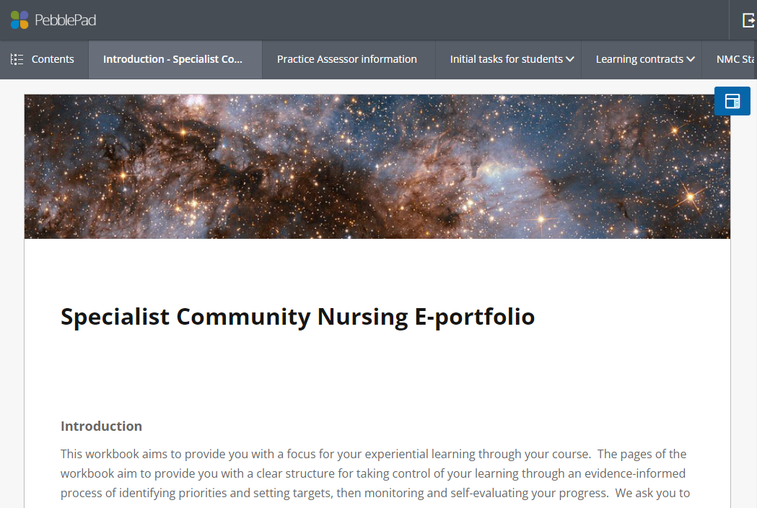

The workbook also provides learners with spaces to complete their learning contracts along with a series of reflective tasks aiming to support their progression. These can be accessed using the tabs at the top of the workbook or by clicking on the ‘contents’ button top-left (see image below).

This will reveal the menu top-left (see below)

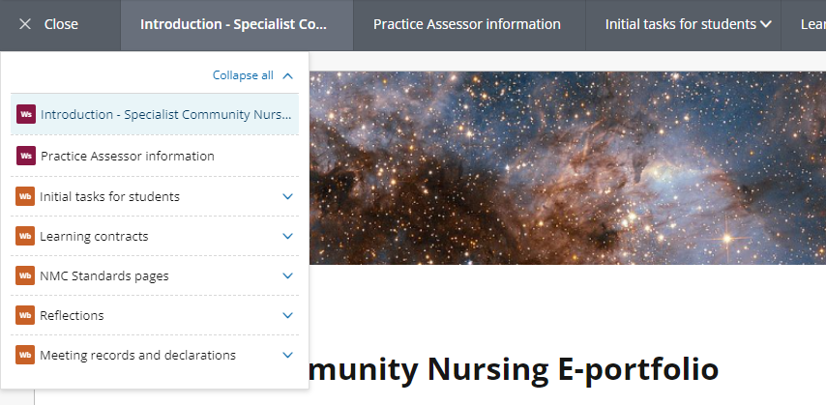

The first tasks for completion are the ‘Practice Assessor information’ and the ‘Initial tasks for learners’.The practice assessor information asks you to confirm your details and the initial tasks for student pages include sections for you to add comments and feedback on your student’s work.

On each page of the workbook, you will see ‘assessor fields’ that allow you to add comments and feedback (see image below).



There is usually at least one assessor field for each page, and you can add to and edit assessor fields as often as you like. Each time you do this, a record will be saved in the field’s ‘history’ showing additions over time. This allows you to comment on your student’s work in development at different times within the same field.

Accessing PebblePad
You will be provided with an ‘assessor’ PebblePad account to enable you to access your student’s e-portfolio. Please note that this is not the same as your student account, if you have one, which you use to complete your own e-portfolio work. Rather, this is an ‘external’ account which provides you with access to student work and allows you to log in to view and comment on your student’s portfolio. The username for your practice assessors account will be your email address as held by the Practice Learning team on the list of approved practice assessors. This will be in addition to and separate to any other PebblePad account that you have.

The process for accessing your student’s e-portfolio workbook is as follows (this can only occur after the Practice Learning team have your contact information):

- You are set up as an external user in PebblePad (Username = email address).
- This triggers an automated email from ‘PebblePad’ from the email address ‘noreply@PebblePad.co.uk’. The email contains your access details.
- Your student shares their workbook with you by searching for you in PebblePad using your email address.
- This triggers an automated email from PebblePad (noreply@PebblePad.co.uk) with the subject line ‘Asset share (With external assessor permissions)’. This tells you that you have been given access to the workbook and includes a link.
- You can change your password from the log-in page and also reset your password by clicking on the links on the log-in page and adding your username. This will trigger an automated email from PebblePad.
- You can log on to view all the assets that have been shared with you at www.PebblePad.co.uk/leedsbeckett.

In order to access your practice assessor account, you will need to be on the practice assessor list and be able to receive emails from PebblePad (you may need to check junk folders if these do not arrive in your inbox). If you have not received the emails you need as above, please contact the Practice Learning team at nursingplacements@leedsbeckett.ac.uk.

By logging on using your practice assessor account, you will be able to access your students’ e-portfolio workbooks at any time.

For further information about PebblePad and your students’ workbook, please see the relevant sections of the resource website at http://www.leedsbeckett.ac.uk/studenthub/placement-information/health-and-social-care-practice-learning-team/nursing/

6.1 The Progression Point
It is important to draw your attention to the assessment that relates to ‘Mid-Point progression’. If you feel that the learner does not meet these criteria, then you must discuss this with the Course Leader and review the ‘Identifying students with difficulties’ section of this handbook.

This assessment stage has been introduced to confirm/assess progress at the midpoint of the students’ course and represents a point at which you, as the Practice Assessor can reflect with the student on progression and confirm that this is appropriate as detailed below.

The learners e-portfolio workbook contains a section entitled ‘Meeting records and declarations’ which allows you to record your confirmation of progress decisions and the related discussions. There is a page for each of the key meeting records: ‘Preliminary’, ‘mid-point’ and ‘final’. The progression records can be found within the ‘mid-point’ meeting record page. There are also further action planning records on this page which should be used where a student is identified as not meeting expected requirements at the progression point.

6.2 Final Practice Report
The Final Practice Report that is agreed and signed by the Practice Assessor and learners and the Self-Declaration of Good Health & Good Character signed by the student and the Practice Teacher must be carried out on completion of consolidation. These must be completed in order for the exam board to confirm completion of the practice element of the course (see the course calendar above).

Finally, the Specialist Community Nursing student is expected to evaluate their placement using the student evaluation tool available online at http://www.healthcareplacements.co.uk. This must be undertaken on completion of consolidation.

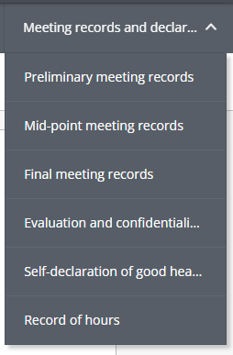
Meeting records and declarations section of a student workbook

7. Practice Support, Learning and Assessment

The Practice Assessor is responsible for assessing practice against the specialist community practice standards, whilst the Practice Supervisor is responsible for facilitating day to day placement learning. At regular times throughout the course, you and your learner will formatively assess and develop the learning contracts within the developing practice e-portfolio, which should be documented in a timely manner in the e-portfolio feedback boxes. Prior to the final deadline, the Practice Assessor is responsible for assessing both the learning contracts and submitted evidence of achievement to demonstrate that the student has met the required NMC specialist programme practice standards. At this stage, the Practice Assessor reviews the learning contracts and, if agreed, signs them as completed signifying Fitness for Practice.

The Practice Learning portfolio is also assessed by the Academic Assessor who will mark the portfolio using the academic assessment criteria contained in the learner’s module handbook.

It is recognised that some learners may experience difficulties in meeting the required practice standards. It is the role of the learner, the Practice Assessor and the Programme Leader to recognise and identify where individuals are struggling to meet the required standards in their practice placement. When identified during the process of ongoing assessment and support the following information describes the process through which the Practice Assessor and the learner would be guided.

7a. Exceptional Circumstances

In their updated Standards, the NMC state “……..that in exceptional circumstances only, the same person may fulfil the role of practice supervisor and practice assessor for a part of the programme where the SCPHN/community nursing SPQ student is undergoing education and training in a practice learning setting.”.

The standards further indicate that “….In such instances, the student, practice supervisor/assessor and the AEI will need to evidence why it was necessary for the practice supervisor and practice assessor roles to be carried out by the same person”.

The course team will work with you and your employer to prevent this from occurring and, as with Prescribing learners where the NMC allow for this exception, it is anticipated this will only occur with smaller employers where there is only one choice to have the same person fulfil both roles.

The process for managing this exception will be via a tripartite meeting and risks identified and managed through the ‘Practice Assessor’ page in the e-portfolio workbook.

8. Procedure when students are identified as having difficulties in practice

Procedure when learners are identified as having difficulties in practice (diagrammatic representation of process at end of document)
We recognise that learning in practice offers all learners and practice placements some challenges. Whilst there are often no issues that need action planning, all learners need the space and time to develop their practice and that sometimes this may not be on the most direct path. We therefore offer the information below as a guide for learners and their practice placements.
Anticipated settling in process
Learners are often new to an area of practice; therefore, it is expected that they will take some time to settle into the new sphere of practice and spend the first few periods of practice observing the norms of teamwork, reflecting upon their observations and gradually starting to participate in practice activities before being allowed to undertake practice unsupervised. During this period of time the Practice Assessor (PA) or Practice Supervisor (PS) (where appropriate) works with learners to ascertain learning needs and to formatively assess the learner’s knowledge, skills and attitude in meeting learning outcomes.
Identification of learner difficulties
If learners are experiencing difficulties in practice these typically become evident to the practice placement quite early, i.e. between the first and second placement meetings. It is crucial that if the PAs, in collaboration with PSs, objectively identity difficulties and address these with the learner, the Academic Assessor (AA) and, where relevant, the sponsor/placement provider. It is more likely that difficulties can be resolved if they are identified in the early stages of the programme. Some helpful strategies to aid learners to resolve issues are; constructive feedback to identify learning needs and to action plan these through written learning contracts/ action plans, reflection upon practice with the PSs and highlighting strengths to overcome weaknesses (building learner self-esteem).
Detailed and specific identification of student difficulties in practice placements
It is important that the PA or PS who identifies a learner who is experiencing difficulties articulates these as specifically and objectively as possible. It is expected that this can be done through the use the learner’s NMC programme standards, competencies or capabilities. Typically, reasons for difficulties are:
- The learners progress is slower than expected/required to meet the learning outcomes and develop practice competencies within the timescale, i.e. the learner has a lot of learning needs and is making progress, but very slowly.
- The learner’s attitude is causing a significant barrier to their learning
- Communication skills are causing the learner difficulties in making progress
- The learner does not appear to be forming relationships within the learning environment that could support their development
- The learner is faced with significant external problems that are acting as a barrier to the student’s progress in practice
If one or more of the above are beginning to emerge, the PA is required to identify and record if the learner’s progress is becoming problematic and the strategies they are taking to address this are not working. The PA needs to identify whether, based on the learner’s current rate of development/progress, they are at risk of not successfully meeting the required level of competence at the end of the placement. If the learner is employed or sponsored by an organisation, they must also be informed of the practice assessor’s concerns at an appropriate stage using the agreed process.
Initial tripartite process to resolve difficulties
PAs must have discussions regarding these progress related issues with the learner and have developed an action plan to ensure that the learner has every opportunity to learn, grow and address the assessor’s concerns. However, if the PA identifies the learner as at risk of not successfully completing the practice placement the process must be documented and communicated to:
- The learner, explicitly and in writing, for example, using the interim meeting schedule
- The AA who will inform the learner that the University team has been contacted regarding these concerns so that a tripartite meeting to support the learner’s progress can take place
n.b. PAs may feel the need to seek advice from the AA regarding their level of concern.
Where the learner is sponsored and/or there is a placement provider who is not the practice assessor’s employer the relevant Education Lead (e.g. Nominated Person) will be informed by the AA that a concern has been raised, a meeting has taken place and a copy of the meeting notes will be provided (if appropriate). The action plan/meeting notes should include this as an automatic course of action. A decision should be made whether the Education Lead/Manager is then included in all or part of the review meeting that will take place.
Review of the tripartite process
At the review meeting the agreed actions will be reviewed to ascertain whether they have been met. If the learner’s needs are now being met at a satisfactory rate a second review meeting or telephone contact between PA and AA should take place a month later to ensure satisfactory progress is continuing and the Education lead/manager informed of the outcome.
Learner identified as at significant risk of failing the practice placement
If the learner continues to cause significant concern the following should be considered:
- If the agreed action has taken place but not resulted in the learner starting to make satisfactory progress the learner is now likely to be at risk of failing the practice element. If this is the case this must be identified formally.
- If the agreed action did not take place as a direct consequence of the learner’s difficulties in practice the learner is likely to be at risk of failing the practice element. If this is the case this must be identified formally.
- If the agreed action did not take place due to lack of placement opportunity a decision needs to be taken whether the placement can realistically provide these opportunities in the immediate future.
Having completed this rigorous and objective process, if the learner is still identified by the PA, placement provider and the AA as being likely to fail the practice element, then they will be advised of this and a tripartite discussion will consider the following options:
- If the option of a ‘contained award’ could be considered by the Examination Board to give credit to the work done to date
- Options of transferring any module credits to another course
- Permanent withdrawal from the course
- Continuing with the placement (providing there are no issues of public safety) in the expectation of failing
If the learner successfully appeals against this process, the University will with work with an employer/sponsor to seek a suitable alternative placement within the original employing/sponsoring organisation or in another appropriate organisation. However, the University has no power to provide placements and therefore, if attempts to find another placement are unsuccessful this will necessitate the termination of the programme. If attempts are successful the new PA must be experienced, they will be informed that the student’s first placement was discontinued, and the module was deemed to have been failed. The specific learning needs that resulted in the cause for concern within the first placement will be summarised and provided to the new practice assessor and form the basis of the new placements learning agreement.
(diagrammatic representation of process on next page)

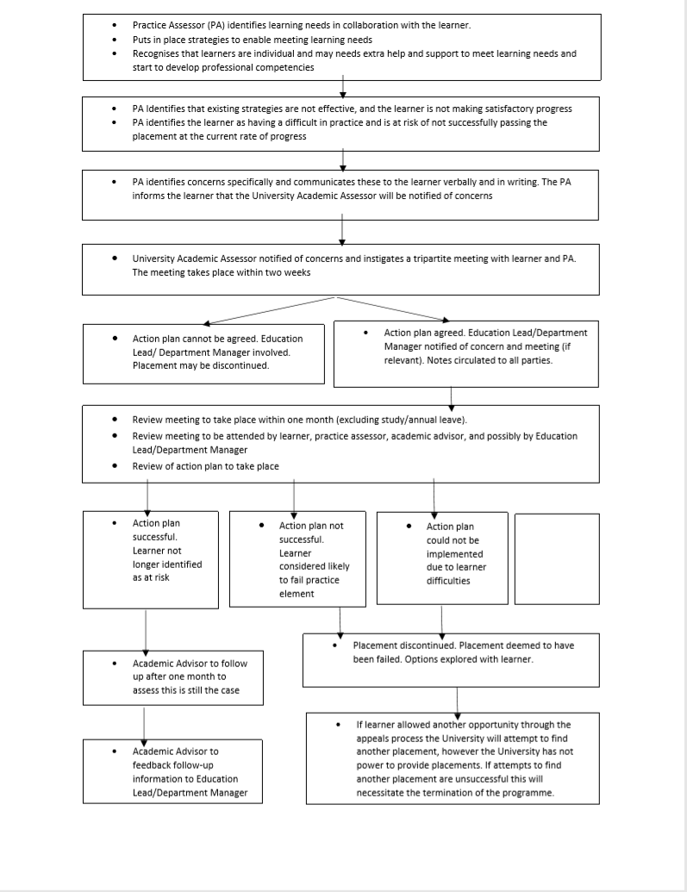

9. Quality Assurance of the Learning Environment and the Practice Learning Team role

It is a requirement of the NMC to quality assure placement areas. The Director of Health Partnerships and Practice Learning and the Practice Learning Team (PLT) manage professional placements and work-based learning for health and social care courses within the School of Health and School of Humanities and Social Sciences.

We provide clear and effective processes to support practice learning and to manage the quality of the student and apprentice placement experience. We source and allocate up to 5500 placements annually in the NHS, local authorities, and private, independent, and voluntary organisations.
What we do:
- Provide support and guidance for our academic groups who are developing placement partnerships with new and emerging employers
- Provide training across all professions for practice assessors to enable them to provide effective support for our students in practice
- Manage stakeholder events and practice networks for each professional group
- Support our students in sourcing and applying for placement and work-based learning opportunities
- Provides clear processes for students and practice colleagues to raise and escalate concerns and access Freedom to Speak Up Guardians
- Manage access to online assessment processes and resources for students on placement, and for our practice assessors
- Manage data and knowledge transfers to NHS England (NHSE)and other local universities to facilitate capacity initiatives and allocation processes across health professions

https://www.leedsbeckett.ac.uk/health-practice-learning-hub/ These pages provide helpful resources, guidance and contact information relating to placement and quality processes. Working in partnerships with local HEIs, NHSE NEY and Care Commissioning Groups (CCGs), public health, social care and private, voluntary and independent organisations the PLT seeks to foster best practice in placement learning. The team works closely with course teams, the Business Engagement team, the Student Union and the International Office to enhance the employability skills of our students and to signpost learners to career advice, employer engagement opportunities and job seeking workshops to maximise graduate outcomes.

10. University Web Pages

During their studies at Leeds Beckett learners are supported by an online Virtual Learning Environment called MyBeckett. MyBeckett gives access to module information, library services and other resources. Learners are encouraged to share information from MyBeckett with their Practice Assessors and Supervisors, this may include:
- Course Handbooks
- MyBeckett modules
- PebblePad
- MyHub (where learners can fill in on-line forms, such as Mitigation or Extension)

As a Practice Assessor you may want to review the webpages to support your role the:
- The School of Health Practice Learning Team who deliver the Health and Social Care Practice Learning Hub

11. Reference List and Resources

NMC (2022) Standards of Proficiency for Specialist Community Public Health Nurses (SCPHN)

NMC (2022) Standards of Proficiency for Community Nursing Specialist Practice qualifications (SPQ)

NMC (2023) Standards for post-registration programmes

NMC (2023) Standards Framework for nursing and midwifery education

NMC (2023) Standards for student supervision and practice

Further Reading

Knowles, M. S., Holton, E. and Swanson, R. (2006) The adult learner: the definitive classic in adult education and human resource development (6th ed,). London, Elsevier

Lidster J, Wakefield S, (2022) Student practice supervision and assessment: a guide for NMC nurses and midwives (2nd ed.). London, Learning Matters.

Moon, J.A. (2000) Reflection in Learning & Professional Development. London, Routledge Falmer.

Quinn, F.M. and Hughes, S.J. (2013) Quinn’s Principles and Practice of Nurse Education (6th ed.). Cheltenham. Nelson Thornes.

Smith, A., McAskill, H. and Jack, K. (2008) Developing Advanced Skills in Practice Teaching. London, Palgrave Macmillan.

Web Sites
Centre for the Advancement of Inter-Professional Education www.caipe.org.uk

Nursing and Midwifery Council www.nmc-uk.org

Practice Based Learning http://www.practicebasedlearning.org

Practice Placement Website http://www.practiceplacements.leeds.ac.uk

Department of Health www.dh.gov.uk

Leadership Academy www.leadershipacademy.nhs.uk

