
Guide for Students for Accessing and Understanding your Timetable
Timetables can be accessed using the VLE MyBeckett or the Leeds Beckett app.

VLE MyBeckett
- Go to my.leedsbeckett.ac.uk/
To login, enter your University username and password.
- Select the 'Course' tab and select ‘Your Timetable’. Your individual timetable for the current week will be displayed.
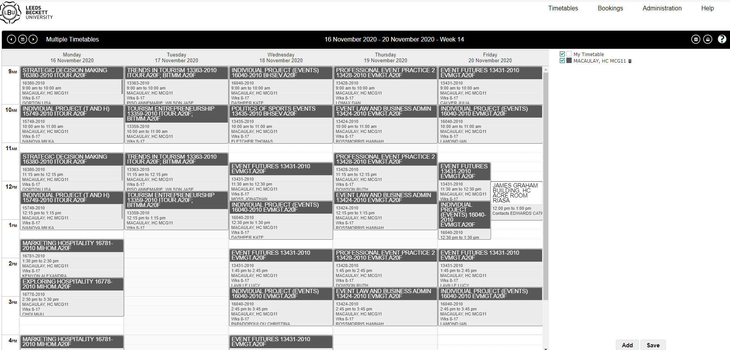

- Double clicking on the event will provide additional information plus a campus map.

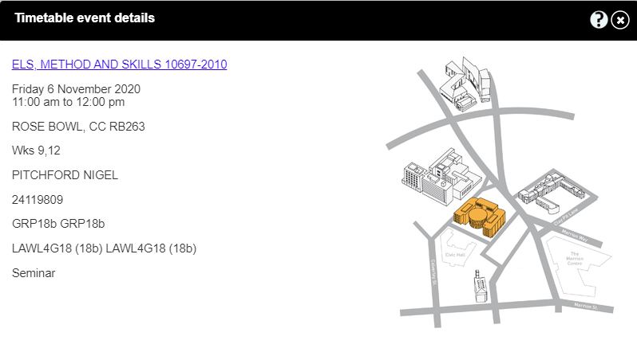
- The time periods available to view are Day, Week or Month. Change the view by selecting ‘Timetables’ (top right).
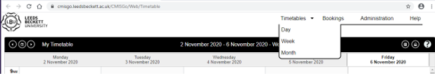

- To select a date, click on the calendar icon (top left).
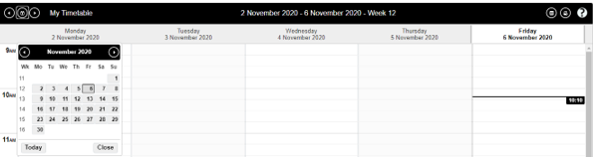
Help function
- Select the question mark symbol to access this function and select to view the Help function in a new browser.
- Provides online support in all areas of CMISGo
Teaching session information
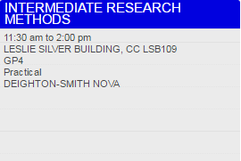
Type of teaching session
Group
(if applicable)
Module
Lecturer/s
Room
Time
Room Code
The room code states the campus, building, then room number, and begins with either HC or CC. HC = Headingley Campus; CC = City Campus.
After the campus and building codes, the room number is indicated. First character of room number indicates the level e.g. G is ground floor & 1 is first floor.
For example:
Room name Campus Building Room number
CC LSB107 = CC (City Campus) LSB (Leslie Silver Building) 107 (1st floor)
HC CAEG03 = HC (Headingley Campus) CAE (Caedmon) G03 (ground floor)
Leeds Beckett App
Leeds Beckett App can be downloaded for free from your app store.
Click on My Timetable and it will display this week’s timetable. The arrows at the top can be used to toggle between weeks or the “settings” button at the bottom right can be used to display specific dates.
As with CMISGo, if you double click on the teaching session additional information is displayed such as teaching group.and type of teaching session.
Move Weeks/Days

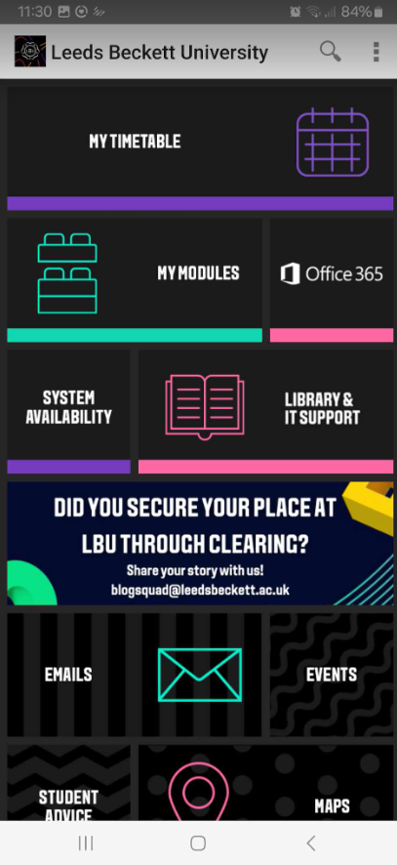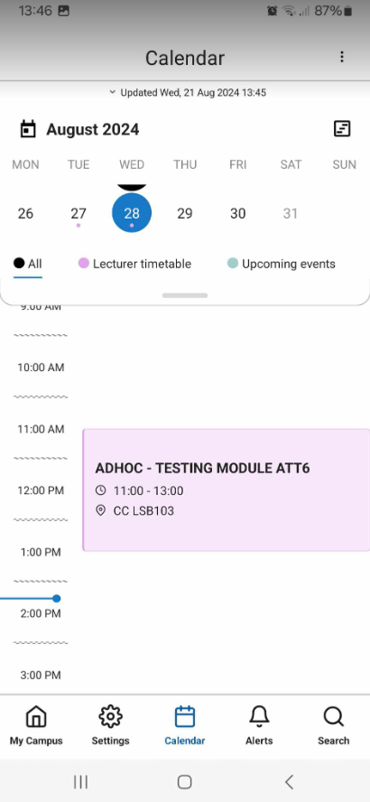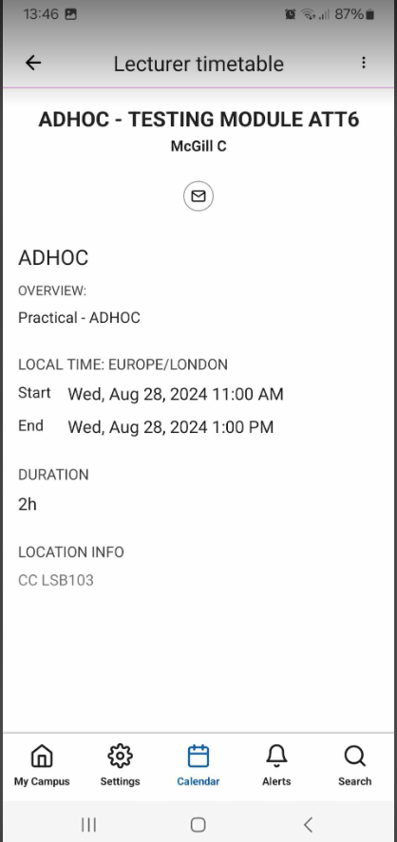
Lecturer
Module

Please note the App must be refreshed every time it is used. How long since it has been refreshed can be checked here
Campus Maps
You can access and download our campus maps PDF at
See https://www.leedsbeckett.ac.uk/our-university/contact-and-find-us/
Term dates
See www.leedsbeckett.ac.uk/our-university/term-dates/ for term dates.

