Form B- General Risk Assessment
Guidance for Risk Assessment Completion.
The Form B as attached below is to be completed for all university related activities undertaken, and will help you to record your findings.
For further information on how to carry out risk assessments and to complete the Form B please see the FAQ on the university SHW A-Z.
Information can also be accessed via the HSE website, under risk assessment.
Step 1- Think about the activity and decide what the significant hazards are, using the table below as a guide
Step2- When you have identified the hazards think about what you are doing to control those hazards-supplementary assessment templates are available on the SHW A-Z.
Step 3- What is the risk of injury or harm from your identified hazard, you can set this as High/Medium or Low based upon the matrix below

Step 4- Can anything else be done to lower the remaining risk and any consequence of any injury

Step 5- Set a timescale to put actions in place to control the hazard or remove it completely, and record in the Form B.

**Review the assessment during/post activity as appropriate to record changes or learning points

Some hazard examples that may apply to the activity (list not exhaustive)
Working at height | Noise | Lighting (including strobe lighting) | Fire and explosion
Falling objects | Vibration | Compressed air | Hazardous chemicals
Slippery, uneven or worn floors | Hand tools | Magnetic fields | Biological risks / disease
Obstructions and projections | Repetitive hand / arm movement | Pressure systems | Animals
Confined spaces | Machine operation | Needles and sharps | Compressed Air
Mechanical Lifting | Manual Handling | Lasers | Hydraulic systems
Poor housekeeping | Vehicle movements | Ionising and non-ionising radiation | Other (please specify on assessment)

Risk Evaluation Matrix
For activities that have a higher degree of risk it is useful to identify whether risk is High - Medium - Low by undertaking a simple calculation:
Consequence | C
1.NONE-No injury
2. MINOR- Short term/resolved in less than 1 month
3. MODERATE- Non permanent injury- up to 1 year
4. MAJOR- Permanent harm-RIDDOR reportable
5. CATASTROPHIC-Death

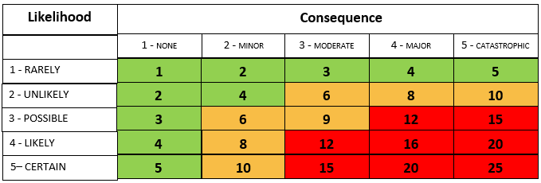
(L) LIKELIHOOD of harm occurring X (C) CONSEQUENCE or severity of harm or injury
Likelihood | L
1. RARELY-Won’t be likely to re-occur
2. UNLIKELY-Not expected to re occur but possible
3. POSSIBLE-Occasionally may occur
4.LIKELY-Will probably re occur but not persistently
5. CERTAIN-Likely to occur persistently

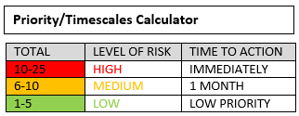

Carnegie School of Sport Teaching & Research Laboratories – Risk Assessment
Procedure/Protocol/Specialised Equipment/Laboratory/Activity: Supplement Procedure Including Preparation and Administration of Supplements
Author of Assessment: A Heywood Role: LSO Signed: A Heywood
Date Completed: 15/09/2020
Review Date:14/09/2021
Approved By: Role: Signed:

Brief Description:
A risk assessment for student supplement procedure inclusive of preparation and administration of supplements.

What are the hazards? | Who might be harmed and how? | Risk Level  H/M/L | What do you need to do to manage the risk? | Residual Risk  H/M/L
Health Risk- Excessive Supplement Ingestion | Participants are at risk of experiencing side effects of supplements if ingested in excess. | L3 x C4 = R12 = H | - Laboratory users must attend Supplement Procedure training and be signed off as competent.  - Laboratory users should complete a supplement calculation sheet as per the Supplement Procedure. Quantities should be agreed by academic staff and adhere to recommendations within the academic literature.  - Appropriately accurate scales should always be used to weight supplements.  - Laboratory users should be supervised by a member of the learning support team at all times whilst making up high risk supplements such as caffeine. Learning support officers will supervise students until deemed competent to weigh low risk supplements. Students should provide their supplement calculation sheet.  - Participants must not be provided with more than one dose of caffeine supplementation or consumption away from the laboratory i.e. the participant must collect separate doses at the relevant time for any studies involving caffeine supplementation on multiple occasions. | L1 x C4 = R4 = L
Health Risk - Contamination | Participants are at risk of consuming cross-contaminated supplements. | L3 x C2 = R6 = M | - Supplements must be prepared in the Nutrition Education Kitchen (CSS 125). Supplements must not be prepared on cooking benches, only use the large table at the front of the room.  - Laboratory users should clean and disinfect the preparation area using hot soapy water and byotrol before and after supplement preparation.  - Laboratory users should wash hands before and after supplement preparation.  - Laboratory users should wear appropriate PPE (Gloves & Lab Coat)  - Hair should be tied back  - Jewellery and nail varnish should not be worn during the process.  - All equipment must be clearly labelled and not stored in biohazard areas.  - Laboratory users should be supervised by a member of the learning support team whilst making up supplements. | L1 x C2 = R2 = L
Health Risk- Contamination from Manufacturer | Participants are at risk of consuming contaminated supplements from manufacturing. | L3 x C2 = R6 = M | - Laboratory users should adhere to Supplement Procedure.  - The participant information sheet must state the nature of the supplement production. This should be if the product is batch tested or Non batch tested.  - Participants will have to sign an informed consent form to ensure they confirm they are aware of the associated risks with supplementation. All athletes should adhere to ‘Strict liability’ as defined by UK anti doping | L1 x C2 = R2 = L
Health risk- Allergies/Intolerances | Participants are at risk of an allergic reaction if intolerant or allergic to supplement | L3 x C4 = R12 = H | - The participant information sheet must state the ingredients contained within the supplements that are to be used during the experiment. It must be stated that participation is not allowed for anybody who has any known allergies to the ingredients or who has experienced any adverse reactions to the ingredients. | L1 x C4 = R4 = L
Overall Risk Evaluation
R4 LOW
General Control Measures
- Laboratory users to be trained in the correct use of scales and associated equipment to prepare supplements.
- Laboratory users to be trained in Supplement Procedure
- Laboratory users to complete supplement sign off sheet
- Laboratory users to be supervised during supplement weighing

Emergency Procedures
Sports science teaching and research laboratories emergency procedure should be followed.

