Accessing and understanding your timetable
Access to the online timetables is via the student portal, MyBeckett.
- Go to http://www.leedsbeckett.ac.uk/mybeckett
- To login, enter your University username and password.
- Select the 'Timetables' tab and select ‘Access your Timetable - Go’. Your individual timetable for the current week will be displayed.
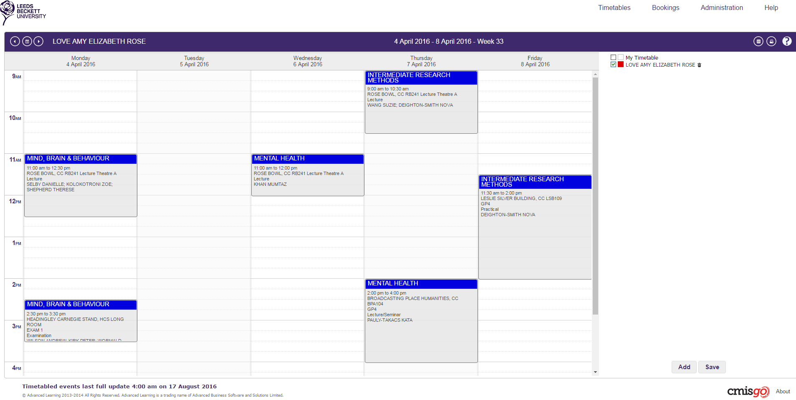
- Double clicking on the event will provide additional information plus a campus map.
- The time periods available to view are Day, Week or Month. Change the view by selecting ‘Timetables’ (top right).
- To view a Room timetable, select the ‘Toggle timetable list’ icon , then ‘Add’ (bottom of the screen). Select the site (building) and then room from the drop down list.

Help function:
- Select the question mark symbol to access this function and select to view the Help function in a new browser.
- Provides assistance in all areas of CMISGo including syncing up your timetable to your smart phone as an integrated calendar.

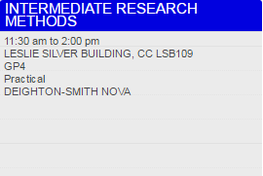
Type of event
Module
Lecturer/s
Group
(if relevant)
Room
Time

Room Code
The room code states the campus, building, then room number, and begins with either HC or CC. HC = Headingley Campus; CC = City Campus.
After the campus and building codes, the room number is indicated.
Numbers prefixed by ‘G’ are on the ground floor (e.g. G15)
Numbers beginning with ‘1’ are on the first floor (e.g. 105)
Numbers beginning with ‘2’ are on the second floor (e.g. 227)
For example:
Campus Building Room number
CC LSB107 = CC (City Campus) LSB (Leslie Silver Building) 107 (1st floor)
HC CAEG03 = HC (Headingley Campus) CAE (Caedmon) G03 (ground floor)
Campus Maps
You can access and download our campus maps PDF at
www.leedsbeckett.ac.uk/campusmaps
Headingley Campus includes Headingley Carnegie Pavilion and Headingley Carnegie Stand, both of which are a 30-minute walk from Headingley main campus.

Term dates
See www.leedsbeckett.ac.uk/about-our-university/term-dates for term dates.

Type of Event
Here is a guide to each kind of event that could appear on your timetable:
Assessment: Any method of assessment other than an examination - such as a performance, presentation, or practical session - which tests your knowledge / proficiency in a subject or skill.
Examination: A formal test of your knowledge / proficiency in a subject or skill.
IT Lab: A session delivered in a computer laboratory.
Lecture: A delivery of information from a lecturer to a large group of students, often from a range of courses and modules.
Lecture / Seminar: A delivery of information from lecturer to students. This may involve lecture-style delivery followed by group work.
Offsite: An event that is delivered away from the university campus. (This will still appear on your timetable.)
Online: A session delivered online.
Practical: A specialist, course-specific practical session.
Practical Lab: A course-specific practical session, run in a specialist laboratory.
Presentations: A session where you and/or other students present your work to a group.
Project Work: A session to work on a set project, sometimes as part of a group.
Resit Exam: An examination that you have already attempted, that you are going to re-attempt. Resit examinations normally occur at the end of a semester.
Seminar: An interactive session between lecturer and students, often involving group work. Seminars are smaller than a lecture and part of a specific course. Seminars give the opportunity for questions, discussion and group work.
Support Session: An additional session to support your studies.
Tutorial: A meeting involving you and your personal tutor - normally 1:1 or a small group - which focuses on your course or academic issues, or on wider concerns.
Workshop: A group session involving intensive discussion and activity on a particular subject or project.
Work placement: Work to be undertaken outside of your course, in a workplace environment.

